CF23
Suzuki GSF1200 Bandit
Suzuki GSX1200 Inazuma

Kit for the left side |  |  |  |  | Kit for the right side
No. | Description | Cat.no. | Pcs |  |  | No. | Description | Cat.no. | Pcs
1 | Crash bar |  | 1 |  |  | 1 | Crash bar |  | 1
2 | Bolt M8x70mm | 841 | 2 |  |  | 2 | Bolt M8x70mm | 841 | 2
3 | Bolt M10x80x1,25mm | 920 | 1 |  |  | 3 | Bolt M10x80x1,25mm | 920 | 1
4 | Pad M8-spring | 800 | 2 |  |  | 4 | Pad M8-spring | 800 | 2
5 | Pad M10-spring | 801 | 1 |  |  | 5 | Pad M10-spring | 801 | 1
6 | Dural.cylinder d=5mm | 433 | 2 |  |  | 6 | Dural.cylinder d=5mm | 433 | 2
7 | Advertising sticker RDmoto |  | 1 |  |  | 7 | Advertising sticker RDmoto |  | 1

Installation:

Make the installation of the crash bar according to the instruction on the below attached photos.

The installation of the crash bar for the left and right side is the same.

During the installation get the crash bar in the lower rear part under duralumin triangle, which connects the frame of the motorcycle with the engine. The triangle separates so. Use the duralumin cylinders (No. 6) for defining a will of bolts M8 in the duralumin triangle.

Warning – we recommend to use safety glue on threads of all bolts (moderate strong – blue colour).

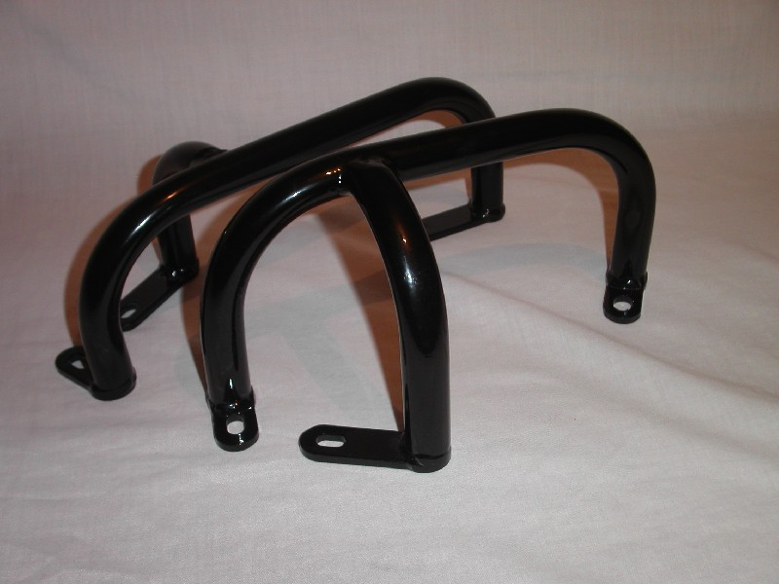

bolt M8x70mm + pad (spring) M8
during the installation get under duralumin triangle; bolt M10x80x1,25 mm + two duralumin cylinders + pad (spring) M10
bolt M8x70mm + pad (spring) M8

