CF25
Suzuki GSF1250 Bandit
2007-

Kit for the left side |  |  |  |  | Kit for the right side
No. | Description | Cat.no. | Pcs |  |  | No. | Description | Cat.no. | Pcs
1 | Crash bar |  | 1 |  |  | 1 | Crash bar |  | 1
2 | Advertising sticker RDmoto |  | 1 |  |  | 2 | Bolt M8x30mm | 834 | 1
 |  |  |  |  |  | 3 | Steel bolt 10x240x30x30 |  | 1
 |  |  |  |  |  | 4 | Pad M10 | 804 | 2
 |  |  |  |  |  | 5 | Nut M10-safety | 810 | 2
 |  |  |  |  |  | 6 | Advertising sticker RDmoto |  | 1
Installation:

Make the installation of the crash bar according to the instruction on the below attached photos.

The installation of the crash bar for the left and right side is the same.

Warning – we recommend to use safety glue on threads of all bolts (moderate strong – blue colour).

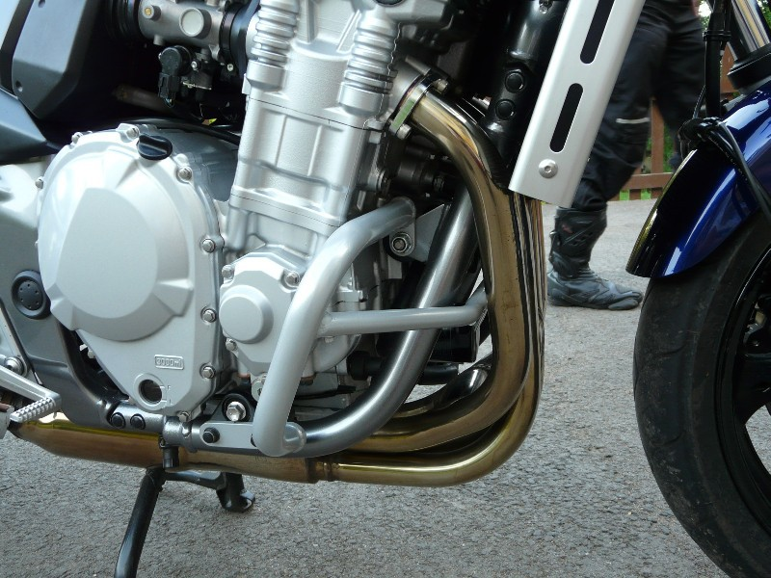
steel bolt M10x240mm + two pads M10 + two nuts M10
bolt M8x30mm to connect left and right crash bar
original bolst

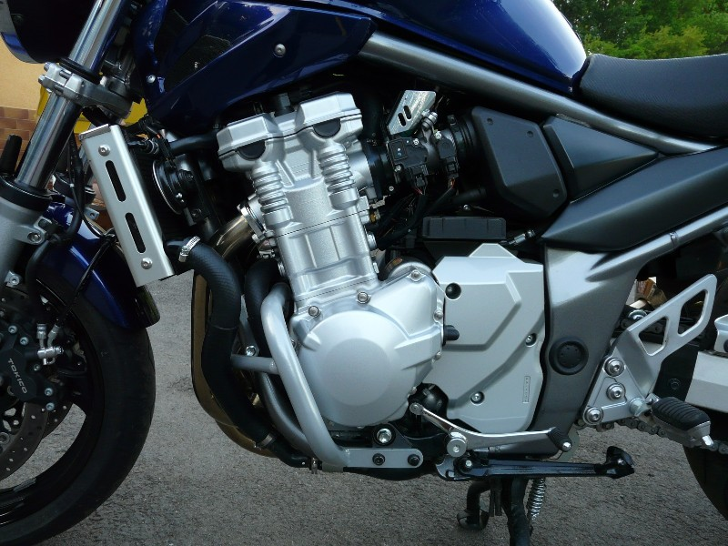
original bolts

