CF26
Yamaha XTZ 750 Super Tenere

Kit for the left side |  |  |  |  | Kit for the right side
No. | Description | Cat.no. | Pcs |  |  | No. | Description | Cat.no. | Pcs
1 | Crash bar |  | 1 |  |  | 1 | Crash bar |  | 1
2 | Bolt M8x40mm | 828 | 2 |  |  | 2 | Bolt M8x40mm | 828 | 2
3 | Pad M8 - plane | 802 | 5 |  |  | 3 | Pad M8 - plane | 802 | 5
4 | Steel adapter with thread M8 | X27 | 1 |  |  | 4 | Steel adapter with thread M8 | X27 | 1
5 | Bolt M8x25mm | 831 | 2 |  |  | 5 | Bolt M8x25mm | 831 | 2
6 | Nut M8 – safety | 809 | 1 |  |  | 6 | Nut M8 – safety | 809 | 1
7 | Steel adapter (bent) | X28 | 1 |  |  | 7 | Steel adapter (bent) | X28 | 1
8 | Bar – strut between bars | X29 | 1 |  |  | 8 | Plastic plug into the tube | X19 | 1
9 | Plastic plug into the tube | X19 | 1 |  |  | 9 | Advertising sticker RDmoto |  | 1
10 | Advertising sticker RDmoto |  | 1
Installation:

Make the installation of the crash bar according to the instruction on the below attached photos.

The installation of the crash bar for the left and right side is the same.

Warning – we recommend to use safety glue on threads of all bolts (moderate strong – blue colour).

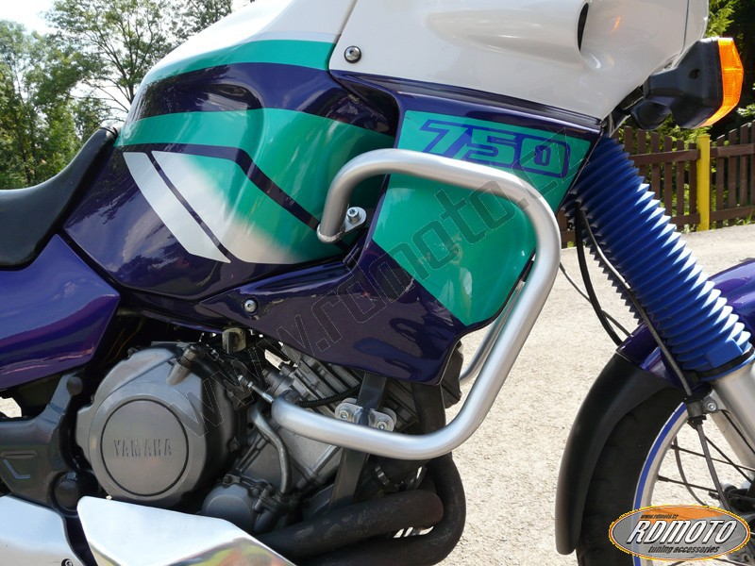
steel adapter with thread M8 + two bolts M8x40mm + two nuts M8 (safety)

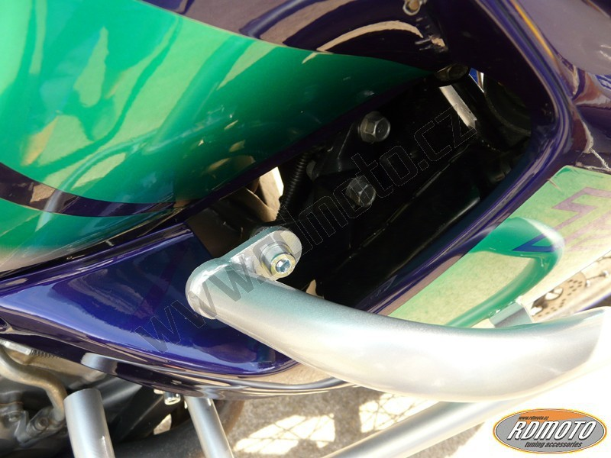
bolt M8x25mm + two pads M8 (plane) + nuts M8 (safety) + steel adapter (bent)

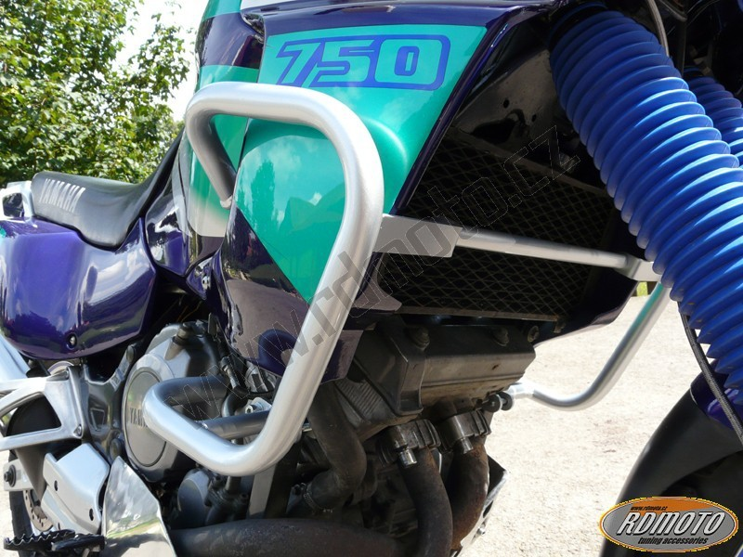
bolt M8x25mm + pad M8 (plane)

bolt M8x25mm + pad M8 (plane)
bar – strut between bars

