CF29
Honda XLV 650 Transalp
2000-2007

Kit for the left side |  |  |  |  | Kit for the right side
No. | Description | Cat.no. | Pcs |  |  | No. | Description | Cat.no. | Pcs
1 | Crash bar |  | 1 |  |  | 1 | Crash bar |  | 1
2 | Steel adapter with thread M8 | X18 | 1 |  |  | 2 | Steel adapter with thread M8 | X18 | 1
3 | Bolt M6x30mm | 863 | 1 |  |  | 3 | Bolt M6x30mm | 863 | 2
4 | Bolt M8x50mm | 837 | 2 |  |  | 4 | Bolt M8x50mm | 837 | 2
5 | Pad M8 (spring) | 800 | 2 |  |  | 5 | Pad M8 (spring) | 800 | 2
6 | Pad M6 (plane) | 987 | 1 |  |  | 6 | Pad M6 (plane) | 987 | 1
7 | Bolt M8x110mm | 844 | 1 |  |  | 7 | Cover on head of bolt | X5 | 2
8 | Nut M8 (safety) | 809 | 1 |  |  | 8 | Tape 3M |  | 1
9 | Cover on head of bolt | X5 | 2 |  |  | 9 | Advertising sticker RDmoto |  | 1
10 | Tape 3M |  | 1 |  |  | 10 | Nut M6 | 948 | 1
11 | Advertising sticker RDmoto |  | 1 |  |  | 11 | Washer M6 | 947 | 2
12 | Washer M8 flat | 802 | 1 |  |  | 12 | Washer M8 flat | 802 | 1

Installation:

Make the installation of the crash bar according to the instruction on the below attached photos.

Warning – we recommend to use safety glue on threads of all bolts (moderate strong – blue colour).

The right side:

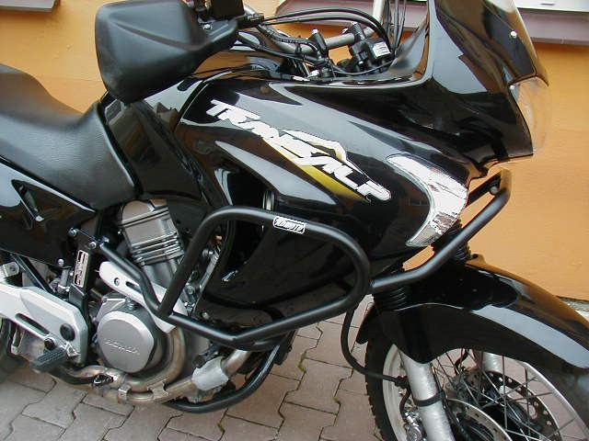

for connecting of the left and right crash bar with frame of the motorcycle; bolt M8x110mm + two pads (plane) + nut M8 (safety)

for connecting of the crash bar with frame of the motorcycle; bolt M6x30mm + pad (plane)

two bolts M8x50mm + two pads (spring) + two coves on head of bolts + steel adapter

For connecting both frames under the light use bolt M6x30 and 2xwashers and nut M6

The left side:

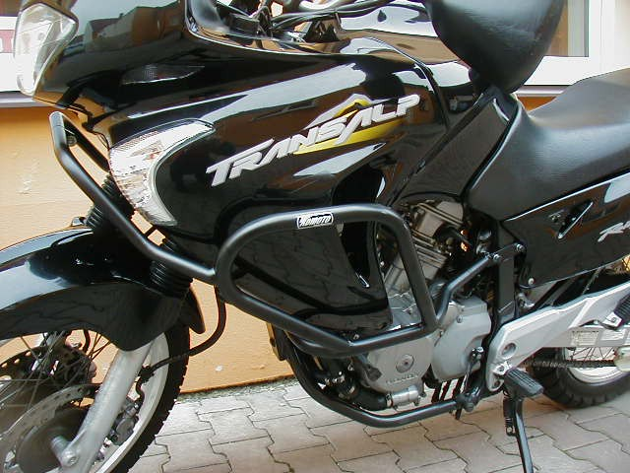

for connecting of the crash bar with frame of the motorcycle; bolt M6x30mm + pad (plane)
for connecting of the left and right crash bar with frame of the motorcycle (viz the right side)
two bolts M8x50mm + two pads (spring) + two coves on head of bolts + steel adapter

