CF30
BMW F 800 GS
2008-

Kit for the left side |  |  |  |  | Kit for the right side
No. | Description | Cat.no. | Pcs |  |  | No. | Description | Cat.no. | Pcs
1 | Crash bar |  | 1 |  |  | 1 | Crash bar |  | 1
2 | Bolt M8x25mm | 833 | 1 |  |  | 2 | Bolt M8x60mm | 838 | 2
3 | Bolt M8x40mm | 828 | 1 |  |  | 3 | Bolt M10x100mm | 885 | 1
4 | Bolt M8x30mm | 834 | 1 |  |  | 4 | Pad M8 (flat) | 802 | 2
5 | Bolt M10x100mm | 885 | 1 |  |  | 5 | Pad M10 (flat) | 804 | 1
6 | Pad M8 (flat) | 802 | 2 |  |  | 6 | Cover on head of bolt M8 | X5 | 2
7 | Pad M10 (flat) | 804 | 1 |  |  | 7 | Cover on head of bolt M10 | X4 | 1
8 | Cover on head of bolt M8 | X5 | 2 |  |  | 8 | Dural. cylinder d=32,5mm | 427 | 1
9 | Cover on head of bolt M10 | X4 | 1 |  |  | 9 | Dural. cylinder d=35,5mm | 426 | 2
10 | Dural. cylinder d=16,5mm | 428 | 1 |  |  | 10 | Advertising sticker RDmoto |  | 1
11 | Dural. cylinder d=50mm | 429 | 1
12 | Advertising sticker RDmoto |  | 1

Installation:

Make the installation of the crash bar according to the instruction on the below attached photos.

Warning – we recommend to use safety glue on threads of all bolts (moderate strong – blue colour).

The right side:

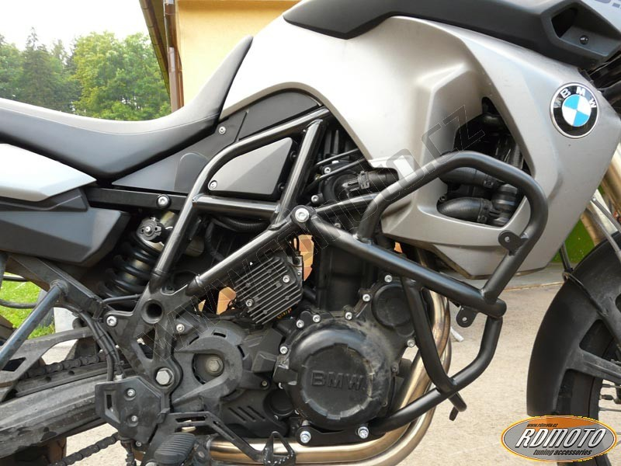

bolt M10x100mm + duralumin cylinder 32,5mm
two bolts M8x60mm + two duralumin cylinders 35,5 mm

The left side:

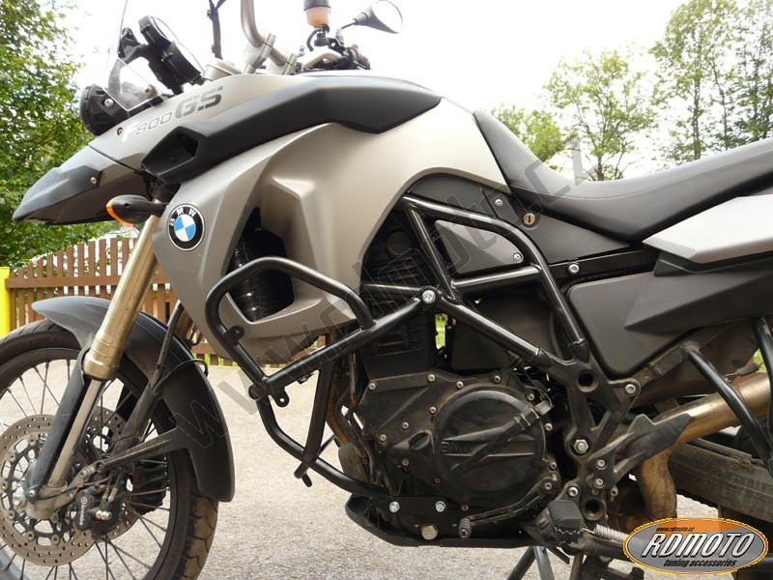

bolt M10x100mm + duralumin cylinder 50mm
bolt M8x25mm to connect both sides
bolt M8x40mm + duralumin cylinder 16,5mm
bolt M8x30mm

