CF33
Suzuki XF650 Freewind

Kit for the left side |  |  |  |  | Kit for the right side
No. | Description | Cat.no. | Pcs |  |  | No. | Description | Cat.no. | Pcs
1 | Crash bar |  | 1 |  |  | 1 | Crash bar |  | 1
2 | Bolt M10x20mm | 819 | 1 |  |  | 2 | Bolt M10x20mm | 819 | 1
3 | Pad M10 - spring | 801 | 1 |  |  | 3 | Pad M10 - spring | 801 | 1
4 | Dural. cylinder d=60mm | 434 | 1 |  |  | 4 | Dural. cylinder d=20mm | 435 | 1
5 | Steel adapter | X26 | 1 |  |  | 5 | Bolt M8x110mm | 844 | 1
6 | Advertising sticker RDmoto |  | 1 |  |  | 6 | Pad M8 - plane | 802 | 2
 |  |  |  |  |  | 7 | Nut M8 - safety | 809 | 1
 |  |  |  |  |  | 8 | Advertising sticker RDmoto |  | 1
Installation:

Make the installation according to the instruction on the below attached photos. The installation of the left and right side is the same.

Warning – we recommend to use safety glue on threads of all bolts (moderate strong – blue colour).

remove original duralumin cylinder and insert shorter duralumin cylinder d=60mm

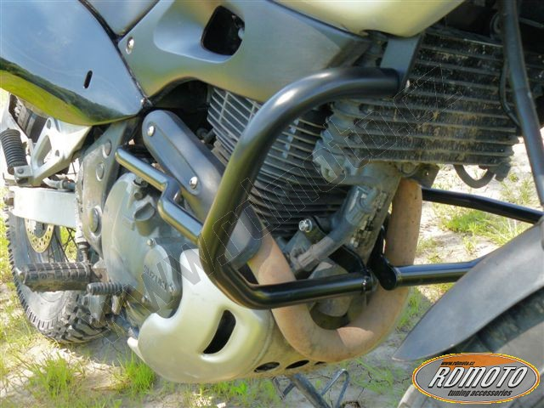
bolt M10x30mm + pad M10 (spring)
steel adapter

bolt M10x30mm + pad M10 (spring)

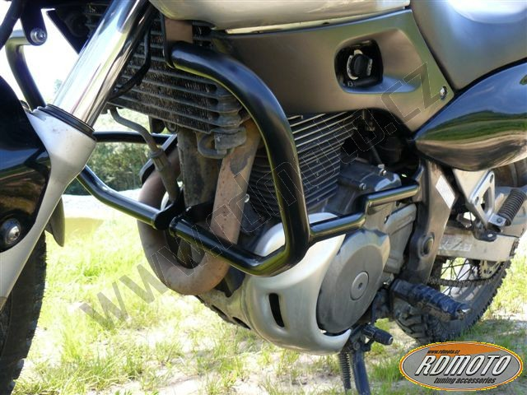
remove original duralumin cylinder and insert shorter duralumin cylinder d=20mm

bolt M8x110mm to connect the left and right crash bar + pad M8 (plane) + nut M8 (safety)

