CF34
Honda XL1000 Varadero
2003-

Kit for the left side |  |  |  |  | Kit for the right side
No. | Description | Cat.no. | Pcs |  |  | No. | Description | Cat.no. | Pcs
1 | Crash bar |  | 1 |  |  | 1 | Crash bar |  | 1
2 | Bolt M10x20mm | 819 | 1 |  |  | 2 | Steel adapter for connecting of the bars | X25 | 1
3 | Pad M10-spring | 801 | 1 |  |  | 3 | Bolt M6x16mm | 962 | 2
4 | Tape 3M |  | 1 |  |  | 4 | Bolt M8x25mm | 833 | 1
5 | Advertising sticker RDmoto |  | 1 |  |  | 5 | Bolt M10x20mm | 819 | 1
 |  |  |  |  |  | 6 | Pad M10-spring | 801 | 1
 |  |  |  |  |  | 7 | Tape 3M |  | 1
 |  |  |  |  |  | 8 | Advertising sticker RDmoto |  | 1

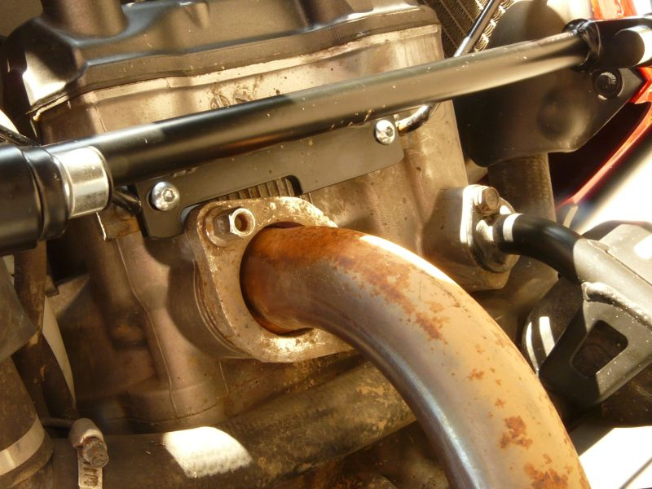
two bolts M6x16mm
The right side:

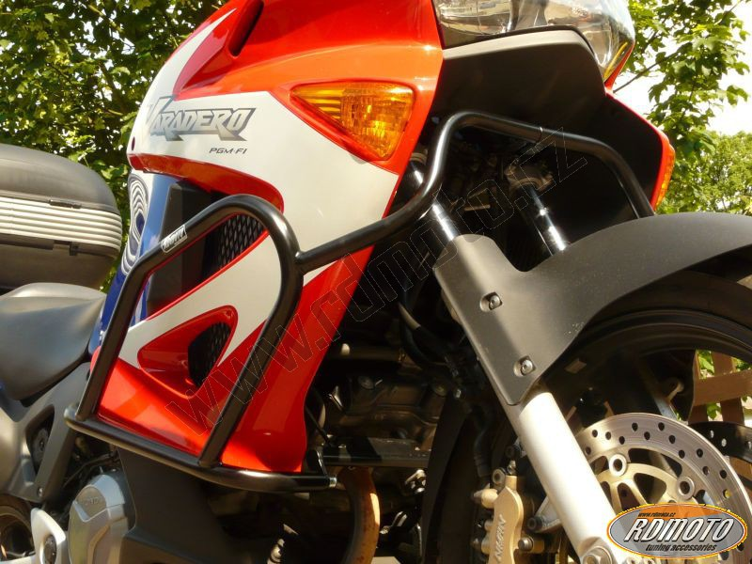
bolt M8x25mm

original bolt + 3M tape
bolt M10x30mm + pad M10 (spring)

The left side:

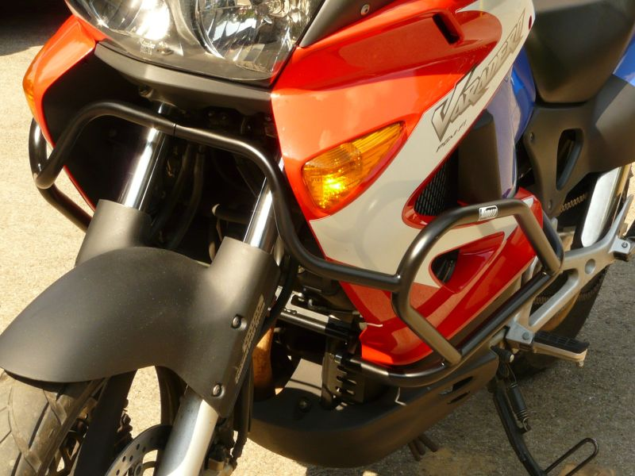
bolt M10x30mm + pad M10 (spring)
original bolt + tape 3M

