CF35
Yamaha TDM900

ID | Description | Cat.n | QTY
1 | Silent-block | X34 | 2
2 | Nut M8 | 813 | 2
3 | Thread bar 10x350x30x30 |  | 1
4 | Dural.cylinder l=22mm | 1158 | 1
5 | Dural.cylinder l=41mm | 1157 | 1
6 | Nut M10 | 961 | 2
7 | Washer spring M10 | 801 | 2
8 | Larg-washer M12 | 803 | 2
9 | 3M tape |  | 2
10 | RDmoto stickers | - | 2
11 | Bolt M12x75x1,25 | 914 | 2

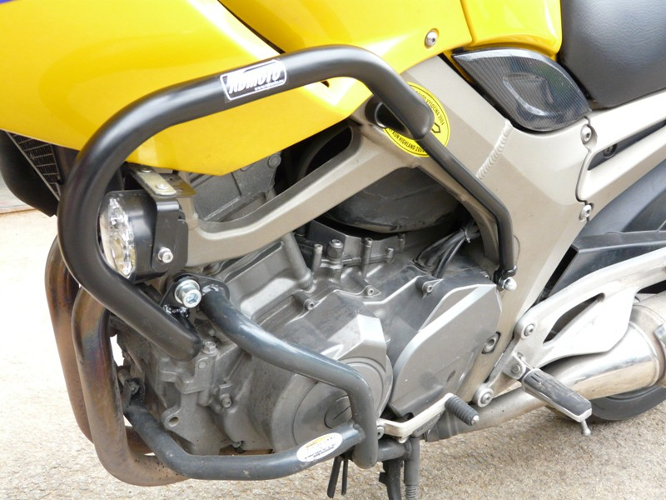
- Silent-block + Nut M8.
- Thread bar, through the frame M10x350mm.
- Into the frame insert dural.cylinder.
- Nut M10 + spring washer M10.
- Bolt M12 +large washer
- 3M tape

Use the glue of all threads-medium strong.
2.,3. a 4.
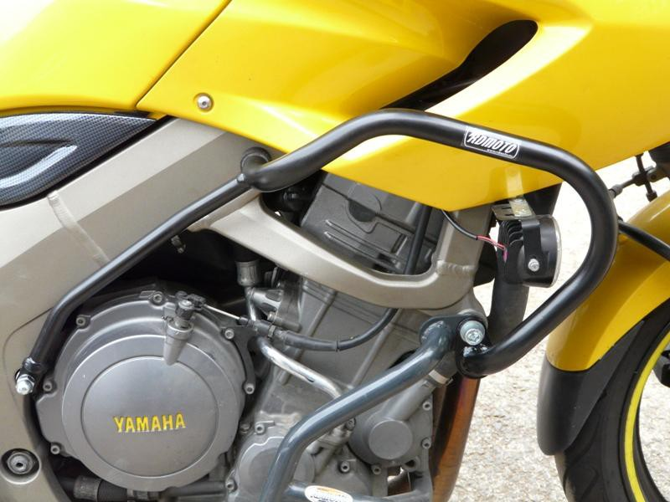
- Silent block+nut M80.
- Insert into the frame dural.cylinder.
- Nut M10 + pwasher spring M10
- Bolt M12 + washer
- 3M tape.

Use the glue of all threads-medium strong.

3. a 4.
2., 3. a 4.

