CF37
Yamaha TDM850, type 3VD

Kit for the left side |  |  |  |  | Kit for the right side
No. | Description | Cat.no. | Pcs |  |  | No. | Description | Cat.no. | Pcs
1 | Crash bar |  | 1 |  |  | 1 | Crash bar |  | 1
2 | Bolt M8x25mm | 833 | 1 |  |  | 3 | Bolt M8x40mm | 828 | 1
3 | Bolt M8x40mm | 828 | 1 |  |  | 4 | Bolt M8-spring | 800 | 1
4 | Pad M8-spring | 800 | 1 |  |  | 5 | Bolt M10x110x1,25mm | 928 | 1
5 | Bolt M10x50x1,25mm | 921 | 1 |  |  | 6 | Pad M10-spring | 801 | 1
6 | Pad M10-spring | 801 | 1 |  |  | 7 | Dural. cylinder d=10mm | 437 | 1
7 | Dural. cylinder d=10mm | 437 | 1 |  |  | 8 | Dural. cylinder d=36,5mm | 490 | 1
8 | Dural. cylinder d=16,5mm | 106 | 1 |  |  | 9 | Nut M10 – safety | 810 | 1
9 | Nut M10 – safety | 810 | 1 |  |  | 10 | Pad M10 – plane | 804 | 1
10 | Pad M10 – plane | 804 | 1 |  |  | 11 | Advertising sticker RDmoto |  | 1
11 | Steel bar 10x320x30x30 |  | 1
12 | Advertising sticker RDmoto |  | 1

Installation:

Make the installation of the crash bar according to the instruction on the below attached photos.

Warning – we recommend to use safety glue on threads of all bolts (moderate strong – blue colour).

The right side:

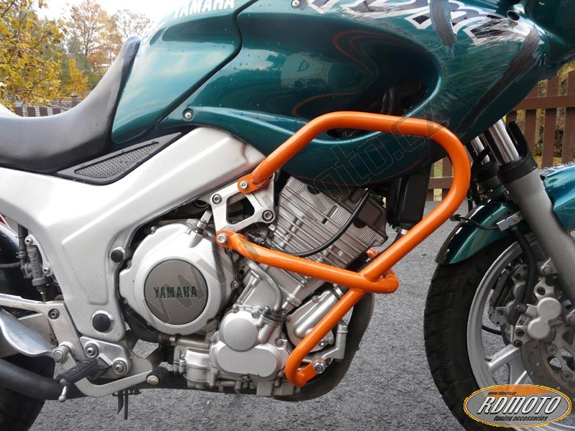

bolt M10x110x1,25mm + duralumin cylinder d=36,5mm + pad M10 (spring)

nut M10 (safety) + pad M10

bolt M8x40mm + duralumin cylinder d=10mm + pad M8 (spring)

The left side:

bolt M8x40mm + duralumin cylinder d=10mm + pad M8 (spring)

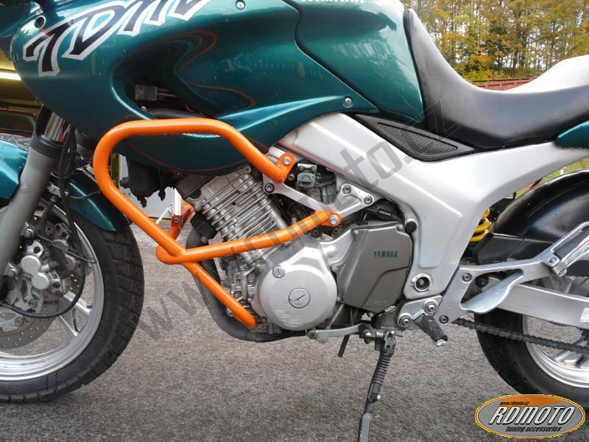

bolt M8x25mm to connect the left and right crash bar
steel bar d=320mm + nut M10 (safety) + pad M10
bolt M10x50x1,25mm + duralumin cylinder d=16,5mm + pad M10 (spring)

