CF38
BMW R1200GS / Adventure
2004-2007

Fitting kit:
No | Description | Cat.N | Qt
1 | Crash frames | CF38 | -
3 | Washer M6 | 947 | 2
5 | Bolt M6x25mm | 874 | 1
6 | Bolt M6x20mm | 875 | 1
8 | Bolt M6x30mm-cone head | 864 | 1
9 | Bolt M8x25 – round head | 831 | 4
10 | Bolt M8x40mm-cone head | 835 | 1
11 | Washer M8 | 802 | 4
12 | Nut M8 | 809 | 2
13 | Washer M8 spring | 800 | 2
14 | Bolt M12x90mm | 808 | 2
15 | Washer M12 | 803 | 2
16 | Tape 3M |  | 4
18 | Alu. spacer diam. 20mm,lengh. 19mm | 477 | 1
19 | Alu. spacer-diam. 16mm,lengh. 5mm | 478 | 1
20 | Alu. spacer-diam. 20mm,lengh. 13mm | 479 | 1
21 | Alu. spacer-diam. 25mm,lengh. 28mm | 480 | 2
22 | Steel conect.bar 230mm | X61 | 1
23 | Steel adapter | X68 | 1
24 | Advert. stickers RDmoto |  | 2

Assembly:

Make assembly as shown opn the pictures.

Warning - on the threads of the screws we recommend using premium adhesive moderate (blue).

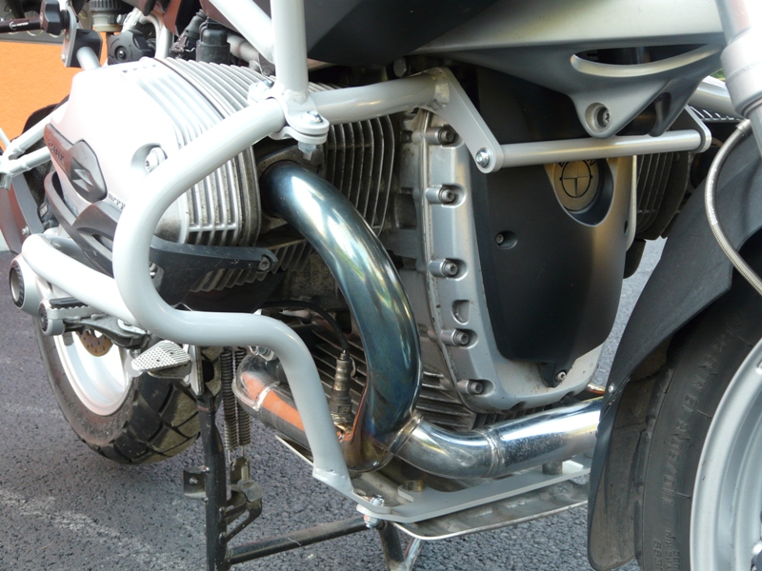
1x bolt M6x25 (No.5)
2x washer M6 (No .3)
1x dural. spacer(No.19)
1x steel adapter (No.23)
1x bolt M8x25mm (No.9)
2x washer M8 (No.11)
1x nut M8 (No.12)
1x bolt M6x30mm (No.8)
1x alu.spacer (No.20)
1x bolt M6x20mm (No.6)
1x podložka M6 (No.3)
1x steel conect. bar (No.22)
2x Bolt M8x25mm (No.9)
2x Washer M8 spring (No.13)
2x bolt M12x90mm (No. 14, left and right)
2x alu.spacer (No.21, left and right)
2x washer M12 (No.15, left and right)

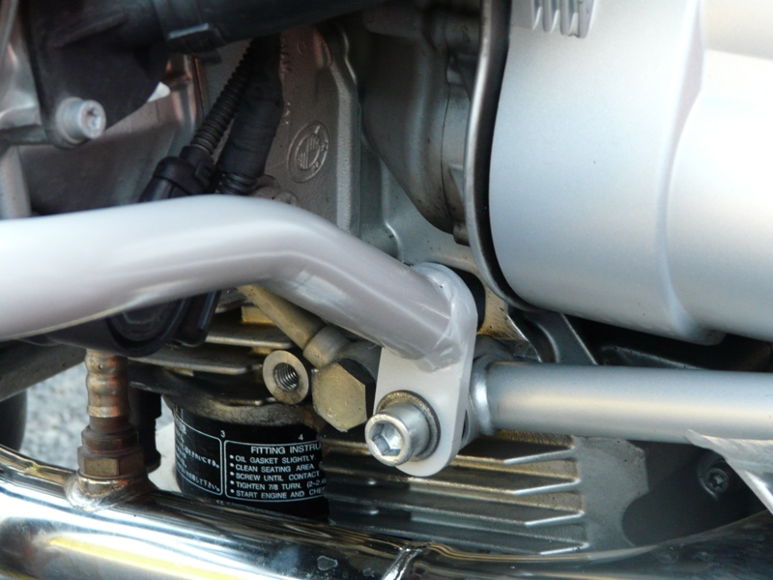

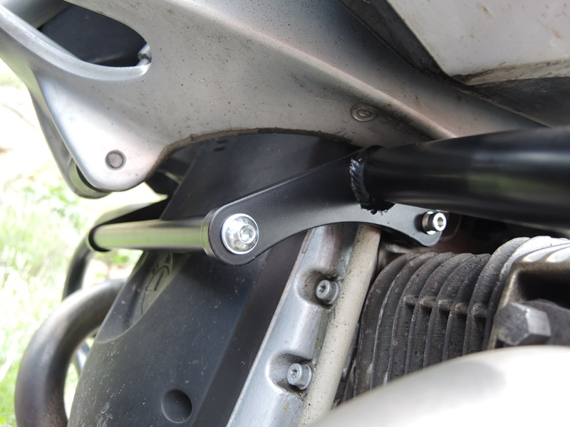
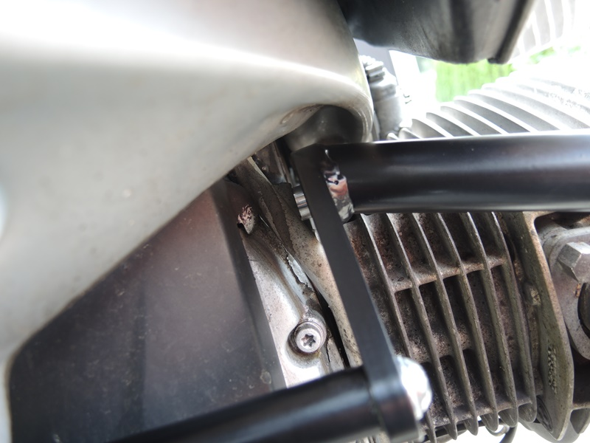
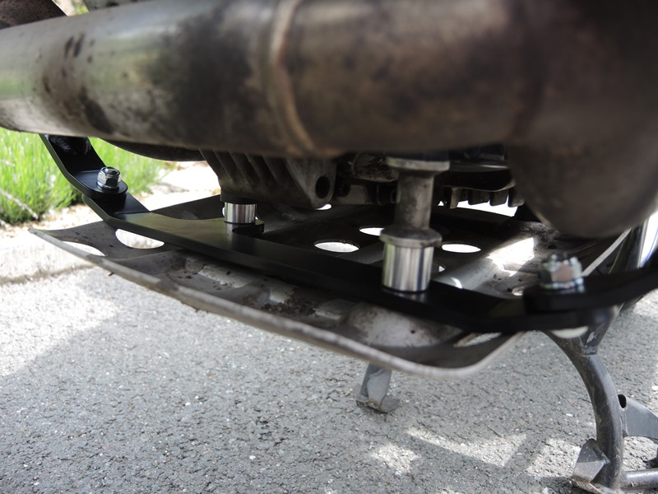
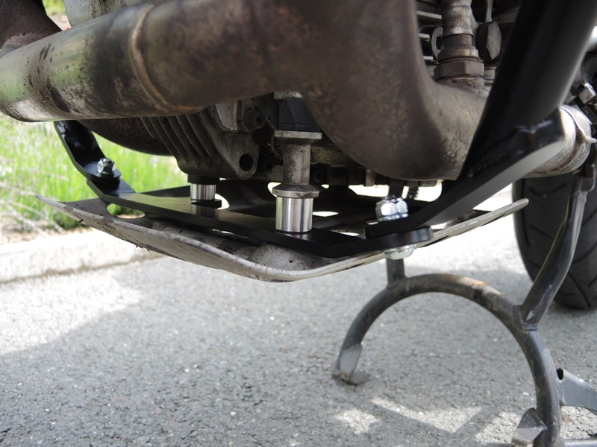
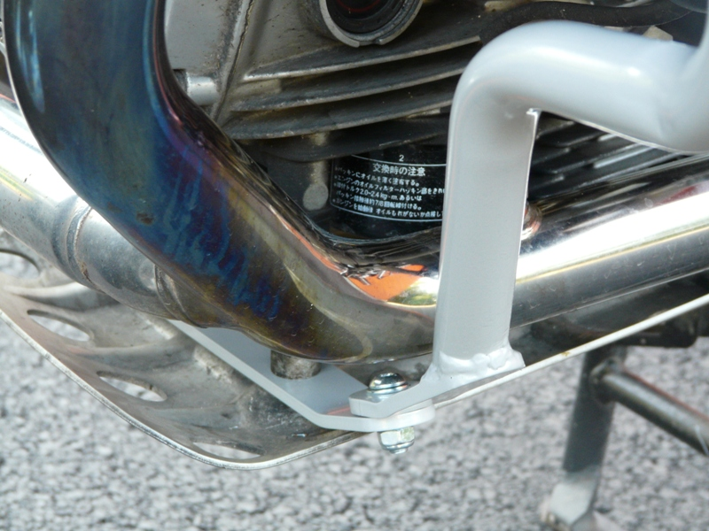

1x bolt M8x25mm (No.9)
2x washer M8 (No.11)
1x Nut M8 (No.12)
1x dural. spacer (No.18)
1x Bolt M8x40mm (No.10)

1x bolt M6x25mm (No.5)
1x washer M6 (No.3)
1x dural. spacer (No.19)

1x Bolt M8x25mm (No.9)
1x washer M8 spring (No.13)

2x bolt M8x25mm (No.9)
4x washer M8 (No.11)
2x nut M8 (No.12)

1x dural. spacer (No.18)
1x Bolt M8x40mm (No.10)

