CF39
BMW R1200GS / Adventure
2004-2007

Mounting kits
No. | Description | Cat.No. | Pcs
1 | crash frames | CF | -
2 | steel stirrup M6 | X52 | 2
3 | washer M6 flat | 947 | 8
4 | nut M6 insurance | 948 | 5
7 | screw M6x30mm | 863 | 1
9 | screw M8x25mm round head | 831 | 4
11 | washer M8 flat | 802 | 12
12 | nut M8 safety | 809 | 6
16 | 3M tape | - | 4
17 | stirrup on the pipe diameter 25mm | X20 | 2
24 | advertising sticker RDmoto | - | 1

Installation :

Installation of the crash frames mount according to the instructions on the attached photos below.
Upper frames not possible to assembly without lower frames.

Warning – we recommend to use safety glue on threads of all bolts (moderate strong – blue colour).

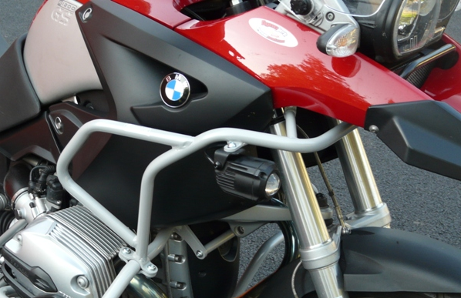

2x stirrup (no.17 – left and right side)
4xscrew M8x25mm (no.9 – left and right side)
4xnut M8 (no.12 – left and right side)
8xwasher M8 (no.11 – left and right side)

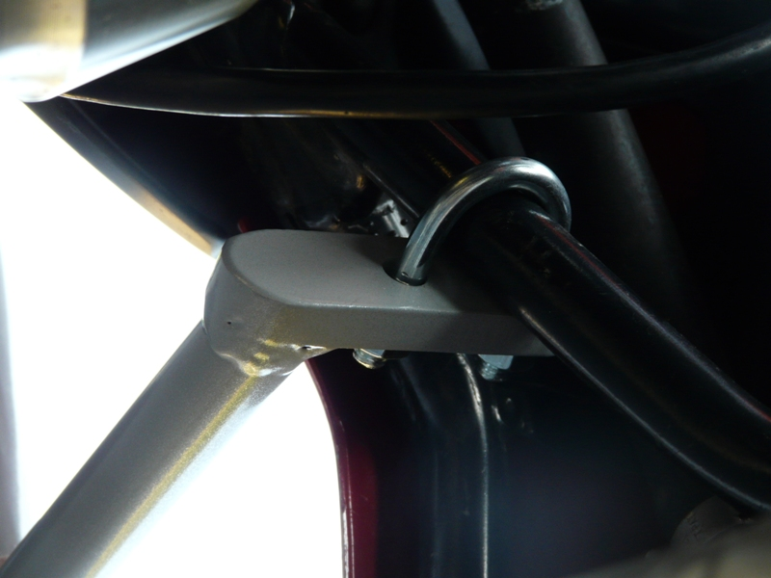
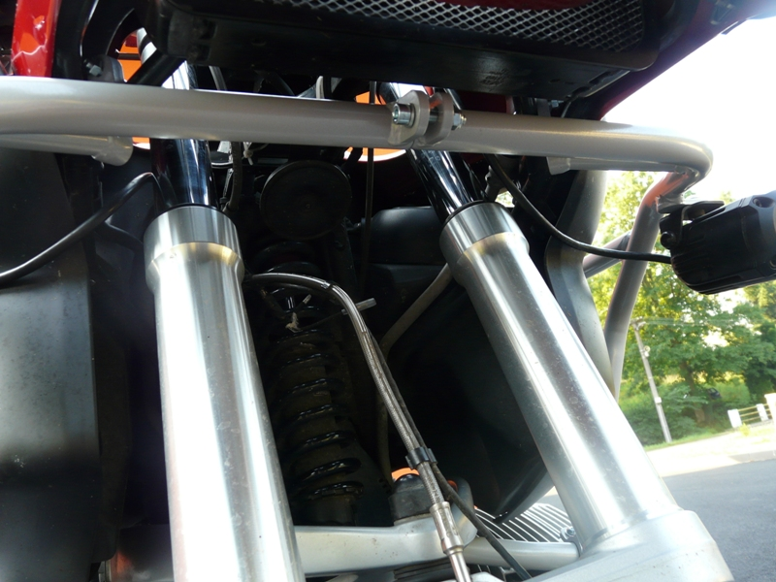
1x screw M6x30mm (no.7)
2x washer M6 (no.3)
1x nut M6 (no.4)
2x steel stirrup M6 (no.2 – left and right side)
4x washer M6 (no.3 – left and right side)
4x nut M6 (no.4 – left and right side)

