CF40
BMW R1200GS / Adventure
2004-2007

Mounting kits
No. | Description | Cat.No. | Pcs
1 | crash frames | CF | -
2 | steel stirrup M6 | X52 | 2
3 | washer M6 flat | 947 | 8
4 | nut M6 insurance | 948 | 5
5 | screw M6x25mm | 874 | 1
6 | screw M6x20mm | 875 | 1
7 | screw M6x30mm | 863 | 1
8 | screw M6x30mm round head | 864 | 1
9 | screw M8x25mm round head | 831 | 8
10 | screw M8x40mm cone head | 835 | 1
11 | washer M8 flat | 802 | 12
12 | nut M8 insurance | 809 | 6
13 | washer M8 spring | 800 | 2
14 | screw M12x80mm | 956 | 2
15 | washer M12 flat | 803 | 2
16 | 3M tape | - | 4
17 | stirrup on the pipe diameter 25mm | X20 | 2
18 | duralumin cylinder-diameter 20mm, length 19mm | 477 | 1
19 | duralumin cylinder-diameter 16mm, length 5mm | 478 | 1
20 | duralumin cylinder-diameter 20mm, length 13mm | 479 | 1
21 | duralumin cylinder-diameter 25mm, length 28mm | 480 | 2
22 | bar – strut between bars | X61 | 1
23 | steel adapter | X68 | 1
24 | advertising sticker RDmoto | - | 1

Installation :

Installation of the crash frames mount according to the instructions on the attached photos below.

Warning – we recommend to use safety glue on threads of all bolts (moderate strong – blue colour).

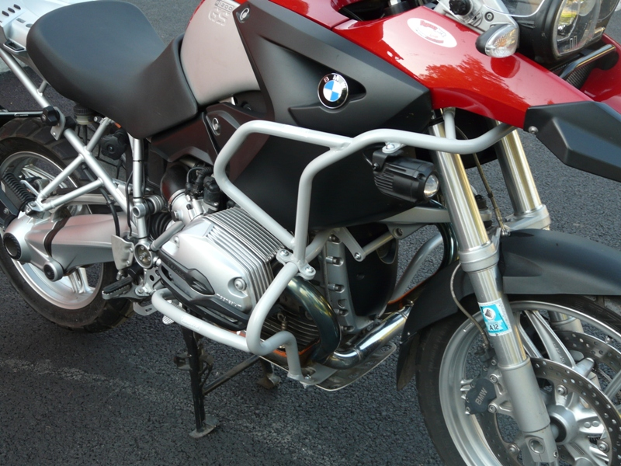
1x screw M6x20mm (no.6)
1x screw M6x25mm (no.5)
2x washer M6 (no.3)
1x duralumin cylinder (no.19)

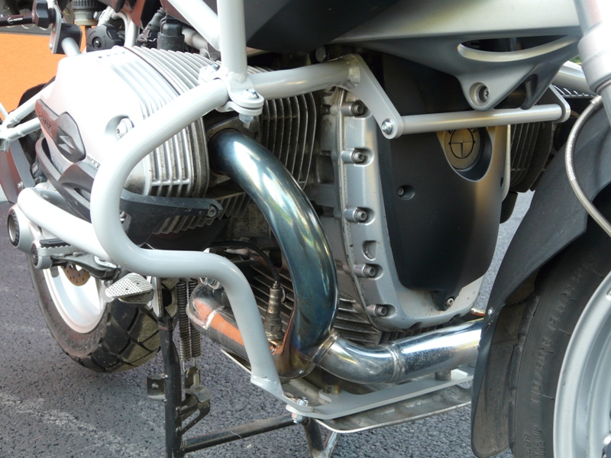
1xbar – strut between bars (no.22)
2xscrew M8x25mm (no.9)
2xwasher M8 spring (no.13)
2x stirrup (no.17 – left and right side)
4xscrew M8x25mm (no.9 – left and right side)
4xnut M8 (no.12 – left and right side)
8xwasher M8 (no.11 – left and right side)
1x steel adapter (no.23)
2x screw M8x25mm (no.9)
4x washer M8 (no.11)
2x nut M8 (no.12)
1x duralumin cylinder (no.18)
1x screw M8x40mm (no.10)
1x screw M6x30mm (no.8)
1x duralumin cylinder (no.20)

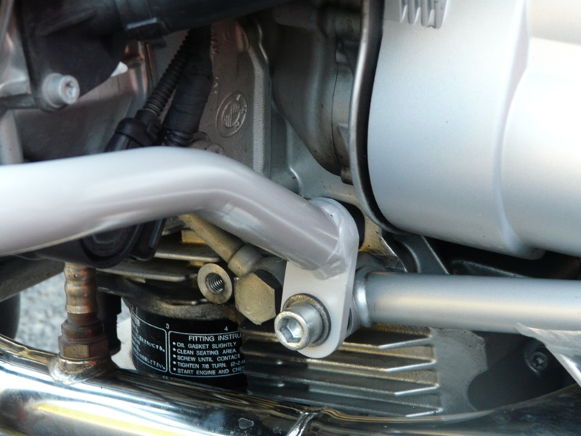
2x screw M12x80mm (no.14 - left and right side)
2x duralumin cylinder (no.21 - left and right side)
2x washer M12 (no.15 – left and right side)

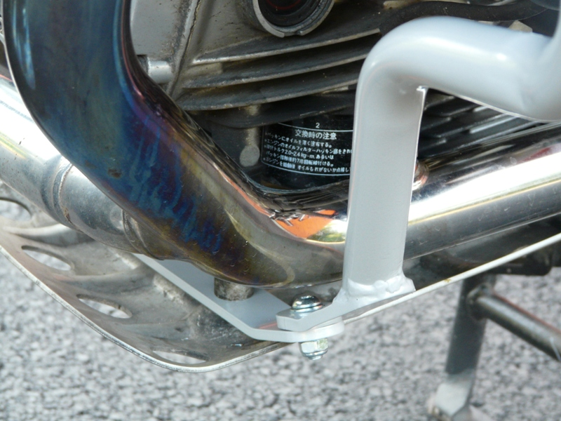

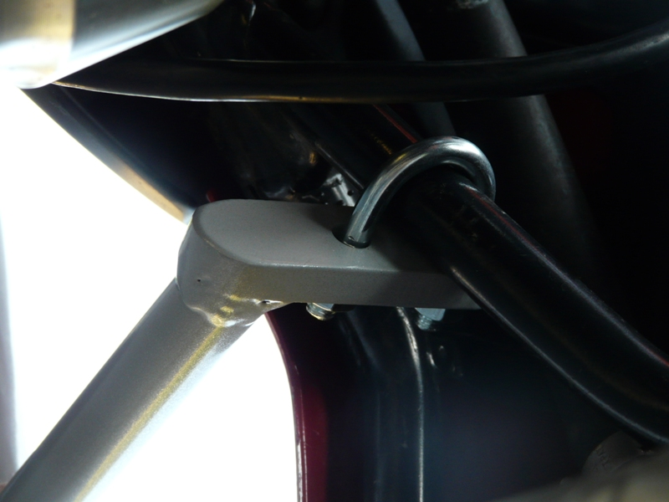
2x steel stirrup M6 (no.2 – left and right side)
4x washer M6 (no.3 – left and right side)
4x nut M6 (no.4 – left and right side)

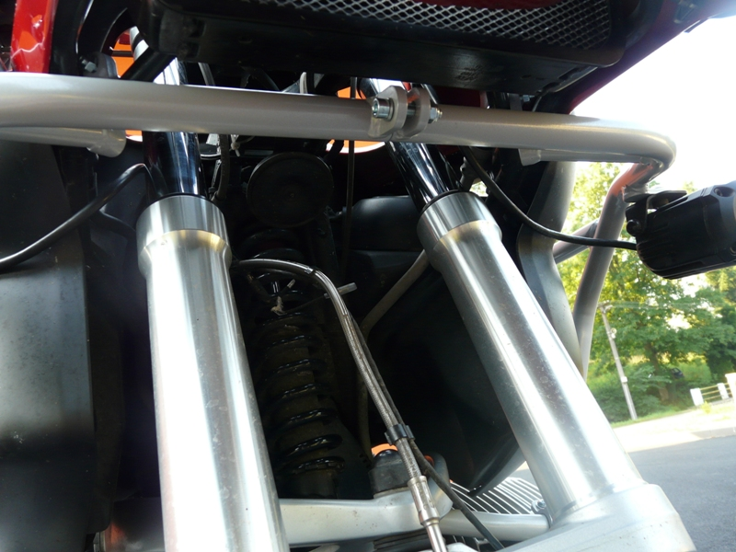
1x screw M6x30mm (no.7)
2x washer M6 (no.3)
1x nut M6 (no.4)

