CF41

**Honda NC700S**

**2012-**

|  |  |  |  |  |  |  |  |  |  |
| --- | --- | --- | --- | --- | --- | --- | --- | --- | --- |
| **Kit for left side** | | | | | **Kit for right side** | | | | |
|  |  |  |  |  |  |  |  |  |  |
|  | Description | Cat. no. | Pcs |  |  | Description | Cat No. | Pcs |  |
| 1 | Crash frame |  | 1 |  | 1 | Crash frame |  | 1 |  |
| 2 | silentblok | X34 | 1 |  | 2 | silentblok | X34 | 1 |  |
| 3 | M8 thread | 813 | 1 |  | 3 | M8 thread | 813 | 1 |  |
| 4 | 3M tape |  | 1 |  | 4 | 3M tape |  | 1 |  |
| 5 | RD moto sticker |  | 1 |  | 5 | RD moto sticker |  | 1 |  |

**Assembly:**

1. Take off the lower pastic under the engine
2. Fit in the silentblocks into the crashframes, including the nuts
3. Crash frames for both left and right side fit under the original screws (acc to photos), but do not tighten them up yet

Right side

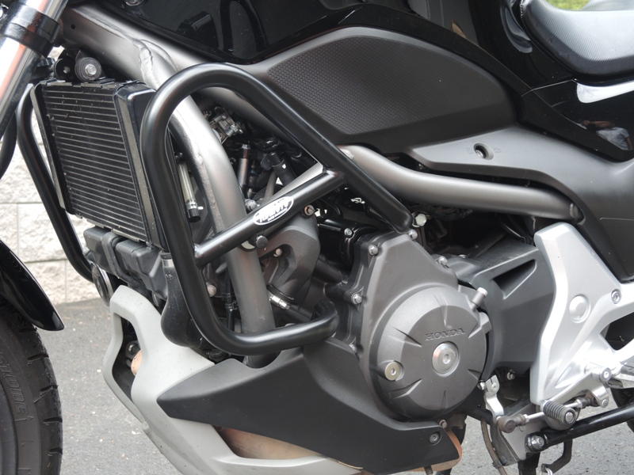

Left side

