CF42
Honda XLV 700 Transalp
2007-

Fitting kit for left side: |  |  |  |  | Fitting kit for right side:
Not. | Popis | Kat.číslo | Počet |  |  | Not. | Popis | Kat.číslo | Počet
1 | Cash bar |  | 1 |  |  | 1 | Cash bar |  | 1
2 | Steel adapter- thread M8 | X36 | 1 |  |  | 2 | Aluminium cylinder D 27 | 123 | 2
3 | screw M8x45mm | 820 | 2 |  |  | 3 | washer M6 | 947 | 2
4 | washer M8 (flat) | 802 | 2 |  |  | 4 | screw M6x50 | 972 | 2
5 | Nut M8 (with pad) | 812 | 2 |  |  | 5 | screw M10x20mm | 819 | 1
6 | Alluminum cylinder D 10mm | 437 | 2 |  |  | 6 | washer M10 (spring) | 801 | 1
7 | screw M8x110mm | 844 | 2 |  |  | 7 | stickers 3M |  | 1
8 | RDmoto stickers |  | 1 |  |  | 8 | RDmoto stickers |  | 1
9 | screw M10x20mm | 819 | 1 |  |  | 9 | Plastic cap | X5 | 2
10 | washer M10 (spring) | 801 | 1
11 | stickers 3M |  | 1

Fitting kit for front side:

1 | Steel adapter- black | X37 | 1
2 | Stainless steel bracket-thread M10 | X38 | 1
3 | Nut M10 (safety) | 810 | 2
4 | washer M10 (flat) | 804 | 2
5 | Plastic cover M10 | X35 | 2
6 | bolt M6x50 | 867 | 2
7 | washer M6 (flat) | 947 | 4
8 | Aluminium cylinder D 13mm | 479 | 2
9 | screw M6x30 | 864 | 1
10 | nut (safety) | 948 | 1
11 | Stickers 3M |  | 1

Mounting instruction :

Make the installation of the crash bar according to the instruction on the below attached photos.
Warning – we recommend to use safety glue on threads of all bolts (medium strong – blue colour).

- Remove plastic cover under the engine.
- Remove original screws at foot brake pump.

A.
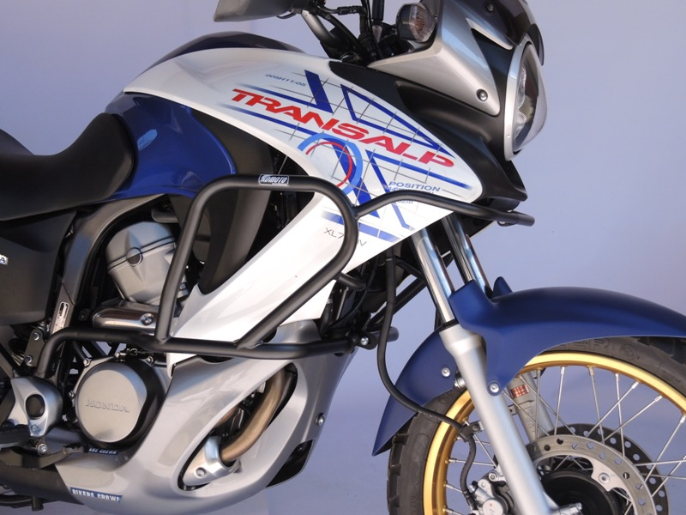 B.

Front side:
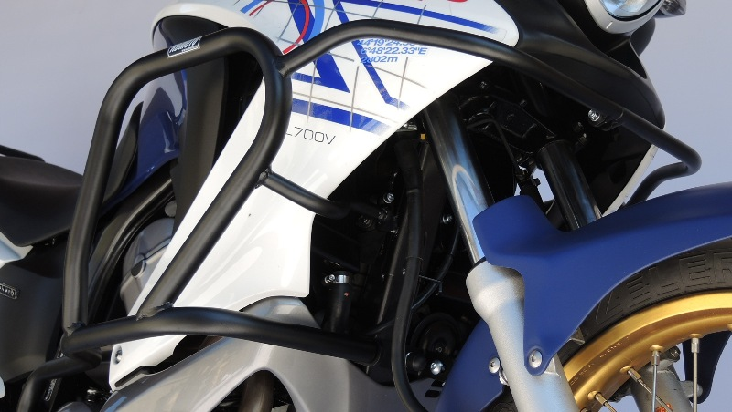
On the frame instalation of steel adapter (not. 1), stick on it 3M sticker (not.11). Steel adapter mount with stainless bracket (not. 2). For fixed use washers and nuts (not. 3.,4.) Put the plastic cover (note 5.)
Remowe original screws. Between crash frame and motorcycle frame put Al roller D 13mm (not.8), fixed screws M6 (note. 6.,7.).
Push a frames together. Fixed with washer(not.11) screw (not.9) and nut (not. 10).

avá strana :

Right side:

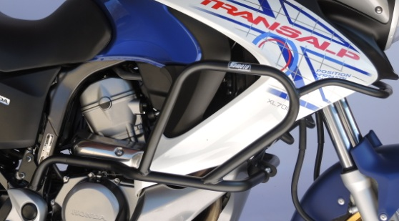
Note 2. Aluminium cylinder D 27 put between crash frame and bike frame
Fixed with screws and washers (note. 3.,4.)
Plast. cover

Frame fixed on the steel adapter with screw M10 (not.5) and washer(note 6.) Frame is fixed on the cooler holder.

Left side:
Frame fixed on the steel adapter with screw M10 (note 9) and spring washer.

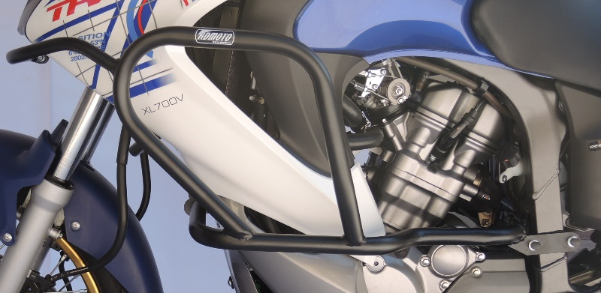
To join the crash frame and bike frame, steel adapter (note 2) screw M8 (note.3),washer M8 (note.4), nut M8 (note5), stickers 3M.
Dismantle both original frame bolts at the horn. Between the horn bracket and a steel plate put alluminum cylinder D10 (note 6), with a washer and screw M8X110 (note 7) is pulled. We use the orig nuts.

