CF43
BMW R1100GS/Adventure

Kit for left side: |  |  |  |  | Kit for right side:
Note | Description | Cat.num | Quant. |  |  | Note | Description | Cat.num. | Quant.
1 | Crash bar |  | 1 |  |  | 1 | Crash frame |  | 1
2 | Steel strut between bars | X70 | 1 |  |  | 2 | Silentblock | X21 | 1
3 | Silenblok | X21 | 1 |  |  | 3 | Nut M8 – lock | 809 | 1
4 | Nut M8 – safety | 809 | 1 |  |  | 4 | Washer M8 | 802 | 3
5 | Pad M8 – plane | 802 | 1 |  |  | 5 | Bolt M8x25mm | 831 | 1
6 | Bolt M8x25mm | 831 | 1 |  |  | 6 | Washer M8 | 800 | 3
7 | Pad M8-spring | 800 | 1 |  |  | 7 | Bolt M10x100mm | 885 | 1
8 | Bolt M10x100mm | 885 | 1 |  |  | 8 | Washer M10- spring | 801 | 1
9 | Pad M10-spring | 801 | 2 |  |  | 9 | Duralumin cylinder d=55mm | 439 | 1
10 | Dural. cylinder d=55mm | 439 | 1 |  |  | 10 | Duralumin cylinder d= 18mm | 1185 | 1
11 | Screw M10x70mm | 851 | 1 |  |  | 11 | Bolt M8x50 | 837 | 1
12 | Dural.cylinder 15mm | 1170 | 1 |  |  | 12 | sticker RDmoto |  | 1
13 | Advertising sticker RDmoto |  | 1
14 | M8x20 | 823 | 2
15 | washer M10 | 804 | 2

Mountin :

Perfomr the assembly by photo.

Warning - the threads of the screws is recommended to use glue. (medium strong- blue).

Right side:
bolt M10x100mm + duralumin cylinder (note 9)d=55mm + washer M10 (flat and spring)

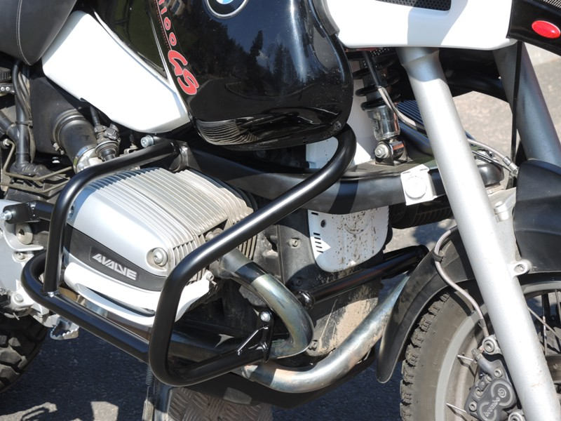
Original bolt or M8x20 (note 14)+ washer
bolt M8x25mm +washer M8 (spring)

bolt M8x50 (note 11) + washer flat + washer spring M8
duralumin cylinder (pzn.10)
nut M8 (lock) + washer M8 (flat) + silentblock

Left side:

Original bolt or bolt M8x20 (note 14)
bolt M10x100mm + duralumin cylinder 55mm + washer M10 (spring + flat)

Steel bar

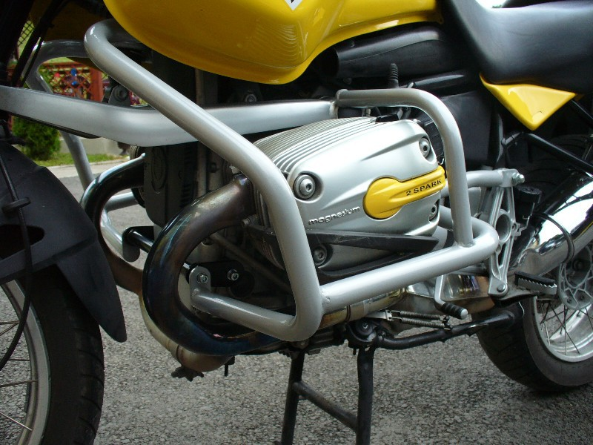
Screw M10x70mm, dural. cylinder l=15mm and spring washer

nut M8 (lock) + washer M8 (flat) + silentblock
Bolt M8x25mm + washer M8 (spring)

