CF45
Honda XLV 600 Transalp
1988-1999

Kit for left side: |  |  |  |  | Kit for right side:
ID. | Description | Cat.N | Qt |  |  | ID. | Description | Cat.N | Qt
1 | Crash frame | - | 1 |  |  | 1 | Crash frame | - | 1
2 | Washer M10 spring | 801 | 1 |  |  | 2 | Washer M10 spring | 801 | 1
3 | Bolt M10x20mm | 819 | 1 |  |  | 3 | Bolt M10x20mm | 819 | 1
4 | Washer M10 spring | 804 | 1 |  |  | 4 | Washer M10 spring | 804 | 1
5 | Nut M10 | 810 | 1 |  |  | 5 | Nut M10 | 810 | 1
6 | Bolt M6x30 | 864 | 1 |  |  | 6 | Nut M6 | 948 | 1
7 | Washer M6 | 947 | 2 |  |  | 7 | Washer M6 | 947 | 2
8 | Bolt M6X40 | 866 | 1 |  |  | 8 | Bolt M6X40 | 866 | 1
9 | Plas.cap M10 | X35 | 1 |  |  | 9 | Plas.cap M10 | X35 | 1
10 | Sticker RDmoto |  | 1 |  |  | 10 | Sticker RDmoto |  | 1

11 | Clevis, thread M10 | X45 | 1
12 | Steel brace | X44 | 1

Fitting instaruction:

Make assembly according to the attached pgotos below.

Warning - on the threads of all bolts recommend the use of premium adhesive moderate (blue).

Dismantle originals bolts. Use are for assembly cash frames.
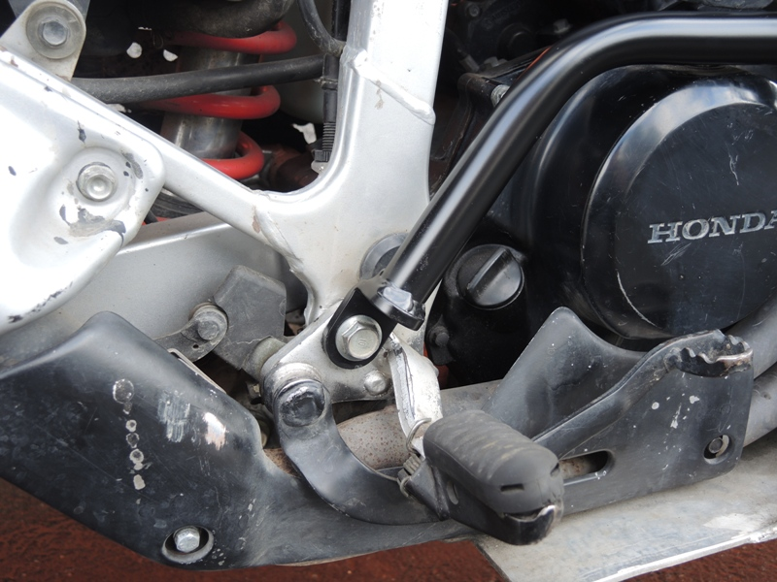

Take out plastic covers (cooler, plastic cover).
Is necessary drill a holes into the plastic.

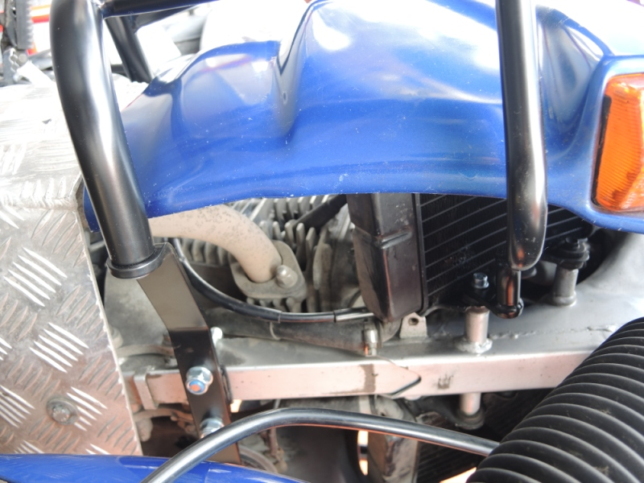

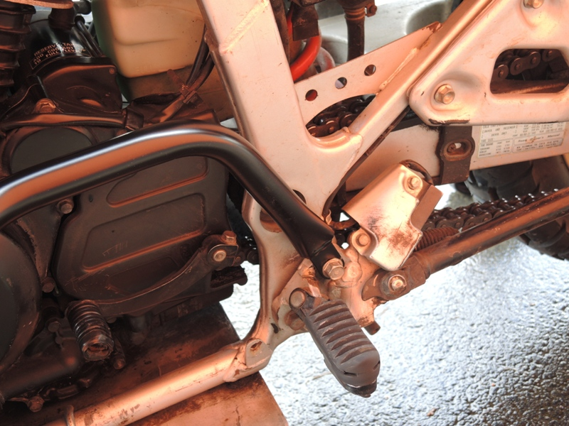

Connect frames. Use washer ID.7,bolt and nut ID.6.

Assembly L+R side:
Insert Clevis ID.11. Put on the bike plast.cover.On the Steel brace, stick 3M tape.Loosely tighten steel brace ID.12. For tighten use nut ID.5 and washer ID.4.
Clevis tighten after connetct cash frames with steel brace. On the nut put plastic covers ID.9.
For connecting brace and frames use bolts ID.3 and washers ID.2
For connecting frames and chassis use bolts and washers ID.8 and ID.7.

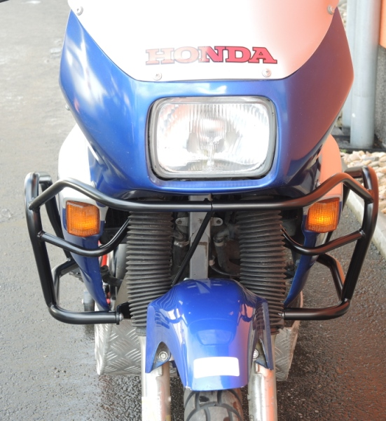
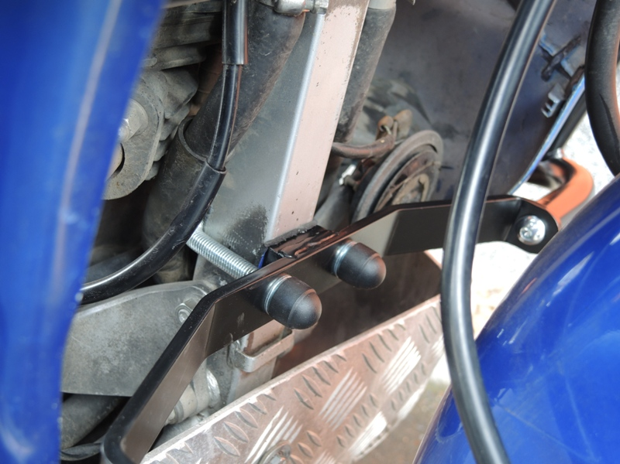

After mounting frames, Check all bolts and nuts, put plastics covers on the coolers.
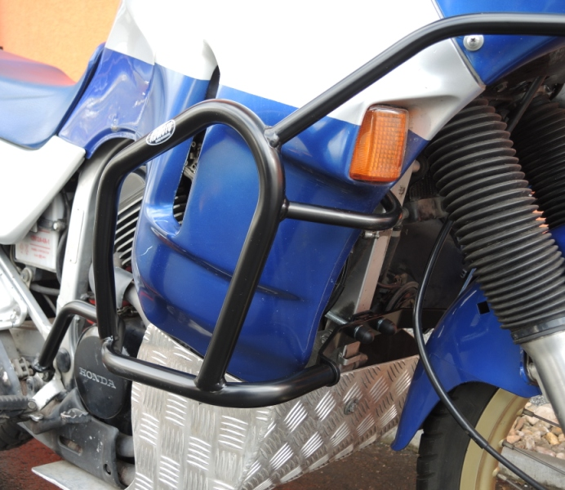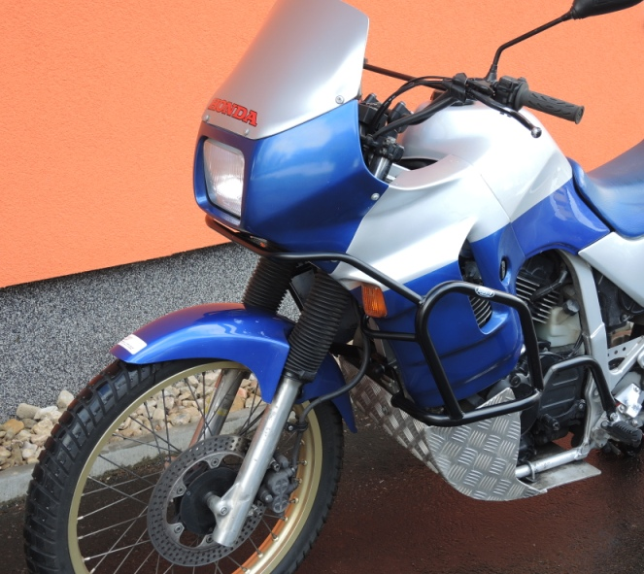

Approximately dimension for wholes.
