CF46
BMW R 1200GS Adventure 2014-

Mounting kit for the left side: Mounting kit for the right side:
ID | Description | Cat.no | Pcs
1 | Bolt M8x35 | 861 | 1
2 | Dural.cylinder - 15mm | 465 | 1
3 | Bolt M10x45 | 848 | 1
4 | Washer M10 | 804 | 1
5 | Washer M8 | 802 | 4
6 | Bolt M8x25 | 833 | 1
7 | Nut M8 | 812 | 1
8 | Bolt M8x40mm | 828 | 1
9 | Plastic cap | X19 | 1
10 | Bolt M8x25mm | 831 | 1
11 | Nut M8 (safety) | 809 | 1
ID | Description | Cat.no | Pcs
1 | Bolt M8x35 | 861 | 1
2 | Dural.cylinder - 15mm | 465 | 1
3 | Bolt M10x45 | 848 | 1
4 | Washer M10 | 804 | 1
5 | Bolt M8x30 | 834 | 1
6 | Dural.cylinder - 8mm | 1105 | 1
7 | Nut M8 | 812 | 1
8 | Washer M8 | 802 | 4
9 | Bolt M8x40mm | 828 | 1
10 | Plastic cap | X19 | 1
11 | Bolt M8x25mm | 831 | 1
12 | Nut M8 (safety) | 809 | 1

Install crash bars according to the pictures below.

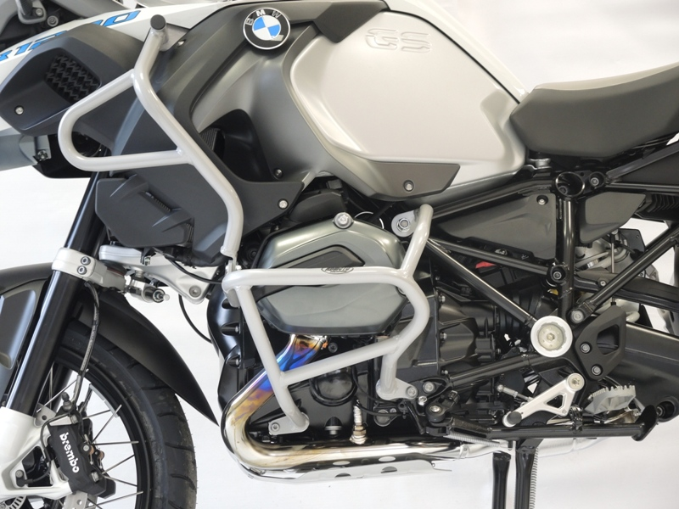
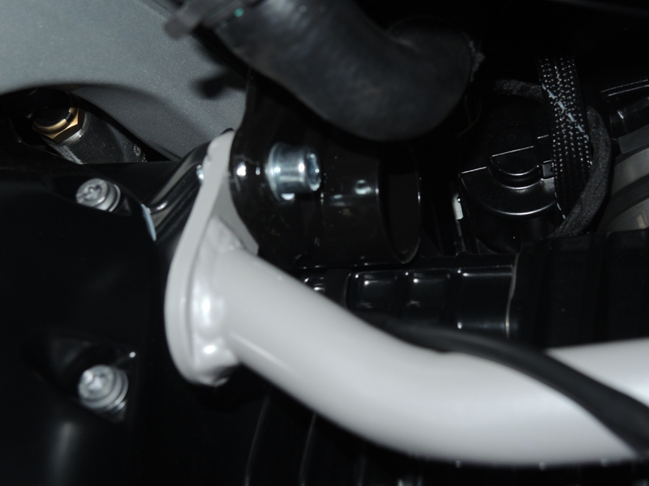

Bolt M8x25 ID6 + washer ID5.

For tightening lower part of crash frame use bolt ID3 and washer ID4.

For tightenng upper part of crash frame use bolt ID1 and dural. Cylinder ID2.

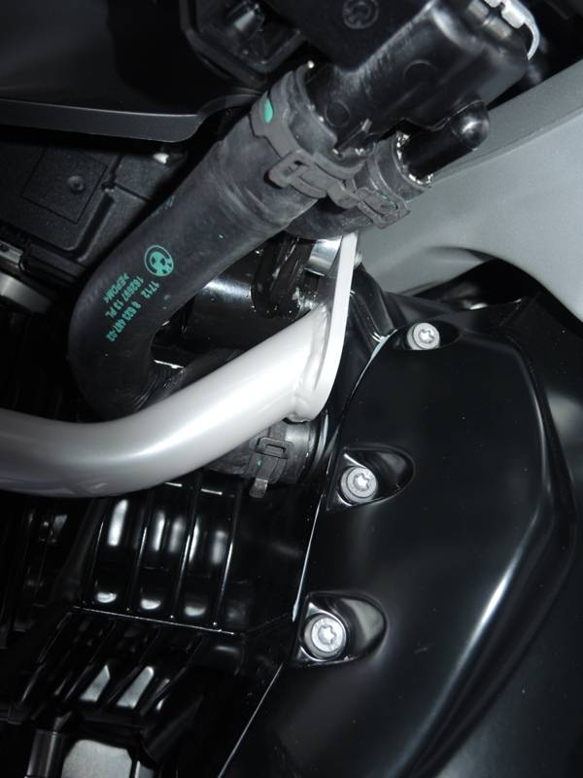
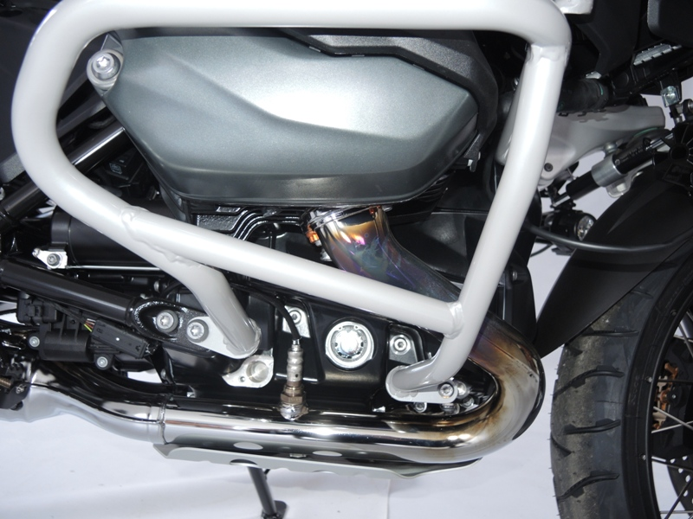
Dural cylinder ID.6.

Nut ID.7 and bolt M8x30 ID.5.

Bolt ID.3 and washer ID.4.

Dural cylinder ID.2.

Bolt ID.1+ washer ID.8

Bolt M8x40
Washer M8
Plastic cap

Bolt M8x25
2xWasher M8
Nut M8 (safety)

We recommend to use the glue on all threads (blue colour – medium strong).

