CF47
BMW R 1200GS Adventure 2014-

Mounting kit for the left side: Mounting kit for the right side:
ID | Description | Cat.no | Pcs
1 | Bolt M8x35 | 861 | 1
2 | Dural.cylinder - 15mm | 465 | 1
3 | Bolt M10x45 | 848 | 1
4 | Washer M10 | 804 | 1
5 | Washer M8 | 802 | 2
6 | Bolt M8x25 | 833 | 1
7 | Nut M8 | 812 | 1
ID | Description | Cat.no | Pcs
1 | Bolt M8x35 | 861 | 1
2 | Dural.cylinder - 15mm | 465 | 1
3 | Bolt M10x45 | 848 | 1
4 | Washer M10 | 804 | 1
5 | Bolt M8x30 | 834 | 1
6 | Dural.cylinder d=8mm | 1105 | 1
7 | Nut M8 | 812 | 1
8 | Washer M8 | 802 | 2
Install crash bars according to the pictures below.
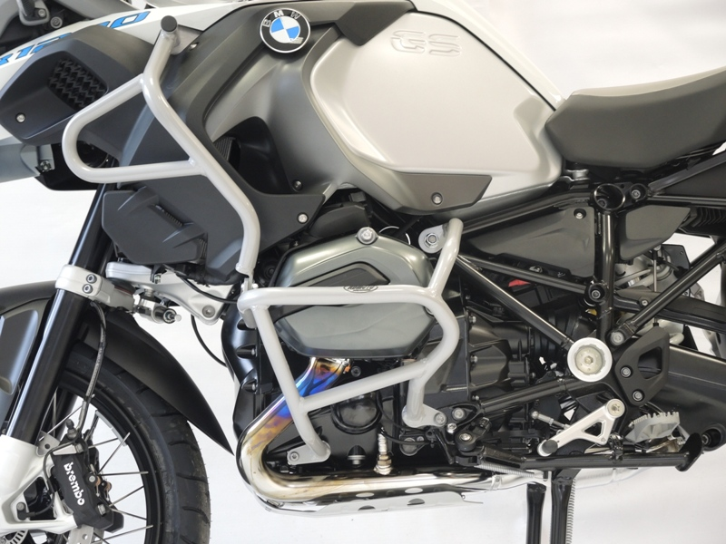
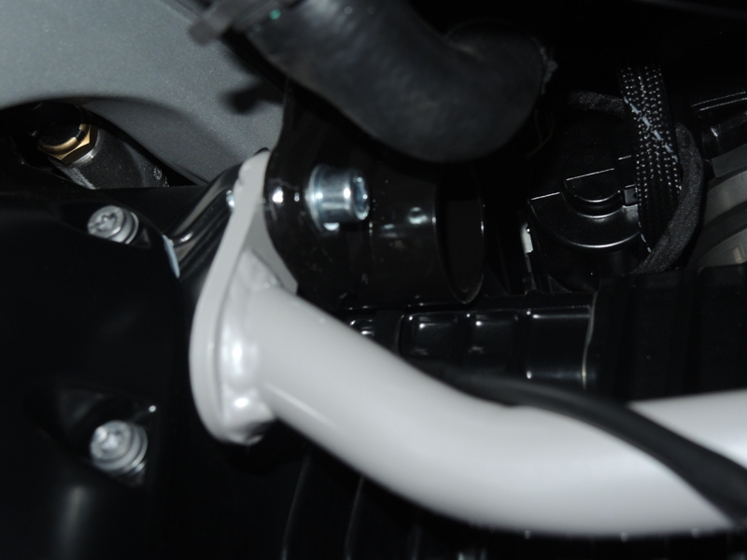

Bolt M8x25 ID6 + washer ID5 + ID.7

For tightening lower crash frame use bolt ID3 and washer ID4.

For tightenng upper crash frame use bolt ID1 and dural. Cylinder ID2 + washer M8 ID.5

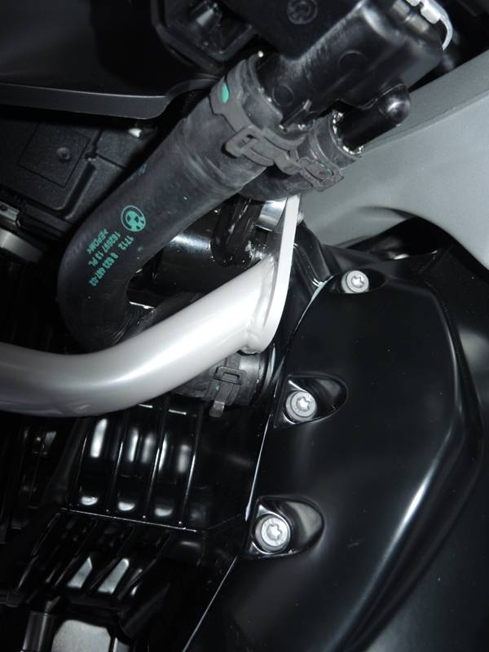
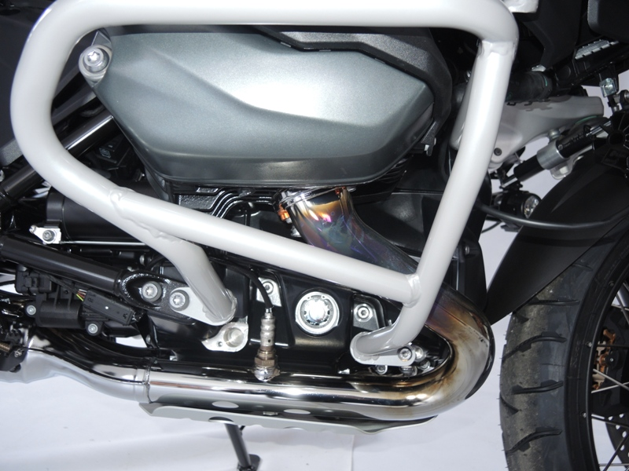
Bolt ID.3 and washer ID.4.
Dural cylinder ID.2.

Bolt ID.1+ washer ID.8

Dural cylinder ID.6.

Nut ID.7 and bolt M8x30 ID.5 + washer ID.8

We recommend to use the glue on all threads (blue colour – medium strong).

