CF48KD
BMW F800R

Left side fitting kit: |  |  |  |  | Right side fitting kit:
ID. | Descrip. | Cat.N | Qt |  |  | ID. | Descrip. | Cat.N | Qt
1 | Crash frame | - | 1 |  |  | 1 | Crash frame | - | 1
2 | Screw M10x90 | 880 | 2 |  |  | 2 | Screw M10x90 | 880 | 2
3 | Washer M10 | 804 | 2 |  |  | 3 | Washer M10 | 804 | 2
4 | Plastic cover | X4 | 2 |  |  | 4 | Plastic cover | X4 | 2
5.1 | Dural roller – 6,5mm | 1105 | 2 |  |  | 5.2 | Dural roller – 7mm | 405 | 2
6 | Sticker | - | 1 |  |  | 6 | Sticker | - | 1
7 | Washer M8 | 800 | 1
8 | Screw M8x25 | 831 | 1

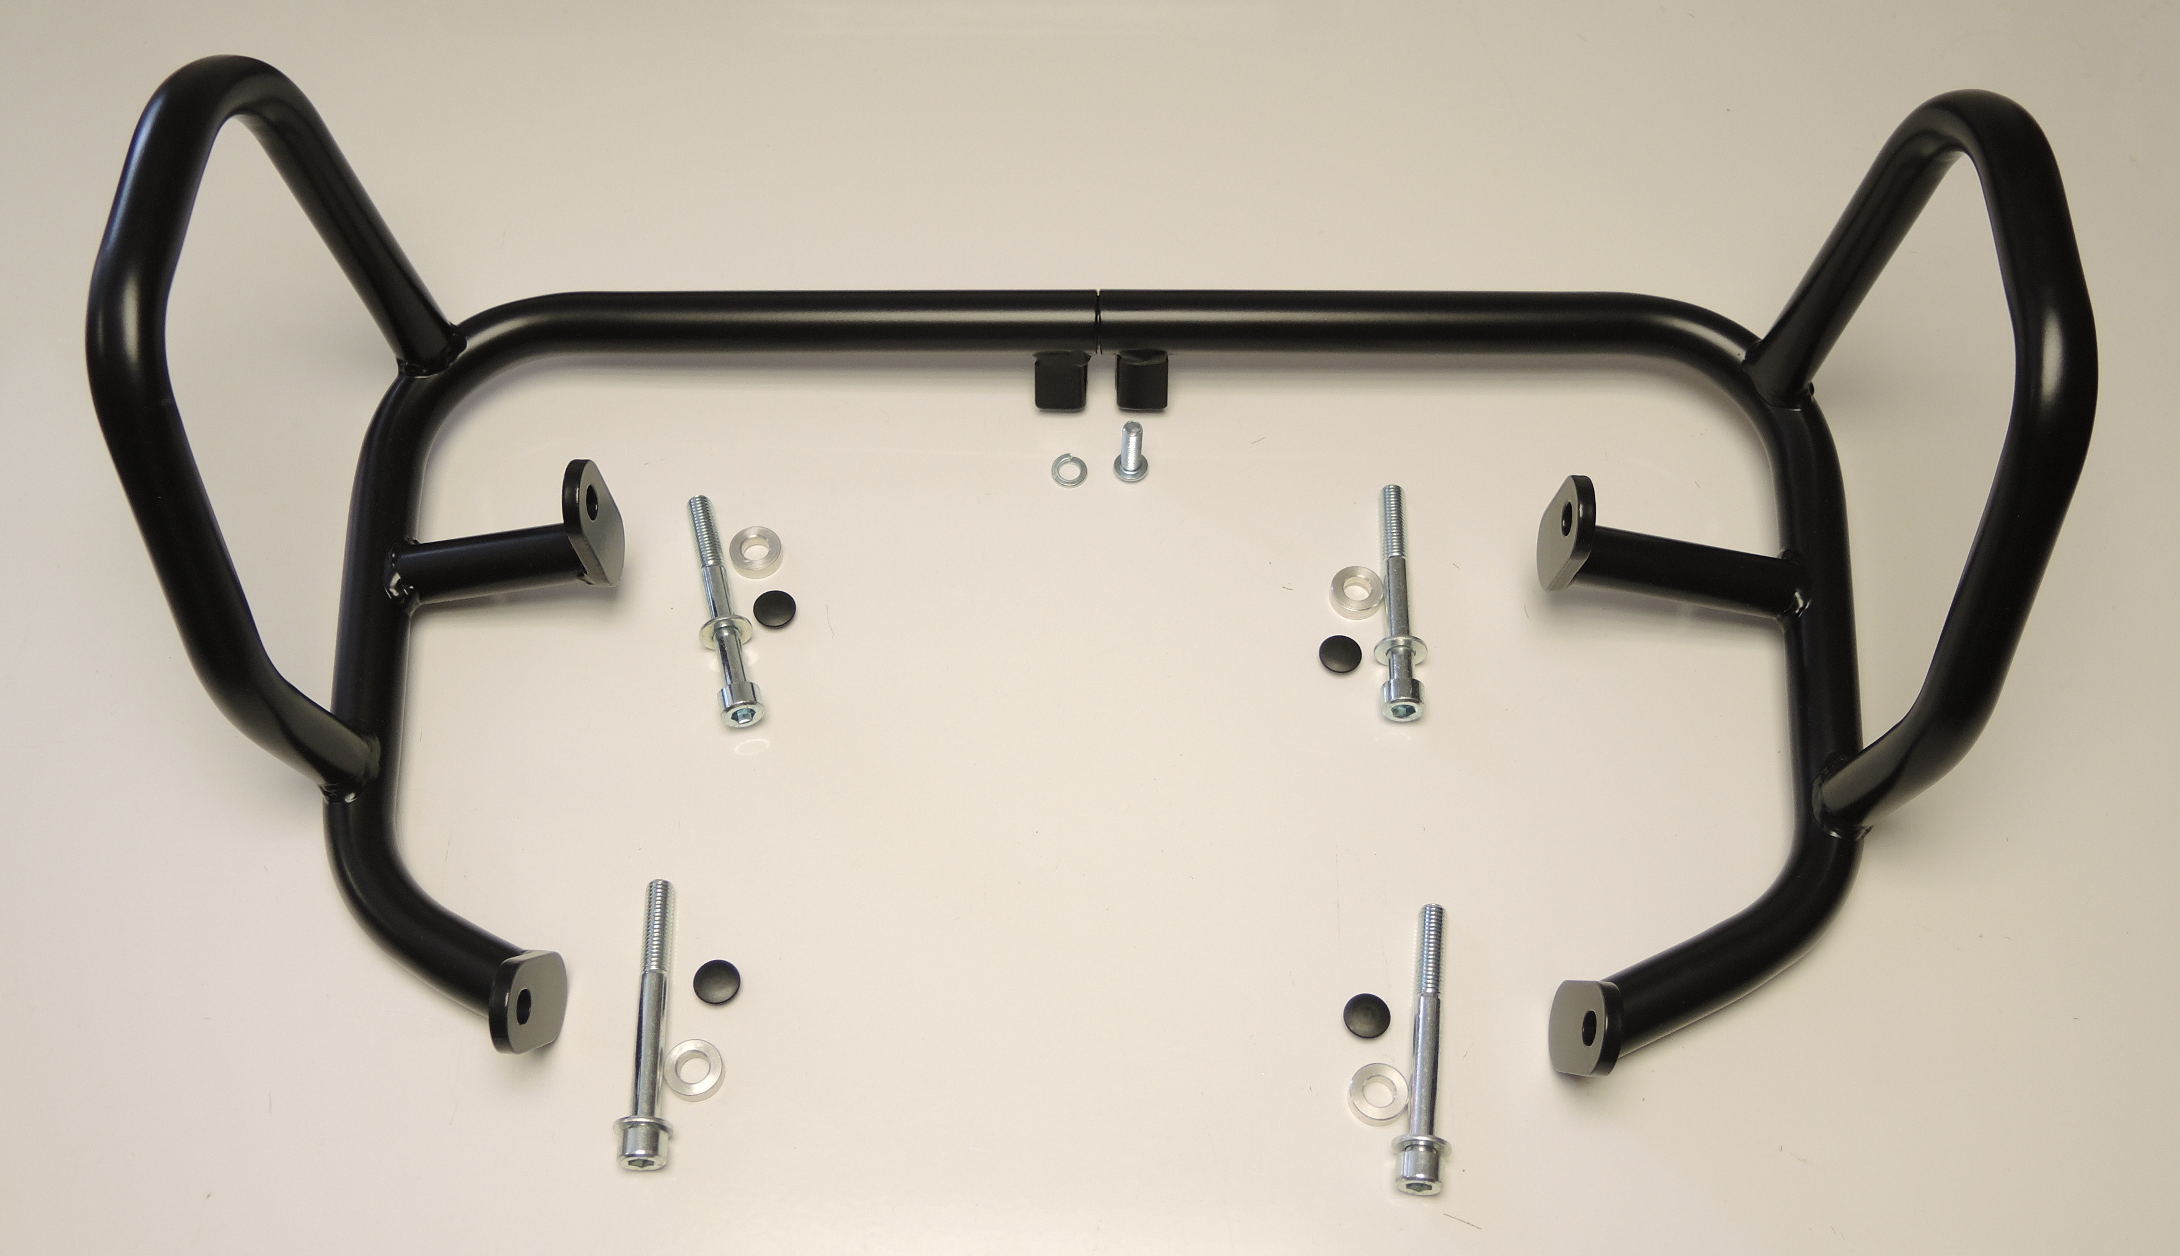

ID7+8

ID2
ID5.1
ID5.2

Instalation (do not tighten screws completely during installation)

- Remove original screws from motorcycle (according to the picture below).
- Put frames (ID1) on motorcycle and connect them with screws M10 (ID2) and washer (ID3).
- Insert dural rollers (ID5.1 – left + ID5.2 - right) between frames and motorcycle.
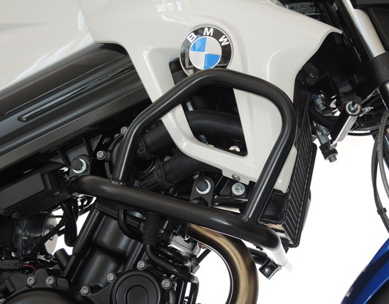

- Connect frames using screw M8 (ID8) and washer (ID7)
- In the end tighten all screws, cover them with plastic covers (ID4) and place stickers (ID6).
