CF49
Yamaha XTZ 1200 Tenere

Left side fitting kit: |  |  |  |  | Right side fitting kit:
ID. | Descrip. | Cat.N | Qt |  |  | ID. | Descrip. | Cat.N | Qt
1 | Crash bar | - | 1 |  |  | 1 | Crash bar | - | 1
2 | Bolt M8x20 | 823 | 1 |  |  | 2 | Bolt M8x20 | 823 | 2
3 | Washer M8 | 802 | 2 |  |  | 3 | Washer M8 | 802 | 2
4 | Washer spring M8 | 800 | 2 |  |  | 4 | Washer spring M8 | 800 | 2
5 | Bolt M8x40 | 828 | 1 |  |  | 5 | RDmoto logo sticker | - | 1
6 | Alu spacer d=19mm | 477 | 1 |  |  | 6 | Plastic cover | X5 | 1
7 | RDmoto sticker | - | 1 |  |  | 7 | Alu spacer d=22mm | 1336 | 1
8 | Plastic cover | X5 | 1 |  |  |  | - on some models

Assembly instruction:

Make the assembly according to the attached photos

Warning- use the Loctite glue of threads, during a mounting. Medium strong.
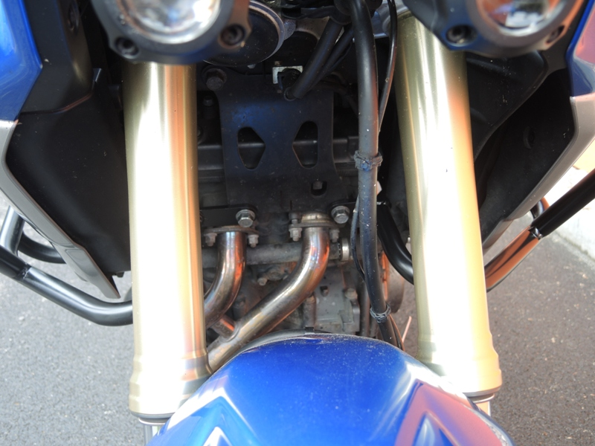

For front gripping use original bolts.

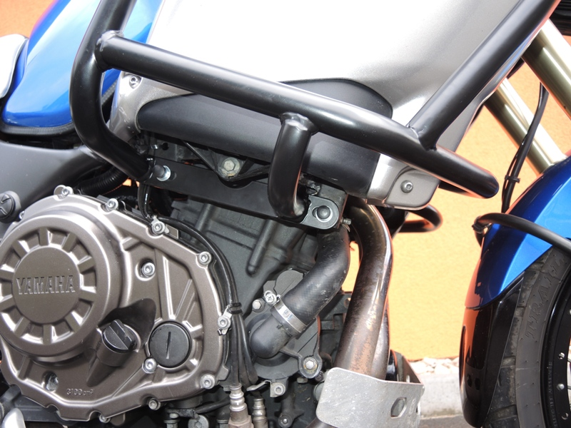
Insert washer ID.3 and ID.4 on the bolts ID.2 M8x20. Tighten these bolts.
Place plastic covers.

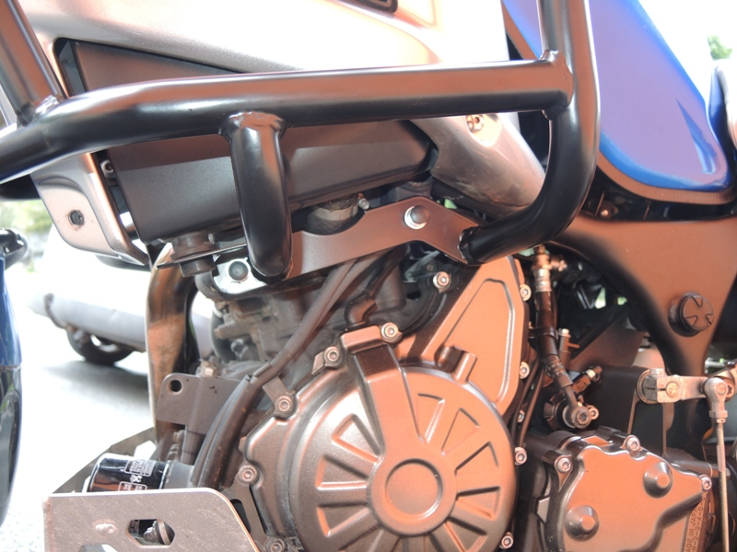
Insert washer ID.3 and ID.4 on the bolts ID.2 M8x20.
Insert washer ID.3 and ID.4 on the bolts ID.5 M8x40.
Between the frames and crahs bar insert spacer ID.6.
Place plastic covers.

