CF50
Kawasaki Versys 650´15-

Kit for lef side: |  |  |  |  | Kit for right side:
ID. | Description | Kat. | Qt |  |  | ID. | Description | Kat. | Qt
1 | Cash bar | CF50 | 1 |  |  | 1 | Cash bar | CF50 | 1
2 | Bolt M6x50 | 867 | 1 |  |  | 2 | Bolt M6x50 | 867 | 1
3 | Washer M6 | 987 | 1 |  |  | 3 | Washer M6 | 987 | 1
4 | Spacer d=12mm | 120 | 1 |  |  | 4 | Spacer d=12mm | 120 | 1
5 | Bolt M10x120 | 881 | 1 |  |  | 5 | Bolt M10x160 | 979 | 1
6 | Washer M10 | 804 | 2 |  |  | 6 | Washer M10 | 804 | 2
7 | Nut M10 | 814 | 2 |  |  | 7 | Nut M10 | 814 | 2
8 | Steel rod 10x300x30x30 |  | 1 |  |  | 8 | Bolt M8x25 | 833 | 1
9 | Spacer d=82mm | 1175 | 1 |  |  | - | - | - | -

Assembly instruction:

We recommend to use glue of threads, medium strong. During the assembly.

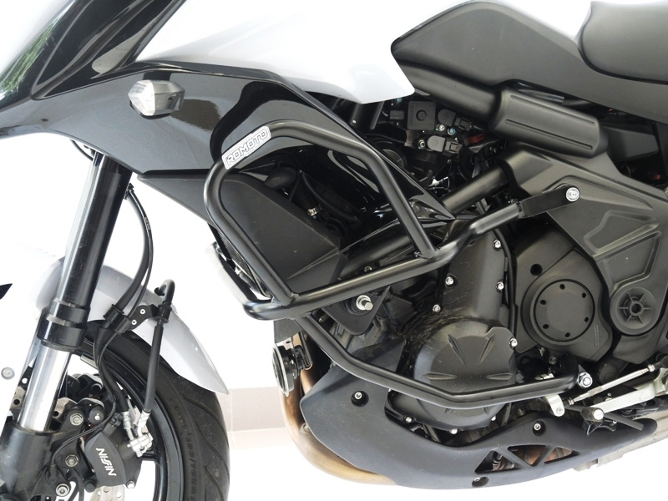

Bolt M6x50 + washer M6.
Place spacer d=12mm. Under the cash bar.

Bolt M10x120 + washer M10. For tighten use nut M10. Replace original nut. Original silentblock leave on the frame.

Take out orig. bolt M10x200. Insert rod M10x300 throught the engine. Insert spacer d=82mm. For tighten use nut M10 + washer M10.

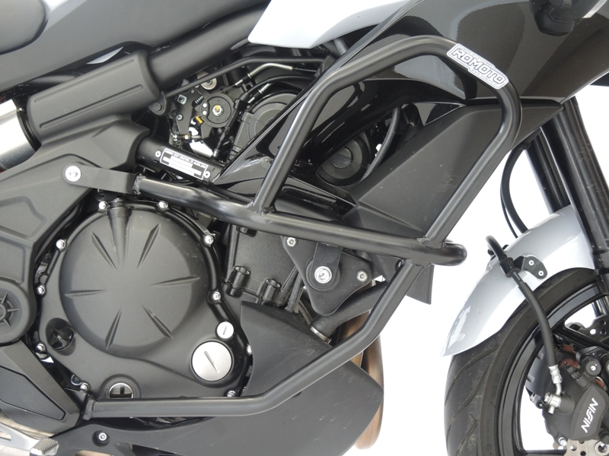

Bolt M6x50 + washer M6.
Place spacer d=12mm. Under the cash bar.

For connecting use bolt M8x25.

Bolt M10x160 + washer M10. For tighten use nut M10. Replace original nut. Original silentblock leave on the frame.

Take off plastic cover and footpeg holder. Mounting nut and washer M10 for tighten .
Place cash bar under the footpeg holder. Use original bolt for tighten. Mounting footpeg and cover back the bike.

