CF51
Kawasaki VN 650 Vulcan ´15-

Kit fir left side: |  |  |  |  | Kit for right side:
ID. | Description | Cat. | Qt |  |  | ID. | Description | Cat. | Qt
1 | Crash bar | - | 1 |  |  | 1 | Crash bar | - | 1
2 | Bolt M8x30 | 834 | 1 |  |  | 2 | Bolt M8x30 | 834 | 1
3 | Bolt M6x30 | 864 | 1 |  |  | 3 | Bolt M6x30 | 864 | 1
4 | Alu. spacer d=10mm | 1164 | 1 |  |  | 4 | Alu. spacer d=10mm | 1164 | 1
5 | Washer M6 | 987 | 1 |  |  | 5 | Washer M6 | 987 | 1
6 | Washer M8 | 802 | 3 |  |  | 6 | Washer M8 | 802 | 3
7 | Washer spring M8 | 800 | 1 |  |  | 7 | Washer spring M8 | 800 | 1
8 | Bolt M8x25 | 831 | 1 |  |  | 8 | Bolt M8x25 | 831 | 1
9 | Silentblock | X34 | 1 |  |  | 9 | Silentblock | X34 | 1
10 | Nut full head | 951 | 1 |  |  | 10 | Nut full head | 951 | 1
11 | Connection bar | X69 | 1 |  |  | - | ------ | - | -
12 | RDMOTO Sticker |  | 1 |  |  | 12 | RDMOTO Sticker |  | 1
Instruction to assembly:

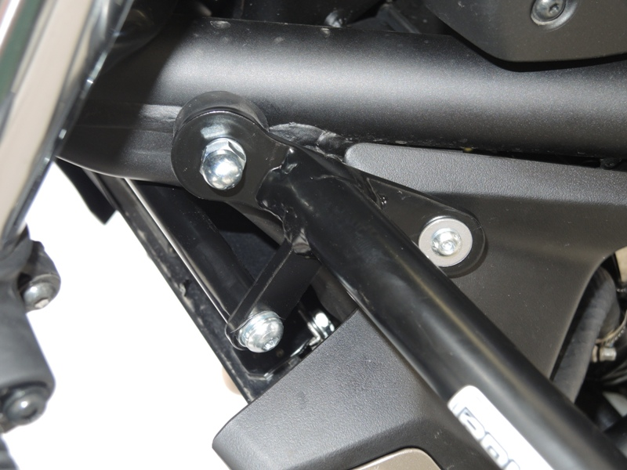
Attention – we recommend to use safety glue for bolts. Medium strong.

Place silentblock between the cash bar and frame. Tighten it by washer ID.6 and nut ID.10

Washer M6 with bolt M6x30. Under the cash bar place alu. spacer ID.4.

Bolt ID.8 with washer ID.6 and washer ID.7 for connecting bar.

Assembyl for right side is same !!

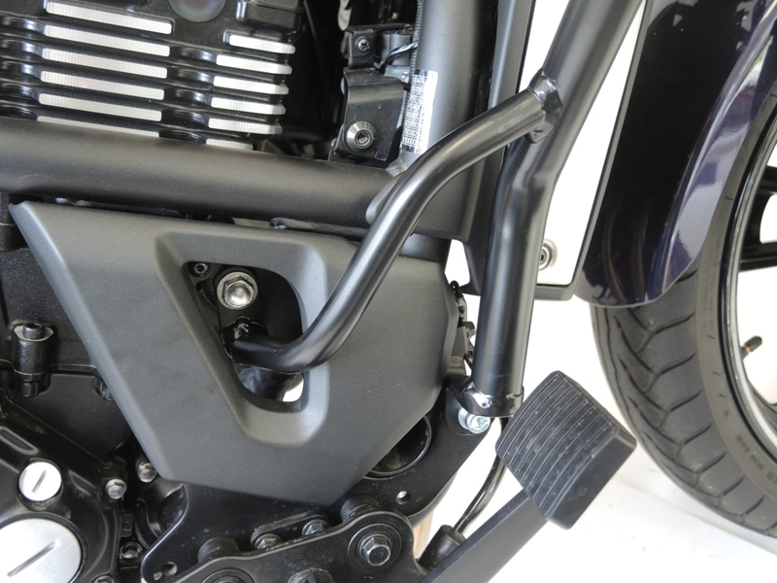

Use original bolt for mounting.

Place bolt ID.2 with washer ID.6
and tighten it.

Assembyl for left side side is same !!

