CF52
Suzuki DL 1000 V-Strom 2014-

Fitting kit left side: Fitting kit right side:
ID | Description | Cat.N | Qt
1 | Crash frames | CF52 | 1
2 | Alu. spacer d=24 front | 1184 | 1
3 | Alu. spacer d=17,5 rear | 1183 | 1
4 | Bolt M10x100x1,25 | 892 | 1
5 | Washer M10 | 804 | 1
6 | Plastic cover | X4 | 1
7 | Nut M12 | 811 | 1

Anathore materials for assembly:
ID | Description | Cat.N | Qt
1 | Crash frames | CF52 | 1
2 | Alu. spacer d=19,5 front | 1121 | 1
3 | Alu. spacer d=30 rear | 170 | 1
4 | Bolt M10x75x1,25 | 938 | 1
5 | Washer M10 | 804 | 1
6 | Plastic cover | X4 | 1
7 | Nut M12 | 811 | 1
ID | Description | Cat.N | Qt
9 | Connecting bar 12x370x30x30mm |  | 1
10 | Bolt M8x20 | 823 | 1
11 | Bolt M6x30 | 863 | 1
12 | Nut M6 | 948 | 1
13 | Washer M6 | 947 | 2

Assembly procedure have be done according to the attached photos below.
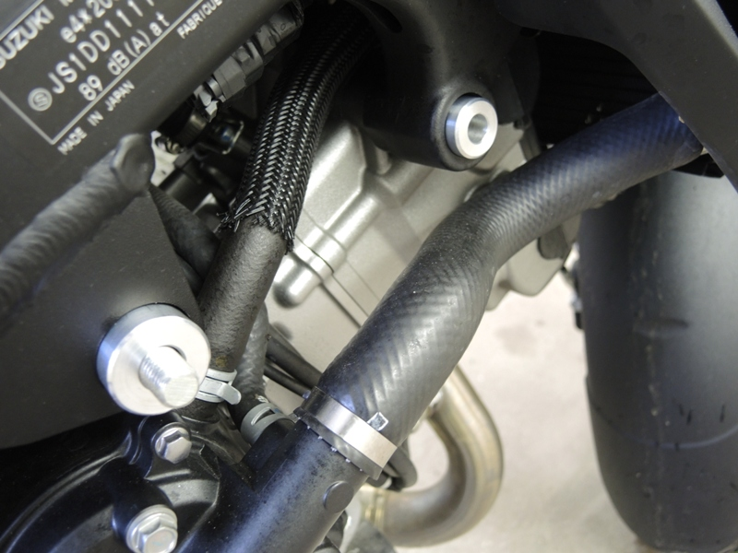
Note: During installation, we recommend using glue on the threads (blue color).

Dismantle original bolts from frame, place steel bar M12 ID.9 throught the frame. Place spacers as shown on the picture.
2

3

9

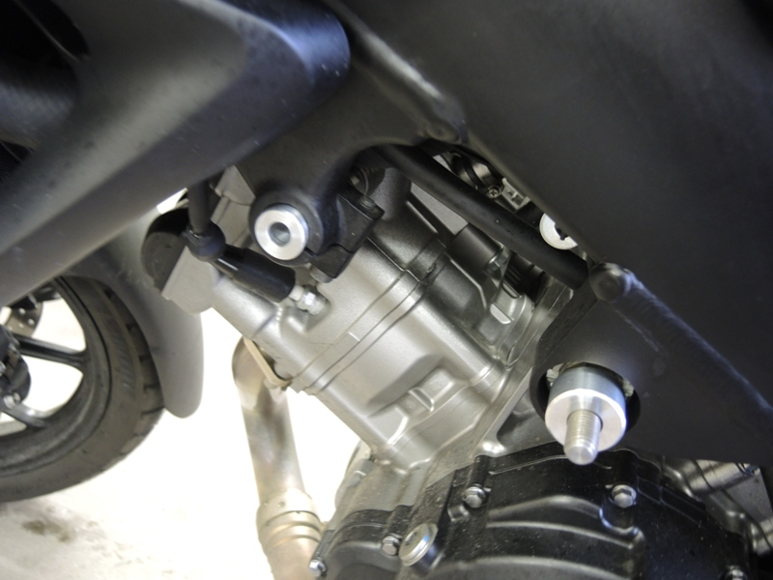

2

3

1
9

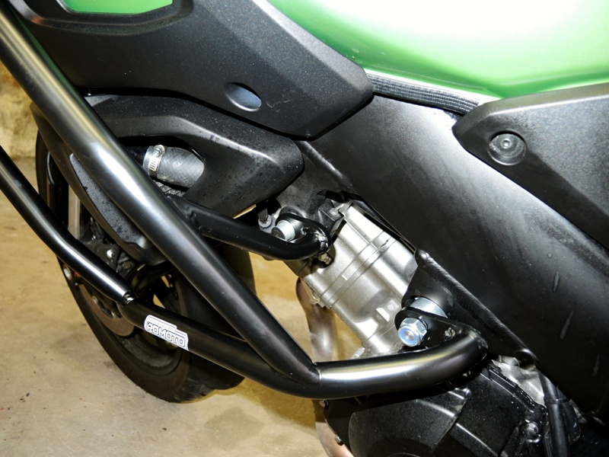
3
Crash frame assembly by bolt M10x100x1,25 with washer.

For rear gripping use nut M12.
4,5,6

3
3
3
3
3
3

7

Crash frame assembly by bolt M10x75x1,25 with washer.

For rear gripping use nut M12.
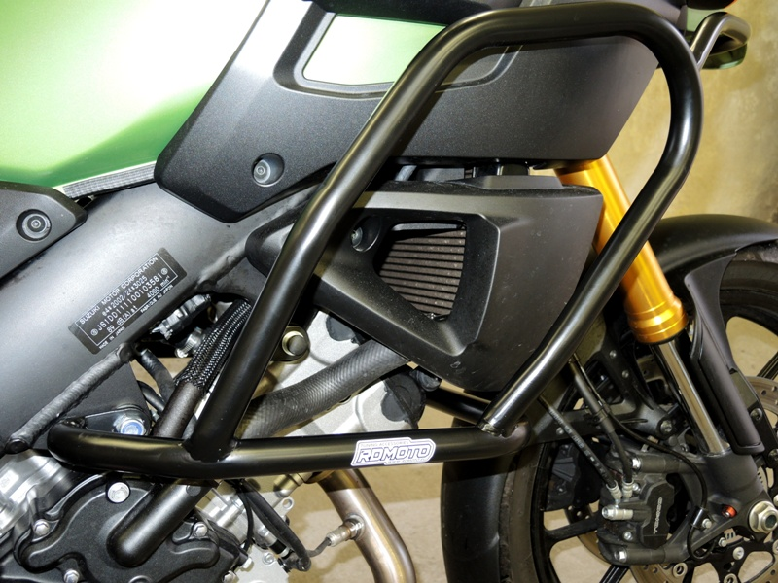
4,5,6

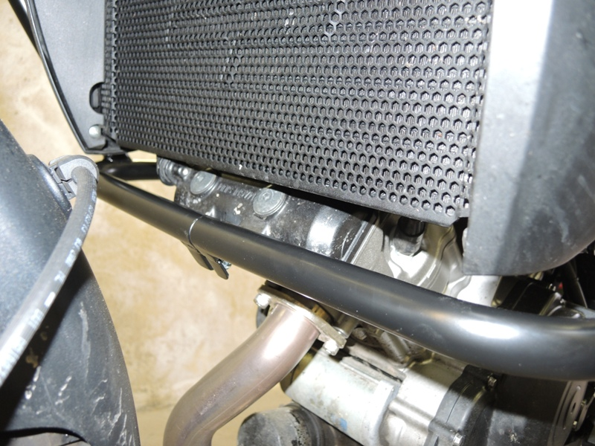
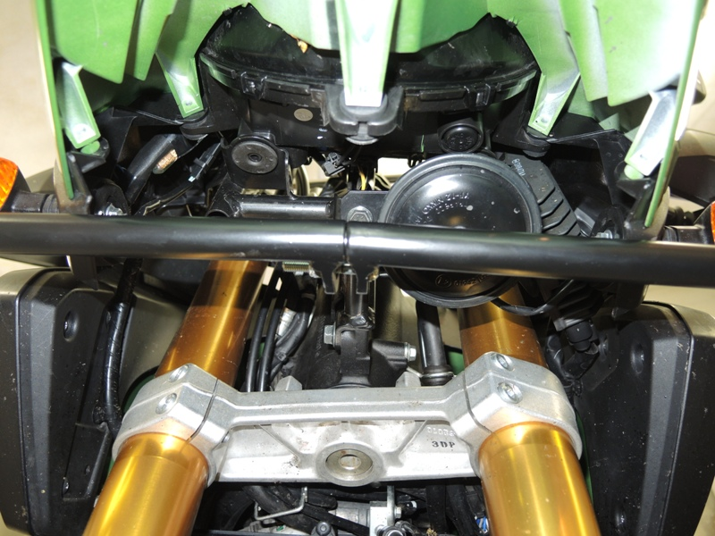
7

Connect the lower and upper frames them together. For lower part place bolt M8. For upper part use bolt M6 + 2x washer + nut M6.
10
11,12,13

