CF54
(upper crash frames)
Honda CRF 1000 Africa Twin ´16-

Fitting kit:
ID | Description | Cat.N | Qt
1 | Bolt M10x120 | 881 | 1
2 | Nut M10 safety | 810 | 1
3 | Washer M10 flat | 804 | 2
4 | Spacer d=12,hole diam. 8,5 | 130 | 1
5 | Bolt M8x120 | 845 | 1
6 | Washer M8 flat | 802 | 2
7 | Nut M8 | 809 | 1

ID | Description | Cat.N | Qt
9 | Steel bracket for upper hold. | X71 | 1
10 | Al. spacer d=12mm | 120 | 2
11 | Washer M6 | 947 | 8
12 | Nut M6 safety | 948 | 4
13 | Bolt M6x20 low head | 1022 | 2
14 | Bolt M6x30 | 863 | 2

Note: We recommend to use medium strong glue for all bolts and threads.

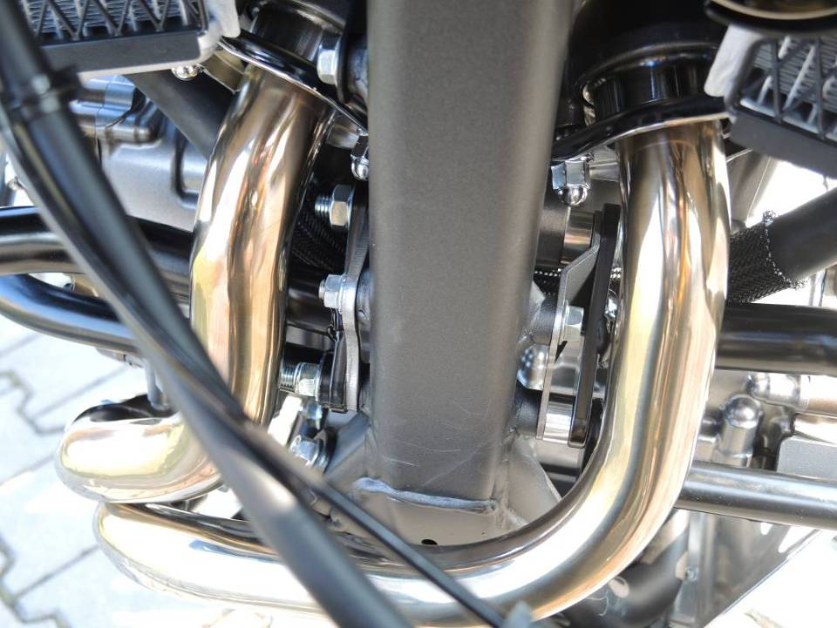
Dismantle bolt M10 from chassi. Place connection bar into the chassi. ID.1, original spacer leave on the place. Insert upper crash bars from booth sides. Place washer ID.3 and nuts ID.2.

Between crash frames and chassi place spacer l=12mm. Place bolt M8x120 ID.5 with washer ID.6 trought the upper crash bars and chassi. From other side place upper crash bar, place washer ID.6 and nut ID.7.

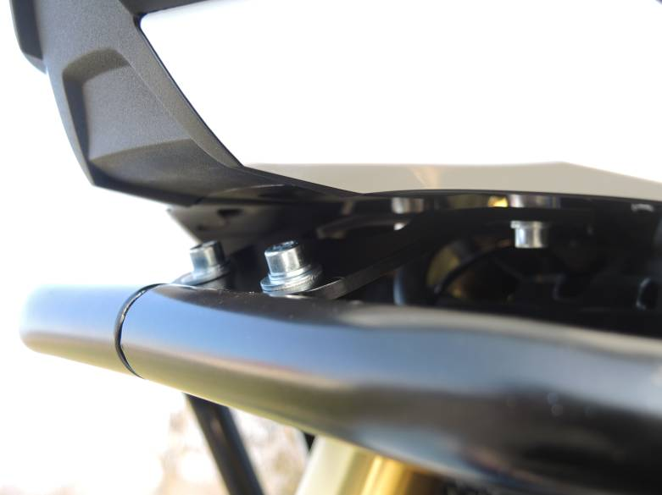
Upper gripping.
Between steel bracket ID.9 and fairing holder place spacers 2x ID.10, use bolts M6x30 ID.14, 4x washers M6 ID.11 and 2x nuts M6 ID.12.
Crash bar and steel holder connect tgoether by bolts M6x20 ID.13, 4x washers M6 ID.11 and nuts ID.12.

3

10
10

9
13,11,12

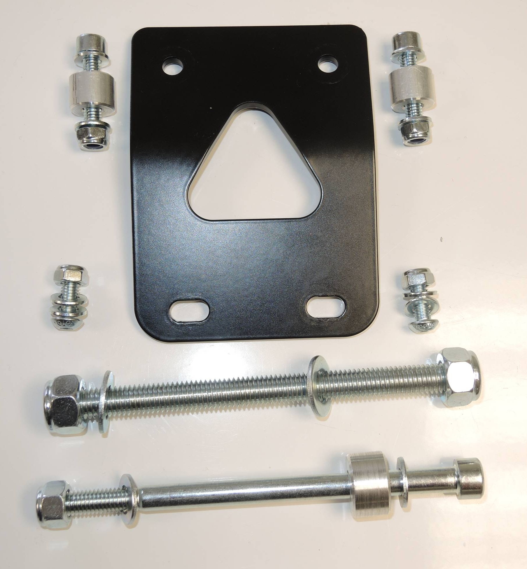

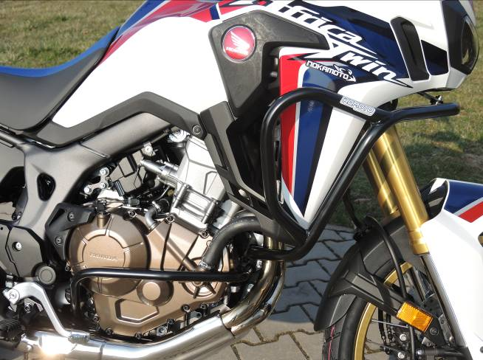

Origin.bolt

