CF55
Lower
Honda CRF 1000 Africa Twin ´16-

Fitting kit:
ID | Description | Cat.N | Qt
1 | Spacer d=5, hole dia. 8,5 | 433 | 1
2 | Spacer d=17, hole dia. 8,5 | 1190 | 1
3 | Bolt M8x130 | 884 | 1
4 | Washer M8 flat | 802 | 2
5 | Nut M8 safety | 809 | 1
6 | Silenblok | X34 | 1
7 | Nut M8 | 813 | 1

Note: Use medium strong glue during assembly on the all threads.

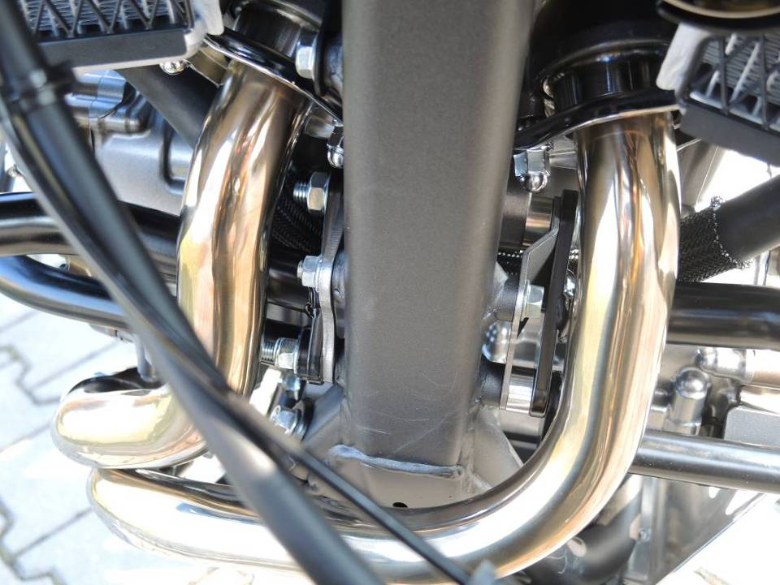
Dismantle original bolt M8 from chassi. Insert washer ID.4 ont he bolt from left side, put crash bar and spacer l=17mm from left side of the bike. Put frame on the chassi.Inser spacer l=5mm, crash bar, washer and tighten it from the right hand side.

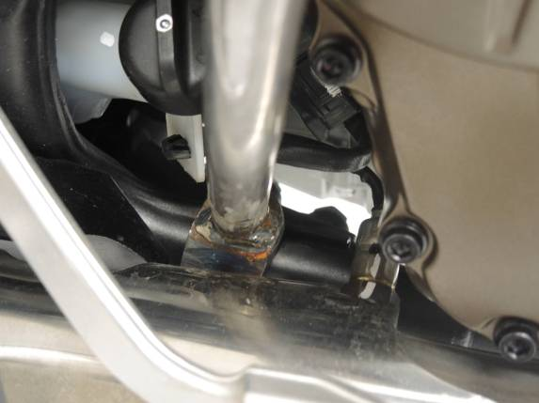
Use original bolts for rear gripping crash bars.

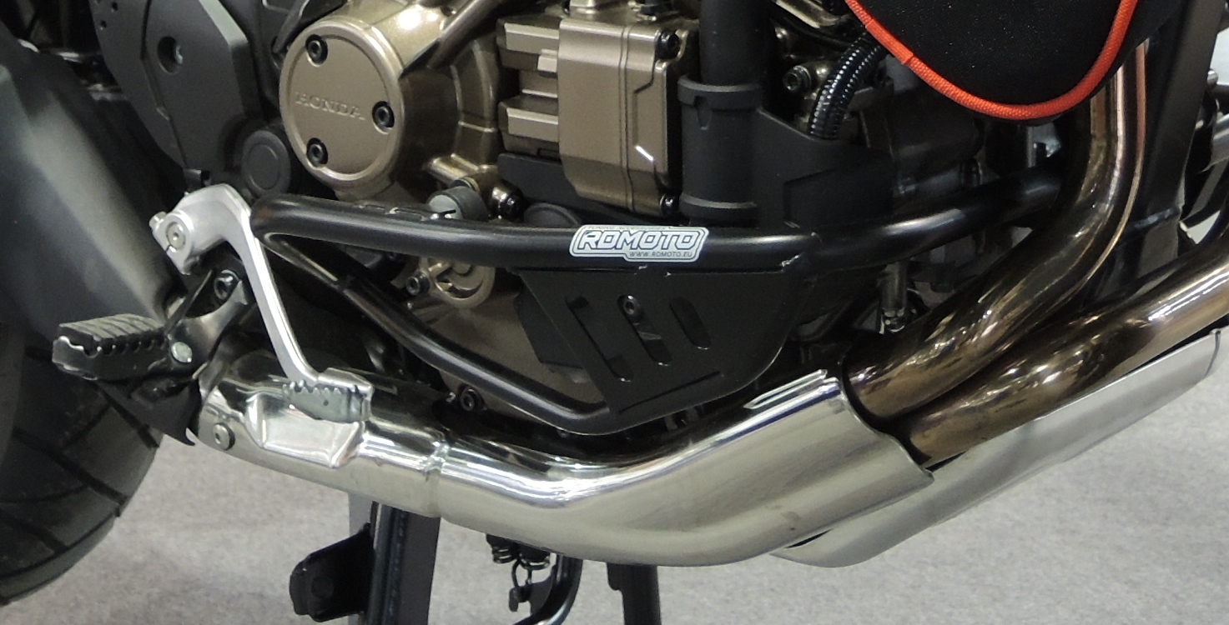
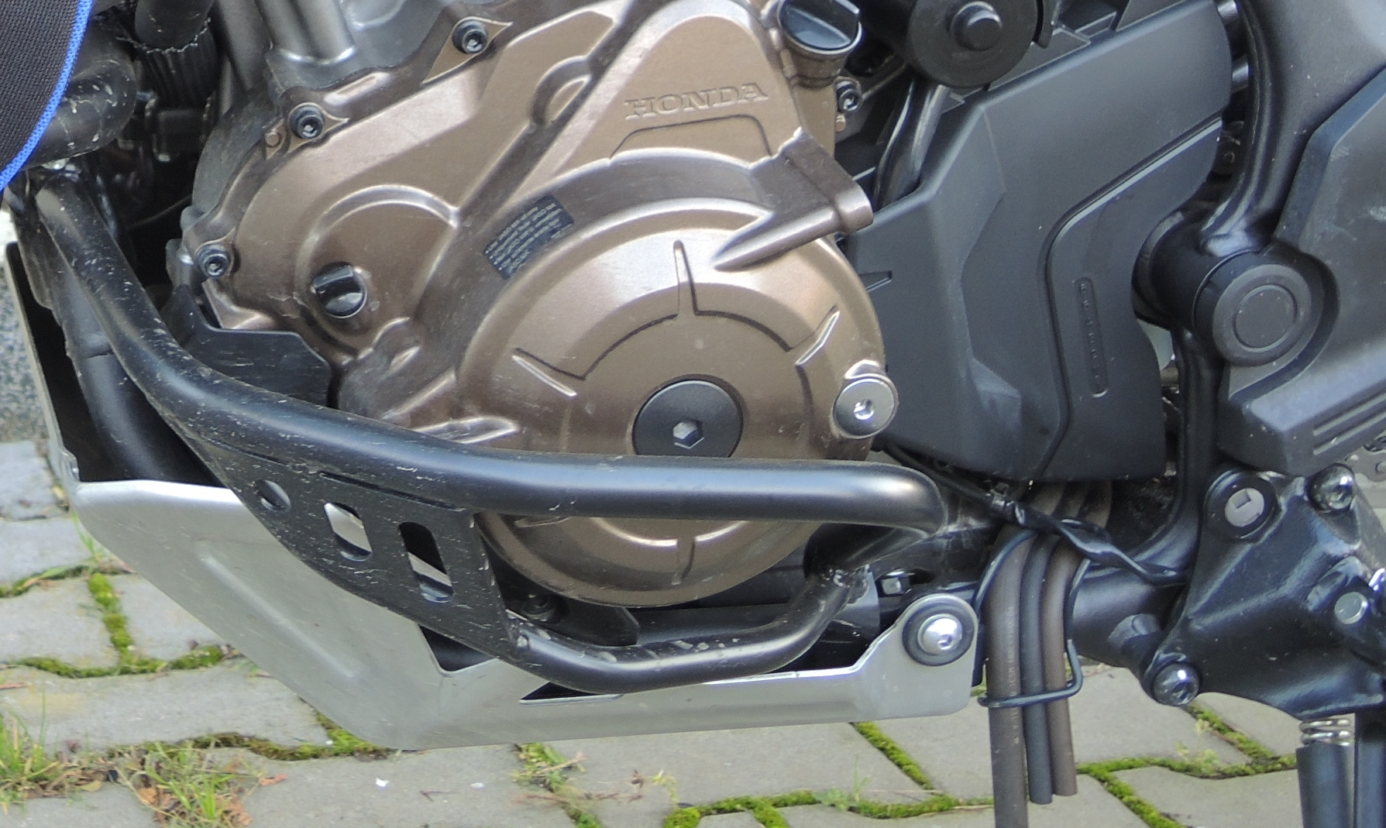
6,7

