CF57
Honda CRF 1000 Africa Twin ´16-

Fitting kit:
ID | Description | Cat.N | Qt
1 | Steel connection bar M10x130x30x30 |  | 1
2 | Nut M10 safety | 810 | 2
3 | Washer M10 flat | 804 | 2
4 | Spacer d=12,hole diam. 8,5 | 130 | 1
5 | Bolt M8x130 | 884 | 1
6 | Washer M8 flat | 802 | 2
7 | Nut M8 | 809 | 1

ID | Description | Cat.N | Qt
9 | Steel bracket for upper hold. | X71 | 1
10 | Al. spacer d=12mm | 120 | 2
11 | Washer M6 | 947 | 8
12 | Nut M6 safety | 948 | 4
13 | Bolt M6x20 low head | 1022 | 2
14 | Bolt M6x30 | 863 | 2
15 | Silenblok | X34 | 1
16 | Nut M8 | 813 | 1

Note: We recommend to use medium strong glue for all bolts and threads.

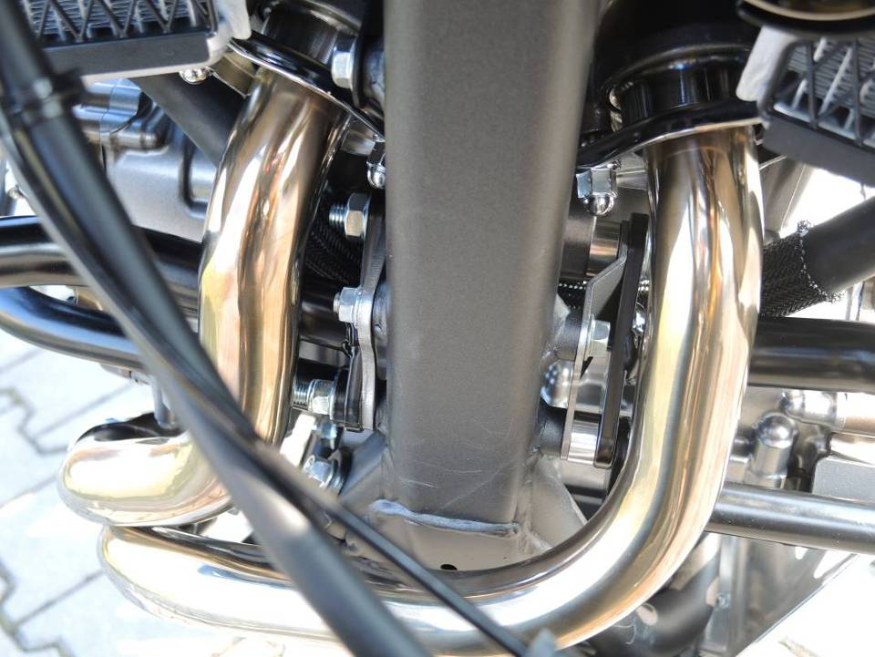
Dismantle bolt M10 from chassi. Place connection bar into the chassi. ID.1, original spacer leave on the place. Insert upper crash bars from booth sides. Place washer ID.3 and nuts ID.2.

Between crash frames and chassi place spacer l=12mm. Place bolt M8x130 ID.5 with washer ID.6 trought the lower and upper crash bars and chassi. From other side place upper and lower crash bars, place washer ID.6 and nut ID.7.

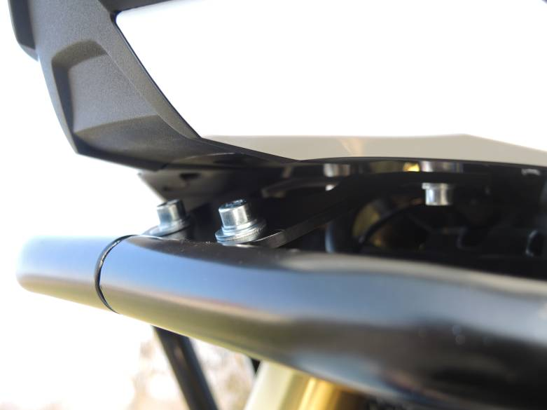
Upper gripping.
Between steel bracket ID.9 and fairing holder place spacers 2x ID.10, use bolts M6x30 ID.14, 4x washers M6 ID.11 and 2x nuts M6 ID.12.
Crash bar and steel holder connect tgoether by bolts M6x20 ID.13, 4x washers M6 ID.11 and nuts ID.12.

3

10
10

9
13,11,12

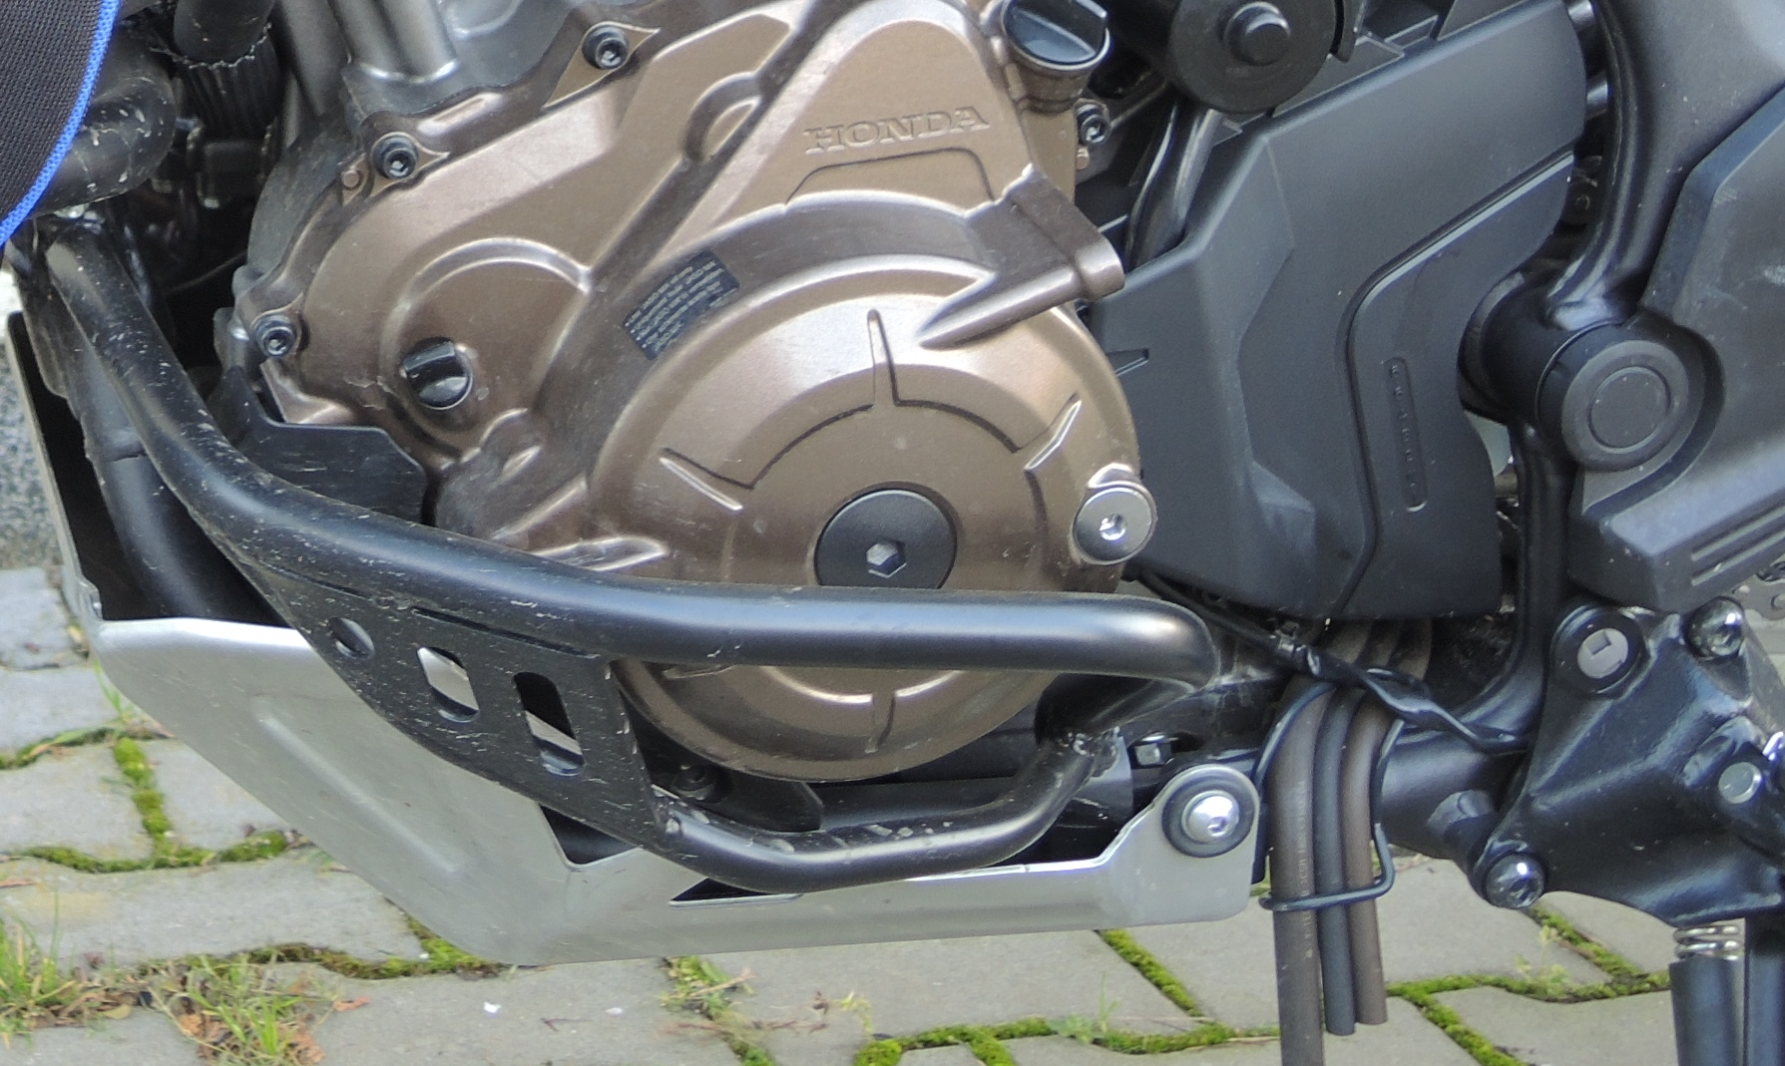
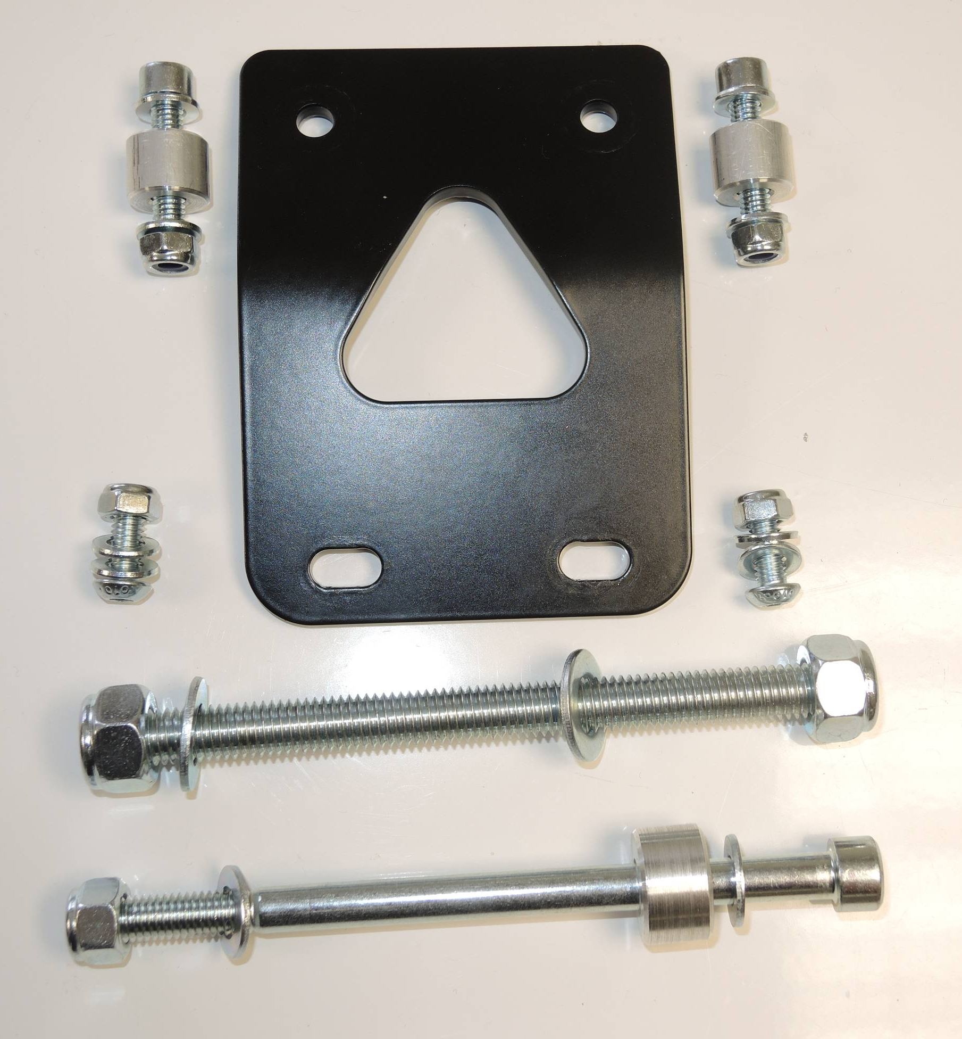
5

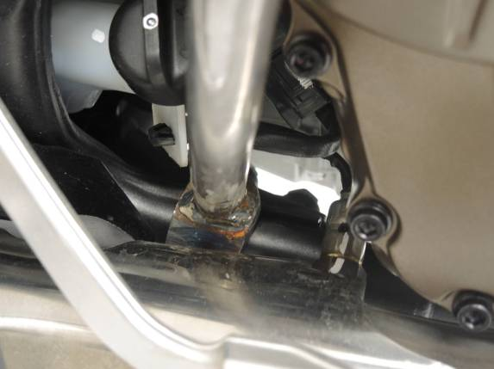
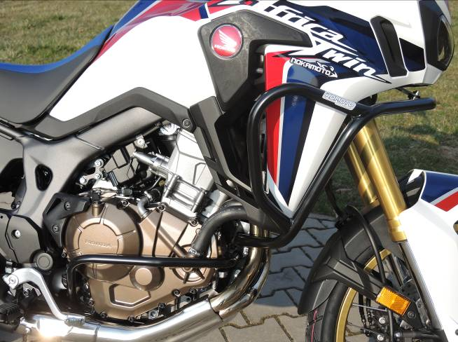

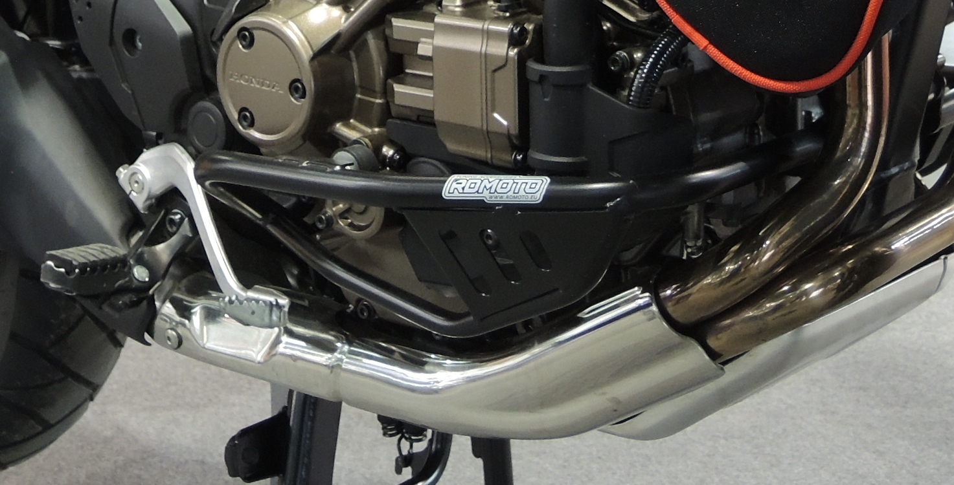
15,16
Origin.bolt
Original bolt. Rear place.

