CF59
Triumph Tiger 1050

Left side: Right side:
ID | Description | Cat.N | Qt
1 | Alu. spacer d=4mm | 119 | 1
2 | Bolt M12x60x1,25 | 916 | 1
3 | Washer M12 | 803 | 3
4 | Nut M12 | 811 | 1
5 | Spacer d=16mm | 127 | 1
6 | Bolt M12x120 | 968 | 1

ID | Description | Cat.N | Qt
1 | Alu. spacer d=9mm | 1197 | 1
2 | Bolt M12x90 | 808 | 1
3 | Washer M12 | 803 | 4
4 | Nut M12 | 811 | 2
5 | Spacer d=26mm | 1198 | 1
6 | Bolt M12x120 | 968 | 1
7 | Bolt M8x25 | 833 | 1
8 | Washer M8 | 802 | 1

Make assembly attached pictures.
Warning: During assembly use medium strong glue for all bolts.

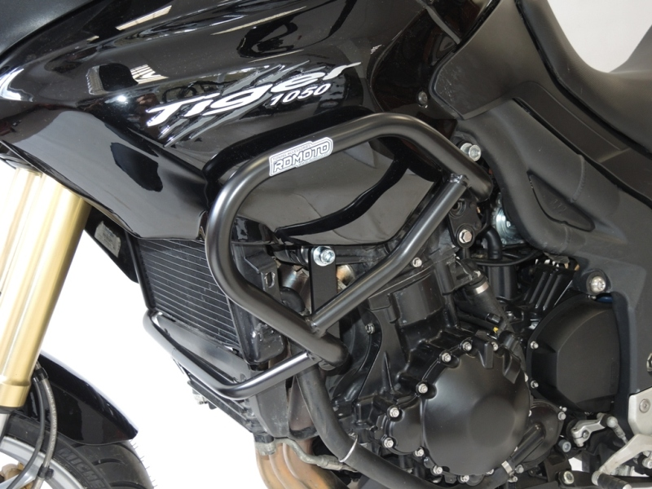
Bolt M12x60x1,25 + washer M12.
Spacer d=4mm.

Spacer d=16mm.
Bolt M12x120 + washer M12 (2x) + nut M12.

Connect crash bars and use bolt M8 + washer M8.

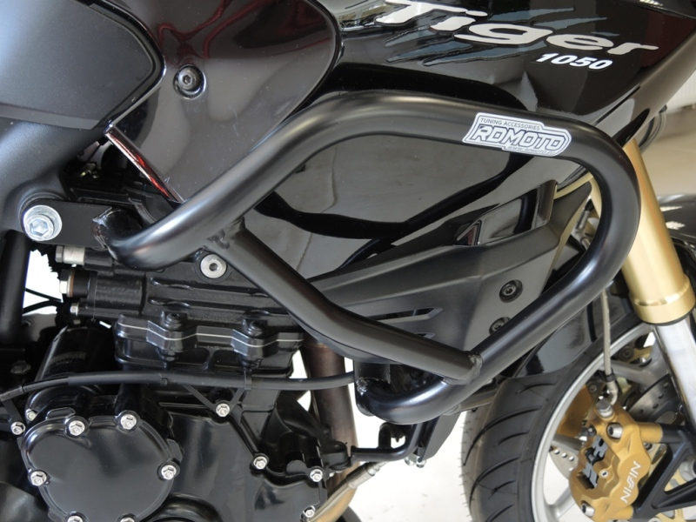
Spacer d=9mm.
Bolt M12x90 + washer M12 (2x) + nut M12.

Spacer d=26mm.
Bolt M12x120 + washer M12 (2x) + nut M12.

9
10

