CF61
Honda CBF500
Kit for the left side |  |  |  |  |  |  |  | Kit for the right side
ID | Description |  | Cat.no. | Pcs |  |  |  | ID | Description |  | Cat.no. | pcs
1 | Cylinder |  | DV435 | 1 |  |  |  | - | - |  | - | -
2 | Nut M10 |  | 810 | 3 |  |  |  | 2 | Nut M10 |  | 810 | 3
3 | Washer M10 flat |  | 804 | 3 |  |  |  | 3 | Washer M10 flat |  | 804 | 3
4 | Steel rod 10x225x30x30 |  |  | 1 |  |  |  | - | - |  | - | -
5 | Steel rod 10x240x30x30 |  |  | 1 |  |  |  | - | - |  | - | -
6 | Steel rod 10x335x30x30 |  |  | 1 |  |  |  | - | - |  | - | -
7 | Nut cover |  | X35 | 1 |  |  |  | 7 | Nut cover |  | X35 | 1

Instructions :
- Remove original bolts from motorcycle according to the pictures.
- Insert all steel rods trough motorcycle.
  - ID4 – rear upper.
  - ID5 – rear lower (cylinder ID1 on the left).
  - ID6 – front.
- Put crash frames on rods and tighten whole kit using M10 nut ID2. Don’t forget to place washers ID3 under nuts.
- Cover front nuts using nut cover ID7.
Direction
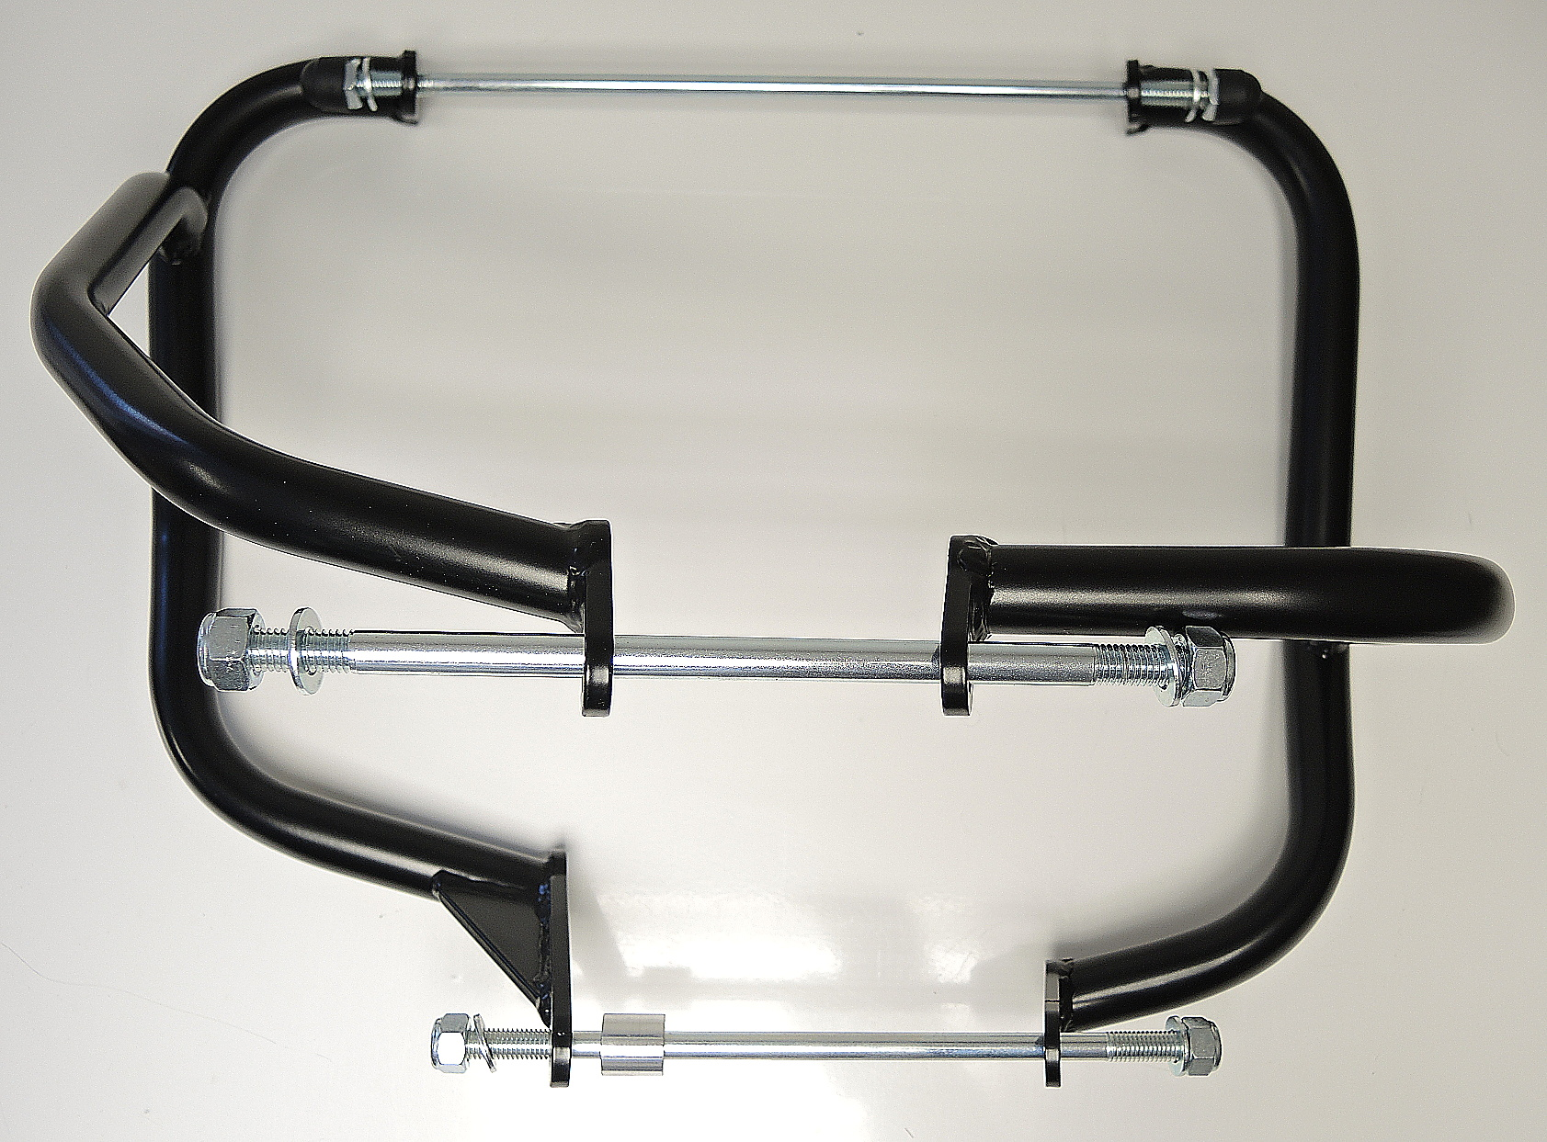
ID6

ID4

ID5

