CF62
Honda CBF600 (2008-2012)

Left side mounting kit |  |  |  |  | Right side mounting kit
ID. | Description | Cat.no. | Pcs |  |  | ID | Description | Cat.no. | Pcs
1 | Crash frame |  | 1 |  |  | 1 | Crash frame |  | 1
2 | Nut M10 – safety | 810 | 1 |  |  | 2 | Nut M10 – safety | 810 | 1
3 | Washer M10 – flat | 804 | 1 |  |  | 3 | Washer M10 – flat | 804 | 1
4 | Bolt M10x70mm | 851 | 1 |  |  | 4 | Bolt M10x70mm | 851 | 1
5 | Dural. cylinder - 14mm | 114 | 1 |  |  | 5 | Dural. cylinder - 14mm | 114 | 1

Instructions:

Mount crash frames according to the picture below.
Installation is same on both sides.
We recommend to use the glue (medium strong).

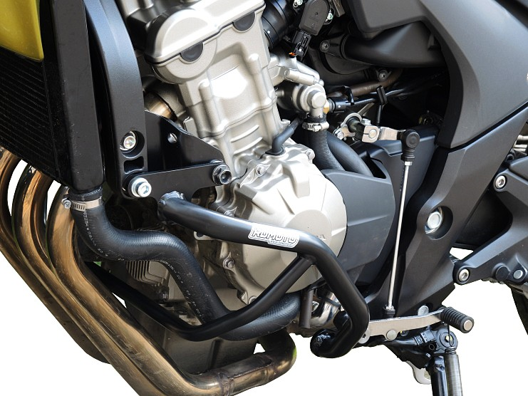
Original Bolts

Bolt ID4 + washer ID3 + dural cylinder into the frame (ID5).

Tighten from back side using nut ID2.

