CF63
Honda CBF600 (2008-2012)

Left Side Kit |  |  |  |  | Right Side Kit
ID. | Description | Cat.no. | Pcs |  |  | ID | Description | Cat.no. | Pcs
1 | Crash Frames | - | 1 |  |  | 1 | Crash Frames | - | 1
2 | Safety nut M10 | 810 | 1 |  |  | 2 | Safety nut M10 | 810 | 1
3 | Flat washer M10 | 804 | 1 |  |  | 3 | Flat washer M10 | 804 | 1
4 | Bolt M10x65mm | 943 | 1 |  |  | 4 | Bolt M10x65mm | 943 | 1
5 | Dura. Cylinder 14mm | 114 | 1 |  |  | 5 | Dura. Cylinder 14mm | 114 | 1
6 | Bolt M12x80x1,25 | 908 | 1 |  |  | 6 | Bolt M12x65x1,25 | 940 | 1
7 | Plastic cover M10 | X4 | 2 |  |  | 7 | Plastic cover M10 | X4 | 2
8 | Plastic cover M12 | X60 | 2 |  |  | 8 | Plastic cover M12 | X60 | 2
9 | Cylinder 5mm | 456 | 1

INSTRUCTIONS

We recommend to use safety glue on all threads (medium strong).

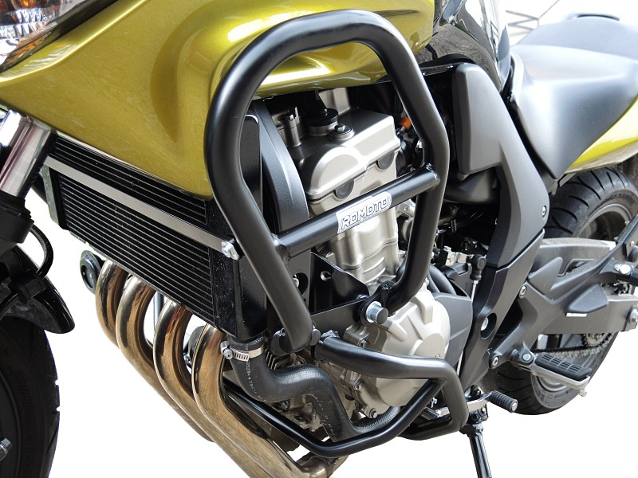

Bolt ID6 (Longer on the left side).

Dural cylinder 5mm (between upper and lower frames) – only on the left side.

+ plastic cover M12.

Bolt ID4
Washer ID3
Dural cylinder ID5
Fit from back side using nut ID2.

+ plastic cover M10.

