CF64
Honda CBF600 (2008-2012)

Left side kit |  |  |  |  | Right side kit
ID | Description | Cat.no. | Pcs |  |  | ID | Description | Cat.no. | Pcs
1 | Crash frames | - | 1 |  |  | 1 | Crash frames | - | 1
2 | Nut M10 – safety | 810 | 1 |  |  | 2 | Nut M10 – safety | 810 | 1
3 | Washer M10 – flat | 804 | 1 |  |  | 3 | Washer M10 – flat | 804 | 1
4 | Bolt M10x70mm | 851 | 1 |  |  | 4 | Bolt M10x70mm | 851 | 1
5 | Dural. cylinder - 14mm | 114 | 1 |  |  | 5 | Dual. cylinder - 14mm | 114 | 1
6 | Bolt M12x85x1,25 | 899 | 1 |  |  | 6 | Bolt M12x70x1,25 | 937 | 1
7 | Plastic cap on M10 bolt | X4 | 2 |  |  | 7 | Plastic cap on M10 bolt | X4 | 2
8 | Plastic cap on M12 bolt | X60 | 2 |  |  | 8 | Plastic cap on M12 bolt | X60 | 2
9 | Cylinder - 5mm | 456 | 1

Installation:
Mount crash frames according to the pictures below.
We recommend to use the glue on all threads (medium strong).
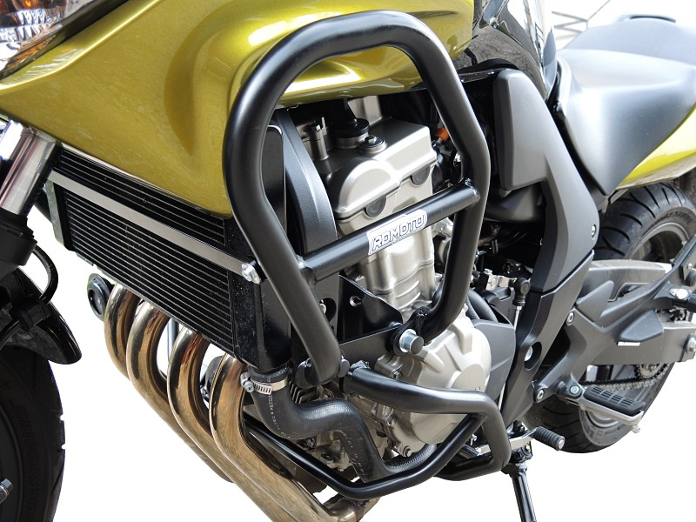

Bolt ID6 (Longer on the left side).

Dural. cylinder 5mm (between upper and lower frame) – only on the left side.

+ plastic cap M12.

Original bolts.

Bolt ID4 + washer ID3.
Dural cylinder into the frame ID5.
Tighten using nut ID2.

+ plastic cap M10.

