CF65
BMW F650 (96)

Mounting kit
ID | Description |  | Cat.no. | Pcs
1 | Steel rod 10x165x30x30 |  | - | 1
2 | Dural. cylinder – 17mm |  | 84 | 2
3 | Washer M10 |  | 804 | 2
4 | Nut M10 |  | 961 | 2

Instructions
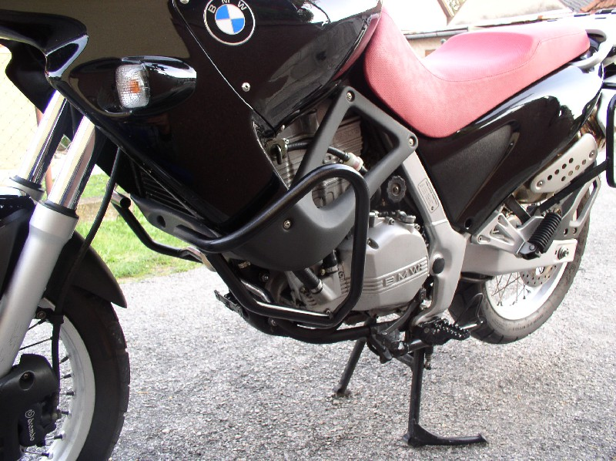
- Prepare both frames and fit them in lower part first.
- Put steel rod through the frame and tighten it using two cylinders, two washers and two nuts M10.
- Tighten upper part using original bolts.

