CF66
Moto Guzzi Breva 750

Mounting kit
ID | Popis |  | Kat. číslo | Ks
1 | Frame |  | CF66 | 1
2 | Rod |  | X91 | 1
3 | Botls M8x25 |  | 831 | 2
4 | Washer flat M8 |  | 802 | 6
5 | Bolts M10x40mm |  | 854 | 2
6 | Nut M8 (safety) |  | 809 | 2
7 | Washer flat M10 |  | 804 | 2

Instructions:

- Remove the original bolts and hood on the rights side of your motorcycle as shown on attached photo.
- Mount the ID.2 rod on the right side of the drop frame ID.1 using the screw ID.3 and the washer ID.4, mount the drop frame on the motorcycle frame using the screw ID.5 and the washer ID.7, use the screw ID at the top .3, washer ID.4 and nut ID.6
- Repeat the same procedure on left side, except that the frame is mounted on the already protruding rod through the motorcycle.
- Finally, tighten all assembly.

Attention: We recommend using medium strenght thread glue during installation (blue color).
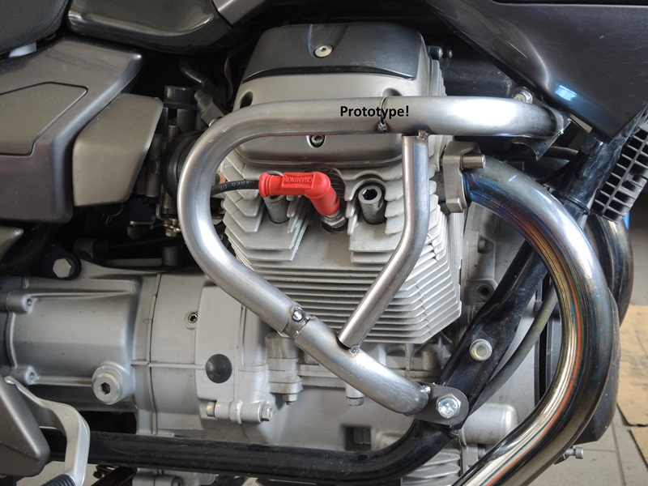
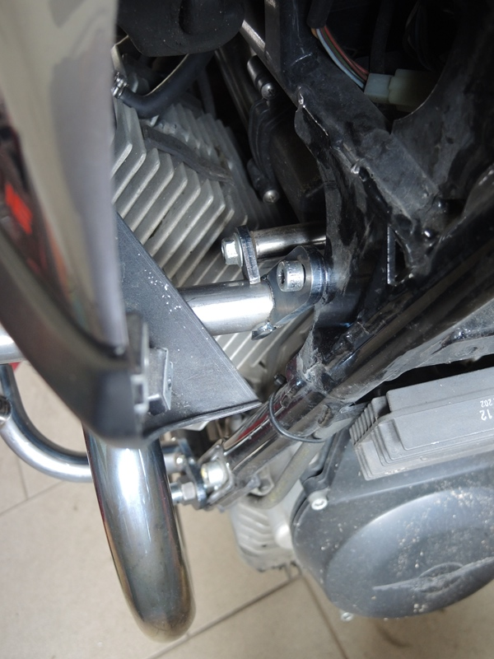
Original
Bolt ID.5 + washer ID.7
ID.2 Rod + ID.3 bolt + ID.4 washer

