CF67
Lower
Honda CRF 1000 Africa Twin DCT ´16-

Fitting kit:
ID | Description | Cat.N | Qt
1 | Spacer l=5, hole dia. 8,5 | 433 | 1
2 | Spacer l=17, hole dia. 8,5 | 1190 | 1
3 | Bolt M8x130 | 884 | 1
4 | Washer M8 flat | 802 | 2
5 | Nut M8 safety | 809 | 1
6 | Silentblock | X34 | 1

Note: Use medium strong glue during assembly on the all threads.

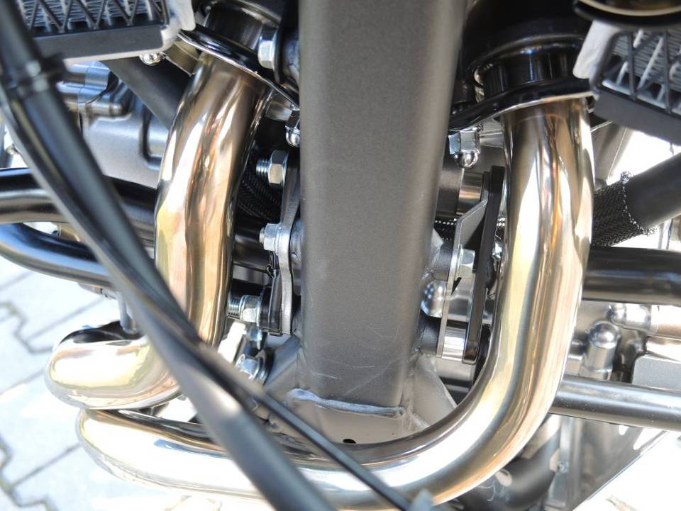
Remove original bolt M8 from the frame of motorcycle.

Left side:
Put washer ID.4 on bolt. Now mount crash bar with spacer l=17mm on the motorcycle.

Right side:
Fit silentblock on the crash bar. Prepare spacer l=5mm, crash bar, washer and fit it on the right side using nut ID5.

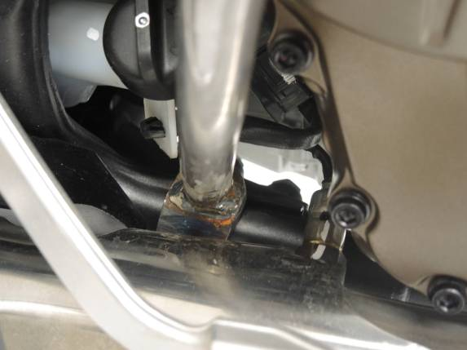

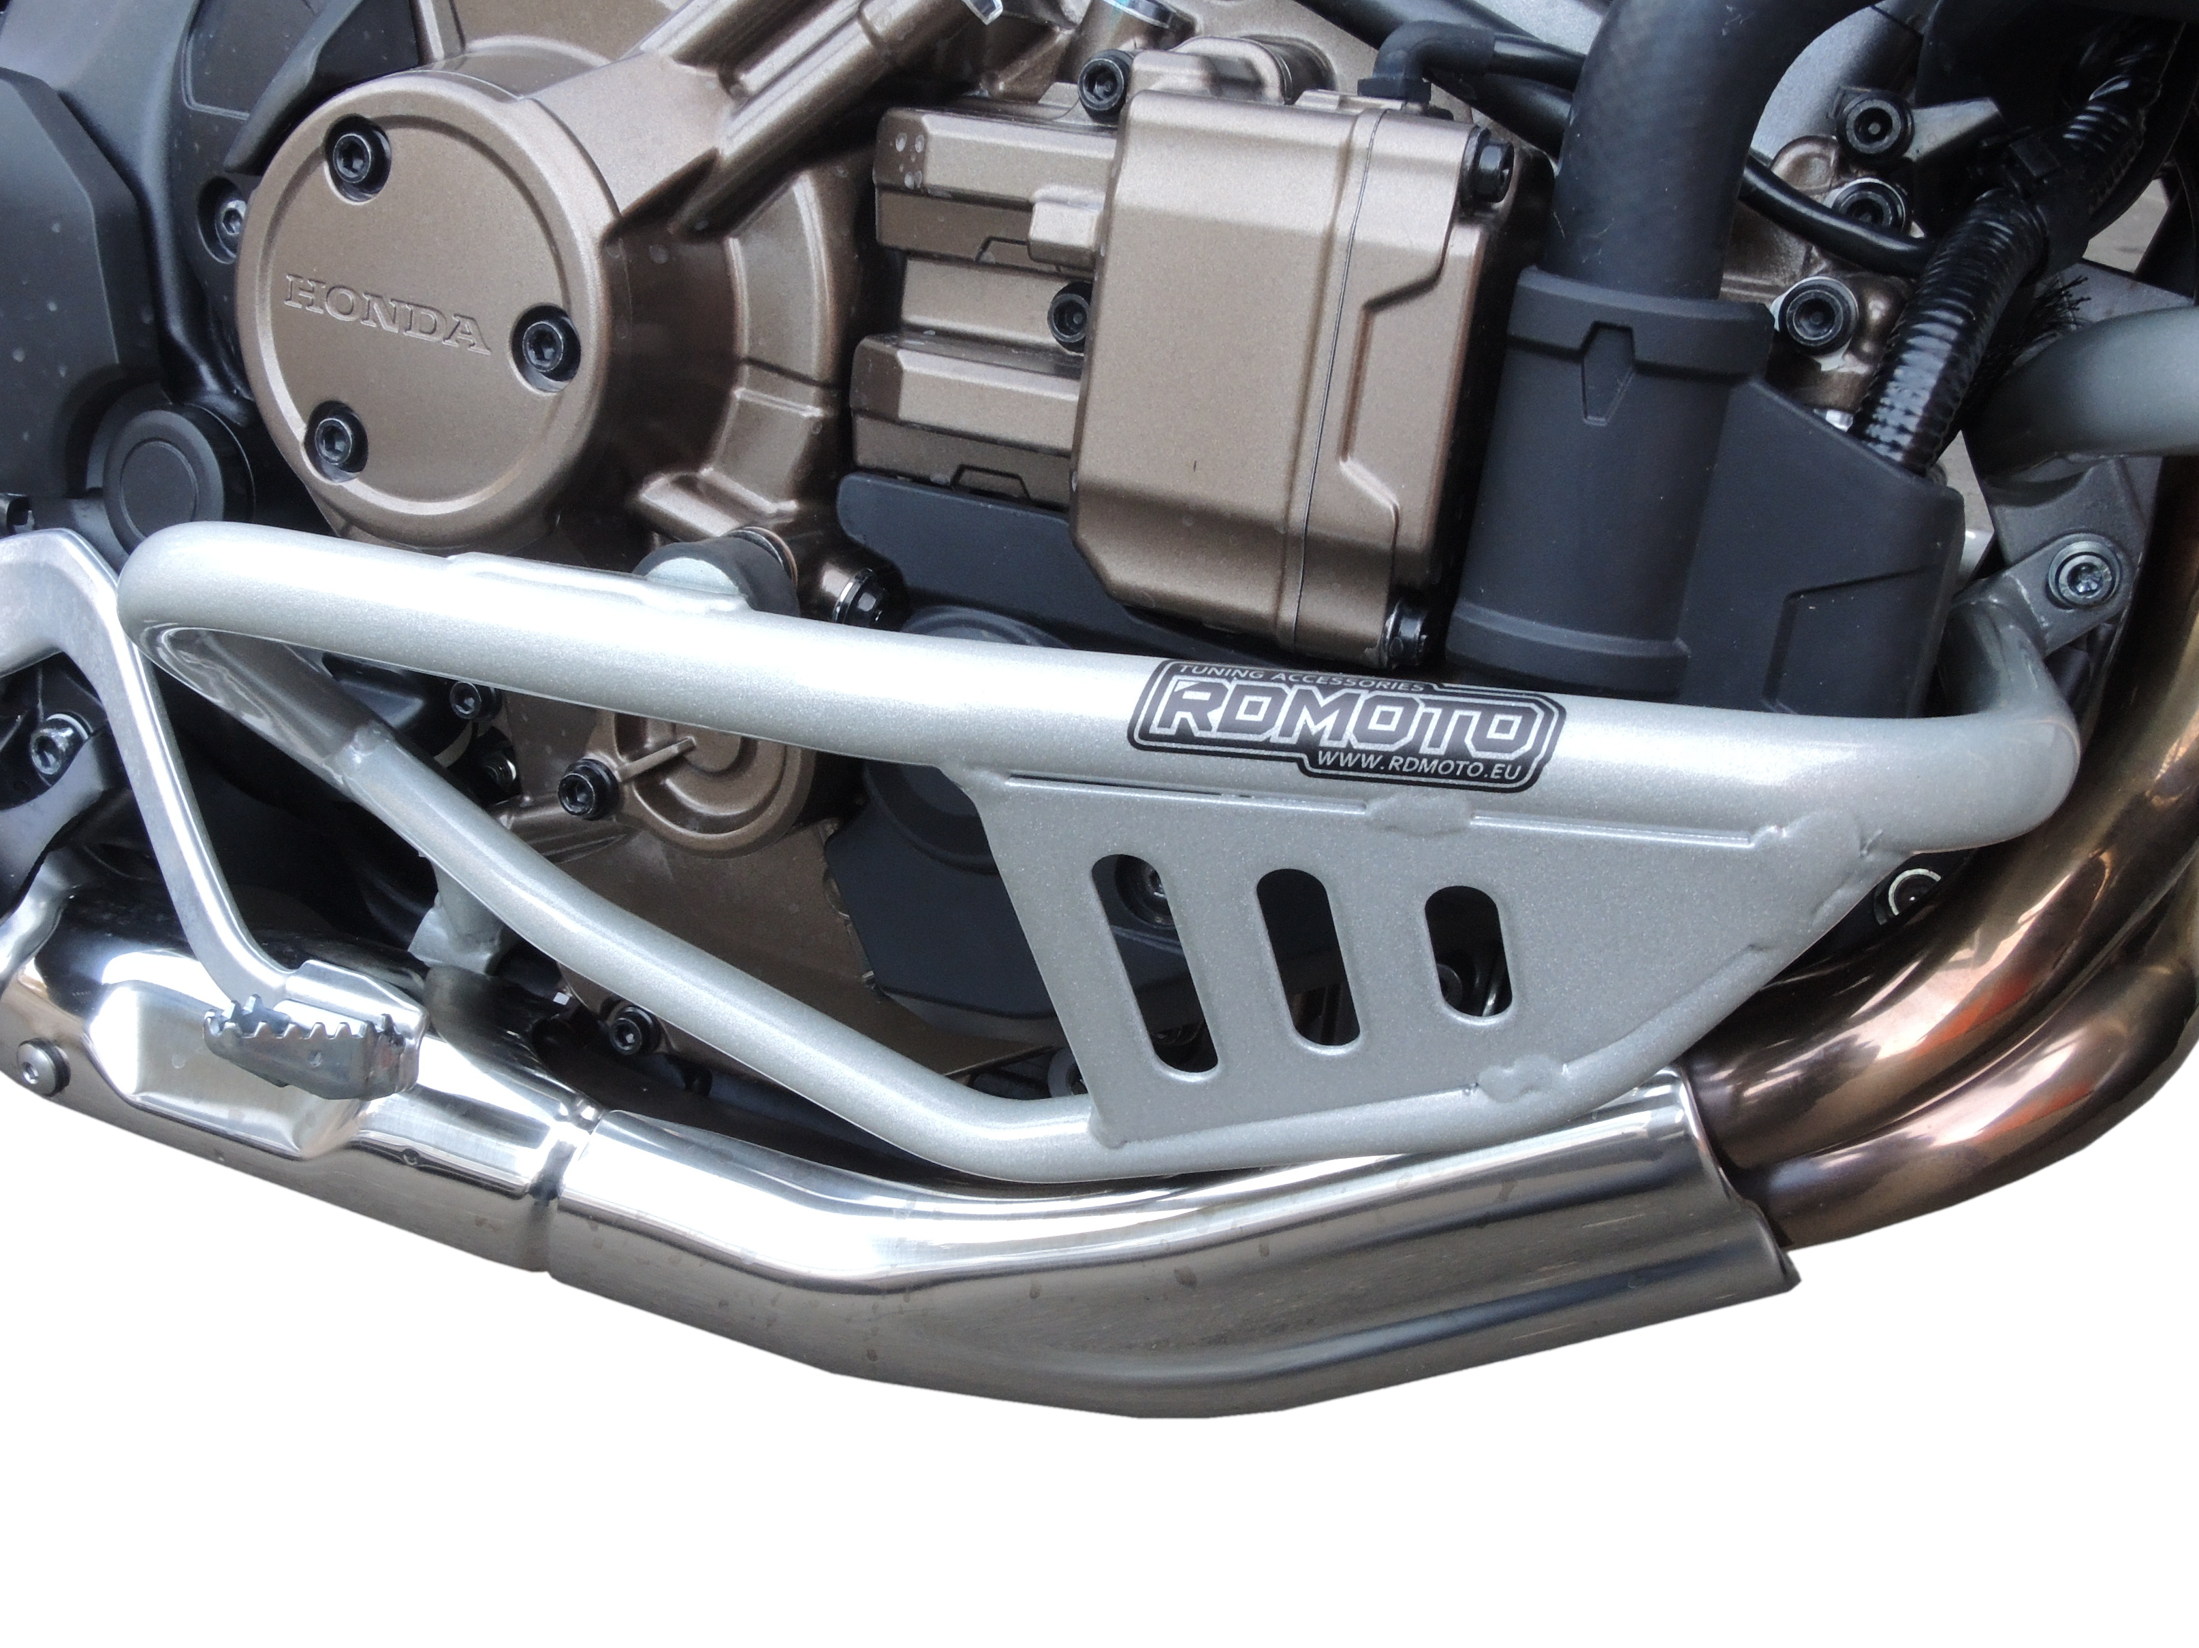
Use original bolts for tightening frame.

