CF68
Honda CRF 1000 Africa Twin DCT ´16-

Fitting kit:
ID | Description | Cat.no | pcs
1 | Threaded rod M10x130x30x30 |  | 1
2 | Nut M10 (safety) | 810 | 2
3 | Washer M10 (flat) | 804 | 2
4 | Cylinder – 12mm diameter of hole =8,5mm | 130 | 1
5 | Bolt M8x130 | 884 | 1
6 | Washer M8 (flat) | 802 | 2
7 | Nut M8 (safety) | 809 | 1

ID | Description | Cat.no | pcs
9 | Steel adapter | X71 | 1
10 | Alu. cylinder - 12mm | 120 | 2
11 | Washer M6 | 947 | 8
12 | Nut M6 (safety) | 948 | 4
13 | Bolt M6x20 | 1022 | 2
14 | Bolt M6x30 | 863 | 2
15 | Silentblock | X34 | 1

We recommend to use the glue on all threads (blue color – medium strong).

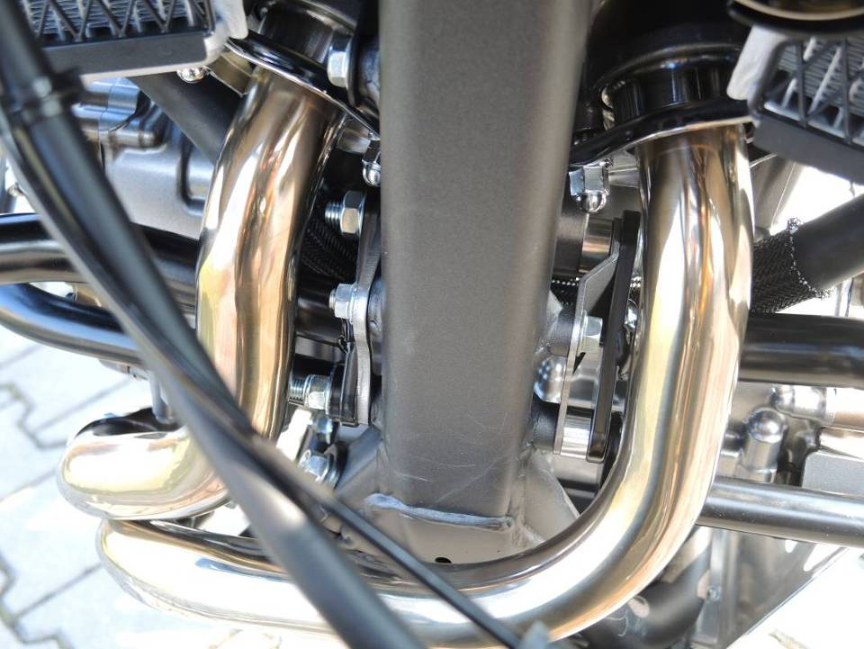
Remove original bolt M10 from the frame of motorcycle. Insert threaded rod ID1 trough the frame. Do not remove original cylinder from the frame.
Put upper crash bars on it. Do not forget to place washers ID3 under nuts ID2.

Insert cylinder ID4 between crash bar and frame of motorcycle. Insert bolt ID5 (+washer ID6) through the upper and lower crash bars and frame of motorcycle. Place both crash bars on the other side and tighten it using nut ID7 + washer ID6.

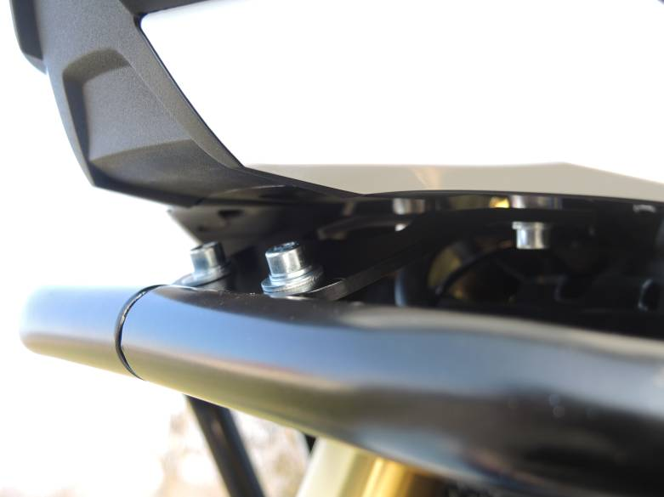
Place 2x cylinder ID10 between steel adapter ID9 and motorcycle. For tightening use bolts ID14 (+four washers ID11) and two nuts ID12.

Connect crash bar with steel adapter using bolts ID13 + (four washer ID11) and nuts ID12.

3

10
10

9
13,11,12

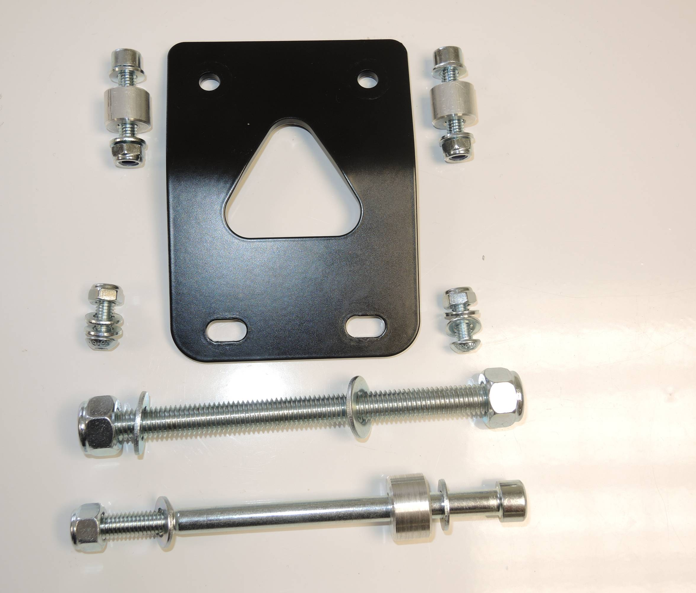
Use original bolt here on the right side.
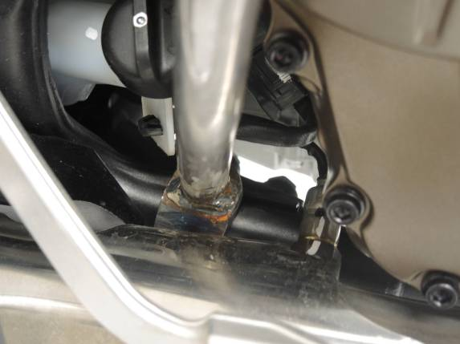

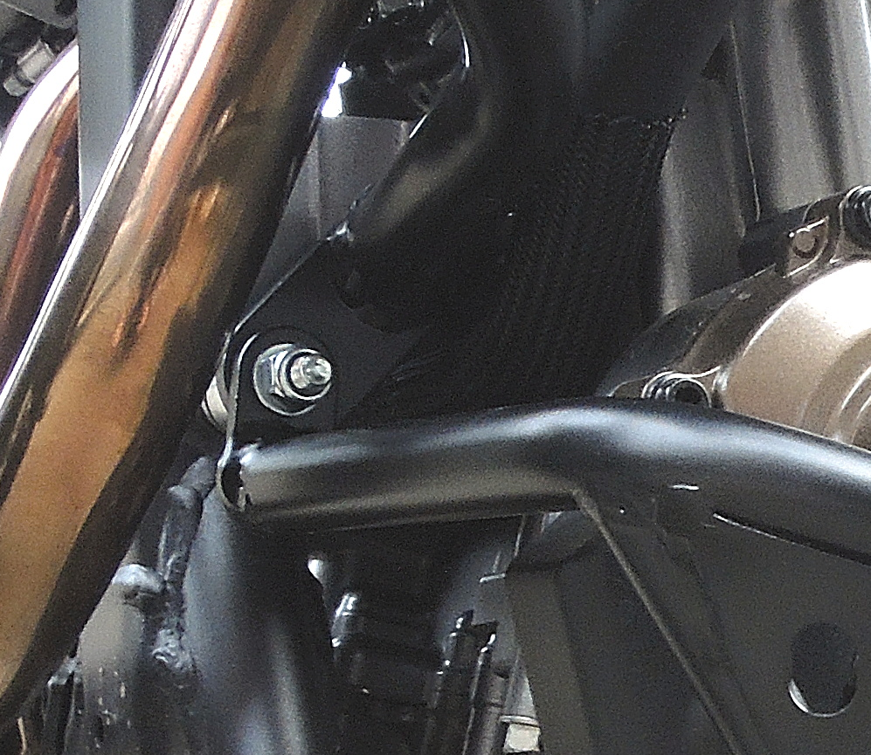

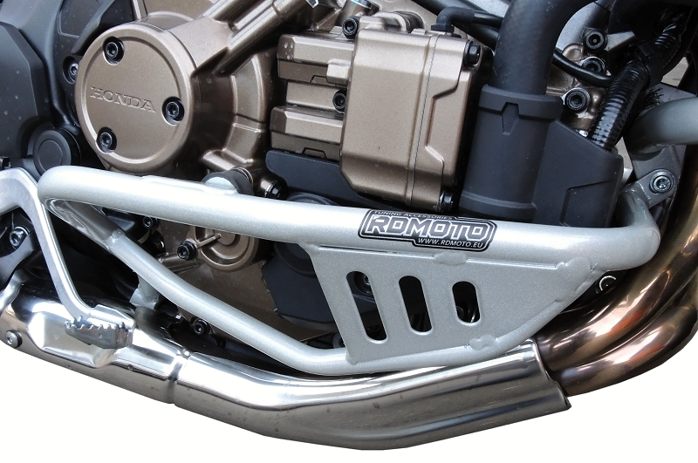
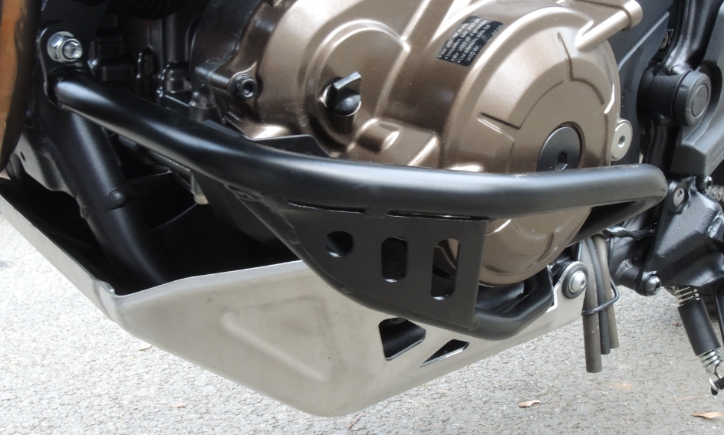
5
15

