CF70
Honda NC750X
2016-

Kit for the left side |  |  |  |  | Kit for the right side
No. | Description | Cat.no. | Pcs |  |  | No. | Description | Cat.no. | Pcs
1 | crash frame |  | 1 |  |  | 1 | crash frame |  | 1
2 | silentblock | X34 | 1 |  |  | 2 | silentblock | X34 | 1
3 | nut M8 | 813 | 1 |  |  | 3 | nut M8 | 813 | 1
4 | 3M tape |  | 1 |  |  | 4 | screw M6x25mm | 874 | 1
5 | sticker RDmoto |  | 1 |  |  | 5 | pad M6 - flat | 947 | 2
 |  |  |  |  |  | 6 | nut M6 – insurance | 948 | 1
 |  |  |  |  |  | 7 | 3M tape |  | 1
 |  |  |  |  |  | 8 | sticker RDmoto |  | 1

Installation :

1. Remove the bottom plastic under the engine
2. To the crash frames mount siding (item 2) and nuts (item 3)
3. Crash frames for the right and left side mount under the original screws (on the pictures), but do not tighten the screws
4. In front of the light connect crash frames by the screw (item 4) with pads (item 5) and nut (item 6)
5. Now you can tighten all the screws and mount back bottom plastic under the engine

The right side:
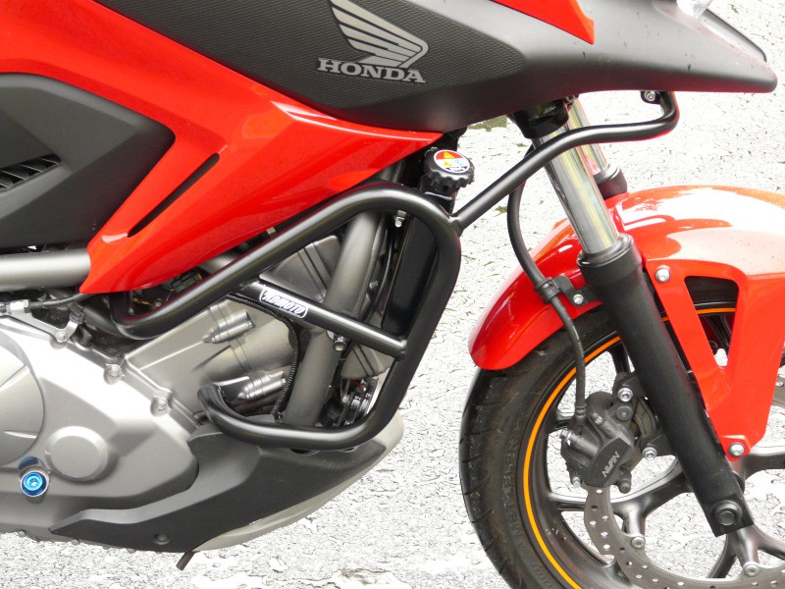

The left side:
