CF71
Yamaha MT-09

Kit for Left Side |  |  |  |  | Kit for Right Side
ID | Description | Cat. No. | Pcs. |  | ID | Description | Cat. No. | Pcs.
1 | Frame |  | 1 |  | 1 | Frame |  | 1
2 | Bolt M10x125x1.25mm | 924 | 1 |  | 2 | Bolt M10x115x1.25mm | 894 | 1
3 | Protector | PVPKN-0/16 | 1 |  | 3 | Protector | PVPKN-0/16 | 1
4 | Washer M10 flat | 804 | 1 |  | 4 | Washer M10 flat | 804 | 1
5 | Dural. roller d=13mm | 1127 | 1 |  | 5 | Dural. roller d=5mm | 168 | 1
6 | Safety nut M10 | 810 | 1 |  | 6 | Safety nut M10 | 810 | 1
7 | Dural. insert to protektor | X131 | 1 |  | 7 | Dural. insert to protektor | X131 | 1
 |  |  |  |  | 8 | Rod 10x300x30x30mm |  | 1

We recommed using medium strenght thread glue during assembly.

Instructions (same for both sides):

- Unscrew the original bolt from top part of the frame.
- Prepare the protector, (ID.2) bolt, insert (ID.7) and (ID.5) roller – depending on which side you are about to install.
- Attach the top part using M10 (ID.2) bolt.
- Now, unscrew the original bolt from bottom part of the frame.
- Now attach the (ID.8) rod, fit the rear part of the frame and tighten using M10 (ID.4) washers and (ID.6) nuts.
- Finally, tighten all.
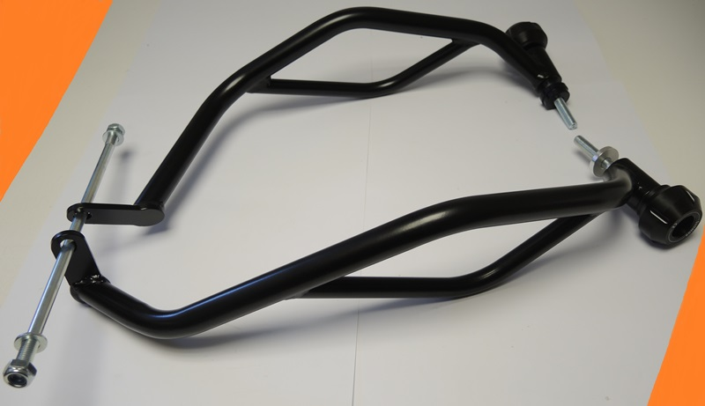

Rod ID.7 + safety nut M10 ID.6 + washer M10 ID.4
ID.5 - P
ID.5 - L

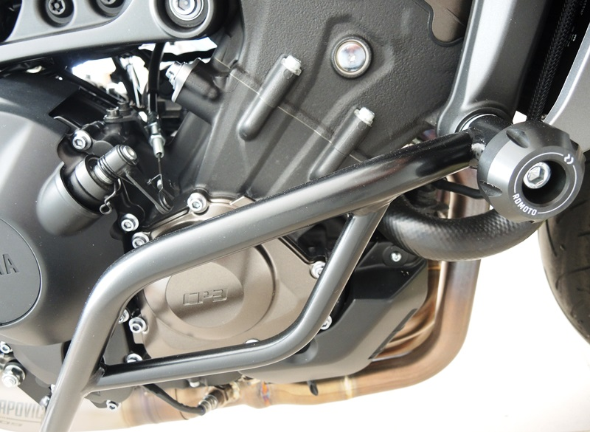
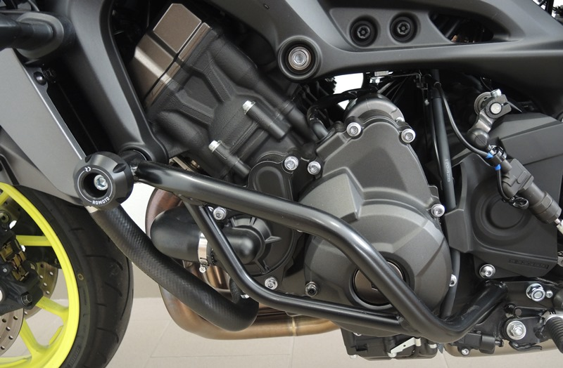
9
13,11,12
10
Origin.bolt
Original bolt. Rear place.

