CF74
BMW F650 1997-/F650ST

MONTAGE SET
ID | Popis |  | Kat. číslo | Ks
1 | Steel bar 10x165x30x30 |  | - | 1
2 | Dural. roller – 10mm |  | 113 | 2
3 | Washer M10 |  | 804 | 4
4 | Cap nuts M10 |  | 961 | 2
5 | Plastic plug-in tube |  | X32 | 2
6 | Nuts imbus M10x120mm |  | 881 | 1
7 | Lock nut M10 |  | 810 | 1

Instructions:

1.) Attach both frames to the motorcycle and fix them at bottom part.
2.) Push the ID.1 steel rod through the frame and tighten it with M10 ID.4 nuts. Also use two ID.2 rollers(cylinders) and ID.3 washers.
3.) For the upper part, use the M10 ID.6 screw with M10 ID.3 washers and tighten with M10 ID.7 nut.
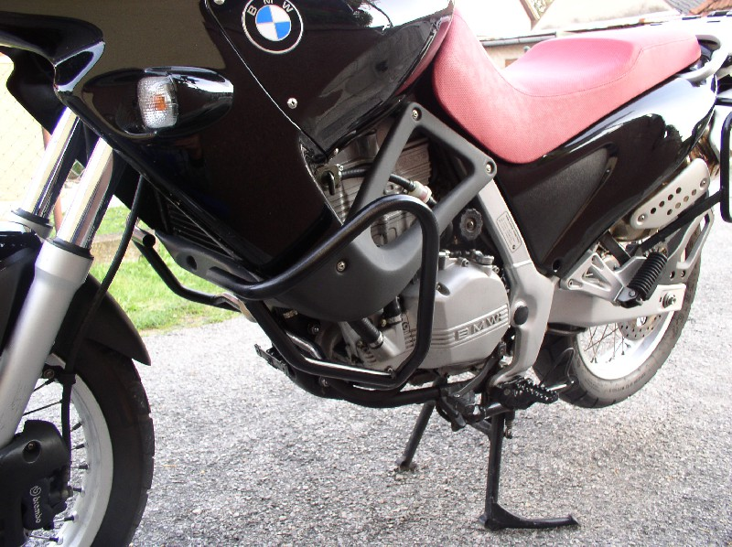
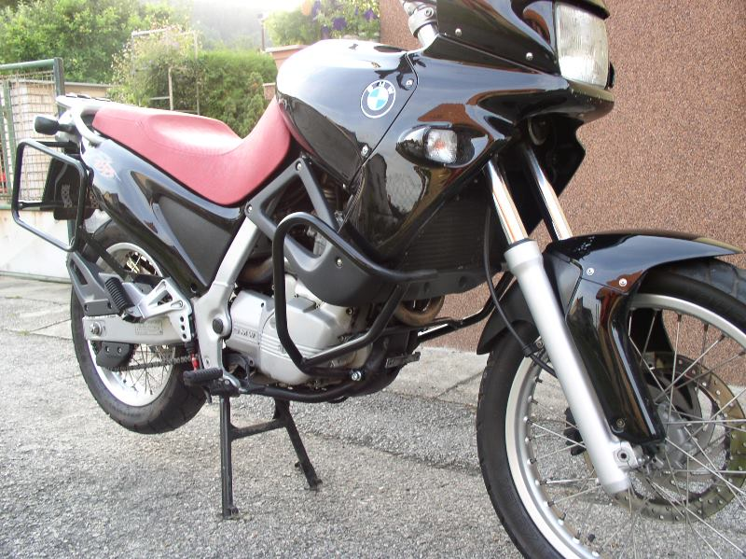
4.) Finally put the plastic plugs into the ID.5 pipe

