CF75
BMW R850R 2002-

Right side kit |  |  |  |  | Left side kit
ID | Popis | Kat.číslo | Počet |  |  | ID | Popis | Kat.číslo | Počet
1 | Crash frame |  | 1 |  |  | 1 | Crash frame |  | 1
2 | Dural. cylinder - 61mm | DV1223 | 1 |  |  | 2 | Dural. cylinder – 61mm | DV1223 | 1
3 | Silentblok | X21 | 1 |  |  | 3 | silentblok | X21 | 1
4 | Nut M10 | 961 | 1 |  |  | 4 | Nut M10 | 961 | 1
5 | Washer M10 – flat | 804 | 3 |  |  | 5 | Washer M10 – flat | 804 | 3
6 | Bolt M10x100 | 885 | 1 |  |  | 6 | Bolt M10x100mm | 885 | 1
7 | Nut M8 | 951 | 1 |  |  | 7 | Nut M8 | 951 | 1
8 | Washer M8 flat | 802 | 1 |  |  | 8 | Washer M8 flat | 802 | 1
9 | Bolt M10x60 | 850 | 1 |  |  | 9 | Bolt M10x50 | 849 | 1
10 | Rod 10x240x30x30 |  | 1 |  |  | 11 | Dural. cylinder - 15mm | DV1170 | 1
11 | Dural. cylinder - 15mm | DV1170 | 1 |  |  | 12 | Dural. cylinder - 95mm | DV1196 | 1
12 | Dural. cylinder - 43mm | DV129 | 1 |  |  | 13 | Sticker RDmoto |  | 1
13 | Sticker RDmoto |  | 1

Installation:

Mount crash frames according to the picture below.

We recommend to use the glue on all threads.

Right side:

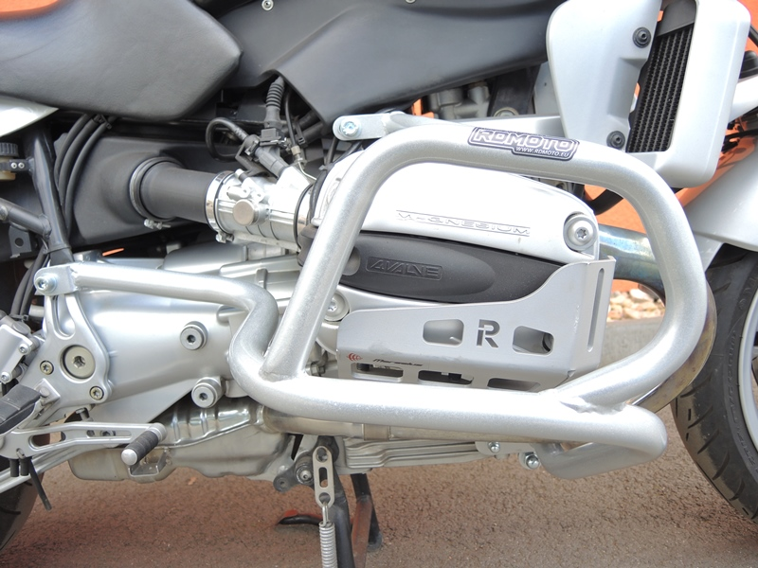
Bolt M10x100 (ID6) + dural. cylinder (ID2).
Rod 10x240x30x30 + cylinder ID12 + washer M10 + nut M10 (ID4).

Bolt M10x60 (ID.9) + flat washer M10 (ID5) + dural. cylinder (ID.11).
Nut M8 (safety) + washer M8 (flat) + silentblok (ID3).

Left side
Bolt M10x100 (ID6) + dural. cylinder (ID2).
.

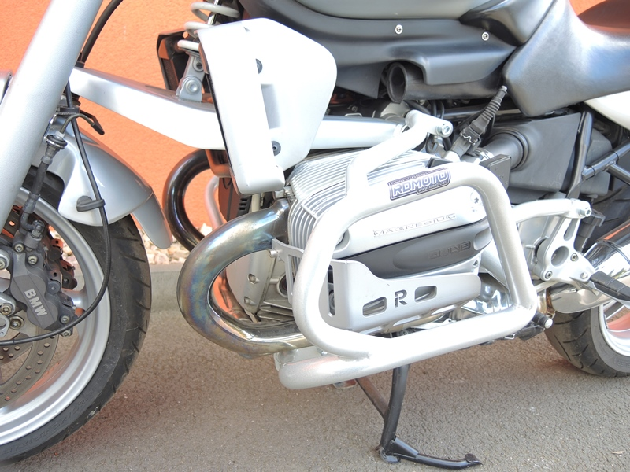
Bolt M10x50mm + dural. cylinder (ID11) + washer M10 (plochá)

Nut M8 + washer M8 (flat) + silentblok.
Dural. cylinder (ID12) + washer M10 + Nut M10.

