CF76
Yamaha FZ6 2004-2012

Mounting kit for right side: |  |  |  |  | Mounting kit for left side:
ID | Description | Cat. No. | Pcs |  |  | ID | Description | Cat. No. | Pcs
1 | Crash frame | CF76 | 1 |  |  | 1 | Crash frame | CF76 | 1
2 | Bolt M10x60x1,25 | 896 | 1 |  |  | 2 | Bolt M10x60x1,25 | 896 | 1
3 | Dural. roller d=14,5mm | 1160 | 1 |  |  | 3 | Dural. roller d=14,5mm | 1160 | 1
4 | Washer M10 flat | 804 | 2 |  |  | 4 | Washer M10 flat | 804 | 2
5 | Bolt M8x30 | 834 | 1 |  |  | 5 | 3M tape |  | 2

Mounting instructions: Use the same procedure for both sides!

We recommend using medium strenght thread glue during assembly.

Remove the original bolt and replace it with M10x60 ID.2 + Washer M10 ID.4. Replace the original. Insert the ID.3 roller between crash frame and frame of the motorcycle.

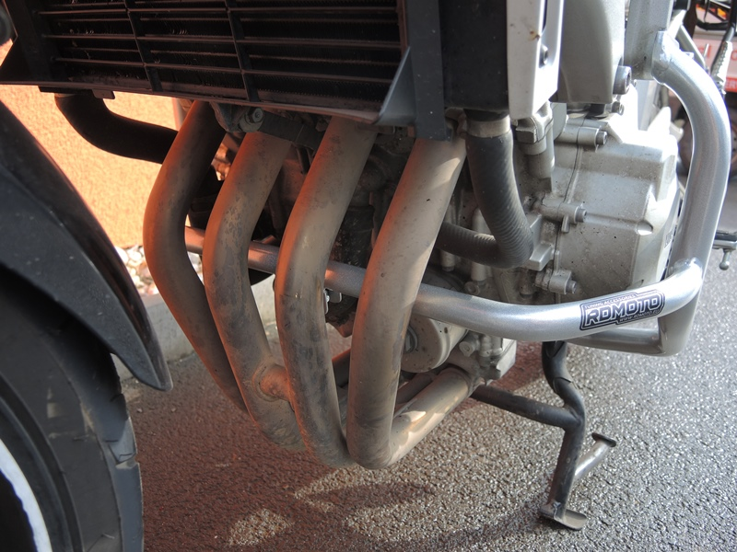
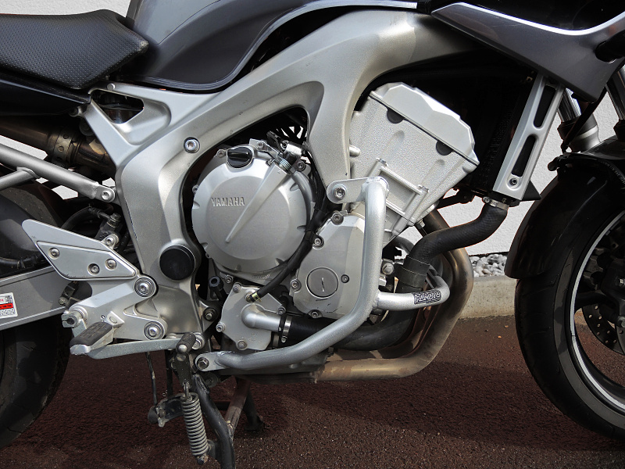
Use the bolt M8x30 ID.5.
Remove the original bolt and put ID.4 washer onto it. Use it to attach the crash frame as shown on picture. Then, push the bolt through motorcycle frame and tighten.

