CF77
Kawasaki ER6N 2009-2011

Left side kit: |  |  |  |  | Right side kit:
ID | Description | Cat.No. | Pcs |  |  | ID | Description | Cat.No. | Pcs
1 | Crash frame | CF77KD | 1 |  |  | 1 | Crash frame | CF77KD | 1
2 | Bolt M10x90 | 880 | 1 |  |  | 2 | Bolt M10x100 | 879 | 1
3 | Nut M10 | 814 | 1 |  |  | 3 | Nut M10 | 814 | 1
4 | Bolt M6x40 | 865 | 1 |  |  | 4 | Bolt M6x40 | 865 | 1
5 | 3M tape |  | 1 |  |  | 5 | Dural. cylinder - 6mm | DV115 | 1
6 | Washer M10 | 804 | 1 |  |  | 6 | Washer M10 | 804 | 1

Instructions:

We recommend to use the glue on all threads (medium strong).

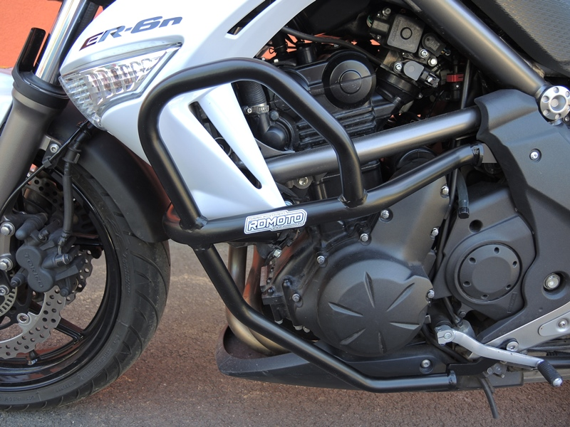
Remove original bolt, and place frames under plastic cover.

Use bolt M6x40 for tightening.

Bolt M10x90 + washer M10.

For tightening use safety nut M10.

Leave original cylinder between frame and engine.

Remove original bolt and stick 3M tape on the motorcycle. Mount original bolt back.

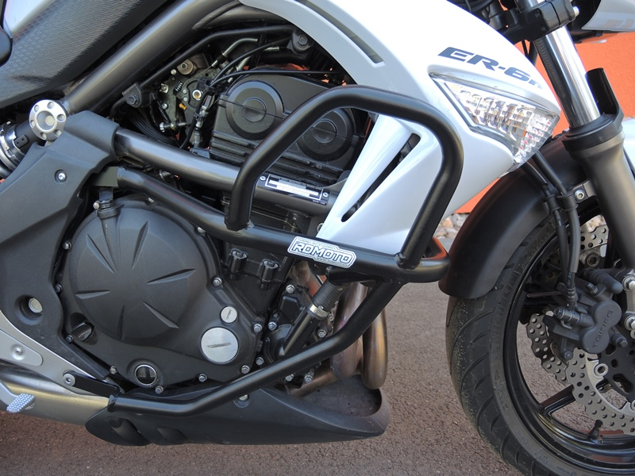
Remove original bolt, and place frames under plastic cover. Insert cylinder ID9 between moto and crash frame. Replace original bolt using bolt M6x40.

Remove original bolt and stick 3M tape on the motorcycle. Mount original bolt back.

Bolt M10x90 + washer M10.

Use safety nut M10 for tightening.

Leave original cylinder between frame and engine.

