CF78
BMW R1200GS / Adventure 2004-2007
Designed for original lower BMW frame.

Mounting kit includes
Poz. | Popis | Kat.číslo | Počet
1 | Crash frame top part | CF | -
2 | Steel clamp M6 | X52 | 2
3 | Washer M6-flat | 947 | 8
4 | Safety nut M6 | 948 | 5
7 | Bolt M6x30mm | 863 | 1
9 | Bolt M8x25mm-round head | 831 | 8
11 | Washer M8-flat | 802 | 12
12 | Safety nut M8 | 809 | 6
16 | Tape 3M | - | 4
17 | Pipe clamp with 25mm diameter | X20 | 2
24 | Sticker RDmoto | - | 2

Montáž :

Install the crash frames as instructed on the attached photos.
Installation can not be done without the lower frame.

Attention: For threads of all screws, we recommend using medium strenght glue (blue color).

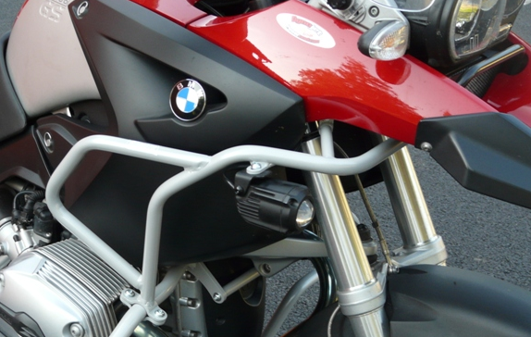

2x clamp (note.17 right and left side).
4x bolt M8x25 (note.9 right and left)
4x nut M8 (note.12 left and right side)
8x washer M8 (note. 11 left and right side)

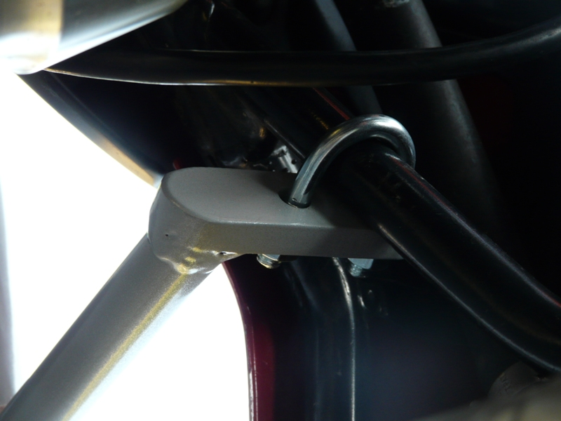
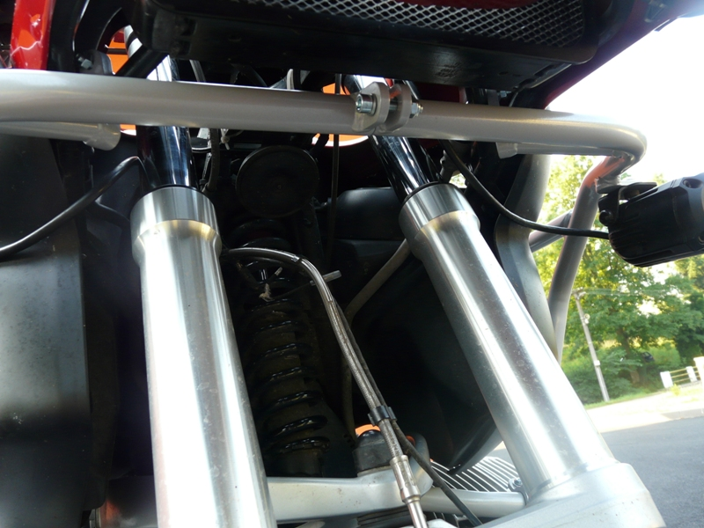
2x steel clamp M6 (note.2, left and right side)
4x washer M6 (note.3 left and right side)
4x nut M6 (note.4, left and right side)
1x bolt M6x30mm (note.7)
2x washer M6 (note.3)
1x nut M6 (note.4)

