CF79KD CF79R
Yamaha MT07

Fitting kit for the left side |  |  |  |  | Fitting kit for the right side
ID | Description | Cat.no. | Pcs |  | ID | Description | Cat.no. | Pcs
1 | Crash frame |  | 1 |  | 1 | Crash frame |  | 1
2 | Screw M12x130x1.25 | 1027 | 1 |  | 2 | Screw M12x130x1.25 | 1027 | 1
3 | Slider | SL01 | 1 |  | 3 | Slider | SL01 | 1
4 | SL adaptér | 1137 | 1 |  | 4 | SL adapter | 1137 | 1
5 | Screw M6x25 | 877 | 3 |  | 5 | Screw M6x25 | 877 | 3
6 | Screw M4x16 | 876 | 2 |  | 6 | Screw M4x16 | 876 | 2
7 | Cover Black | CAPSL-K | 1 |  | 7 | Screw M10x40x1.25 | 941 | 1
8 | Dural. roller d=45mm | 1303 | 1 |  | 8 | Dural. roller d=45mm | 1303 | 1
 |  |  |  |  | 9 | Cover black | CAPSL-K | 1
 |  |  |  |  | 10 | Washer M10 flat | 804 | 1

We recommend to use glue on all threads (medium strong).

Instructions (for both sides):

- Remove original screw from upper part of frame.
- Prepare protector and screw.
- Attach the upper part with adapter and duralumin with roller (ID8), screw M12 (ID2)
- Remove original screw from lower part of frame.
- Attach lower part of frame using this original screw, but right screw M10x40x1.25(ID4)
- Tighten both screws.
- Attach the SL adapters using the M6 screws(ID.5) and then the cover, using screws M4(ID.6).
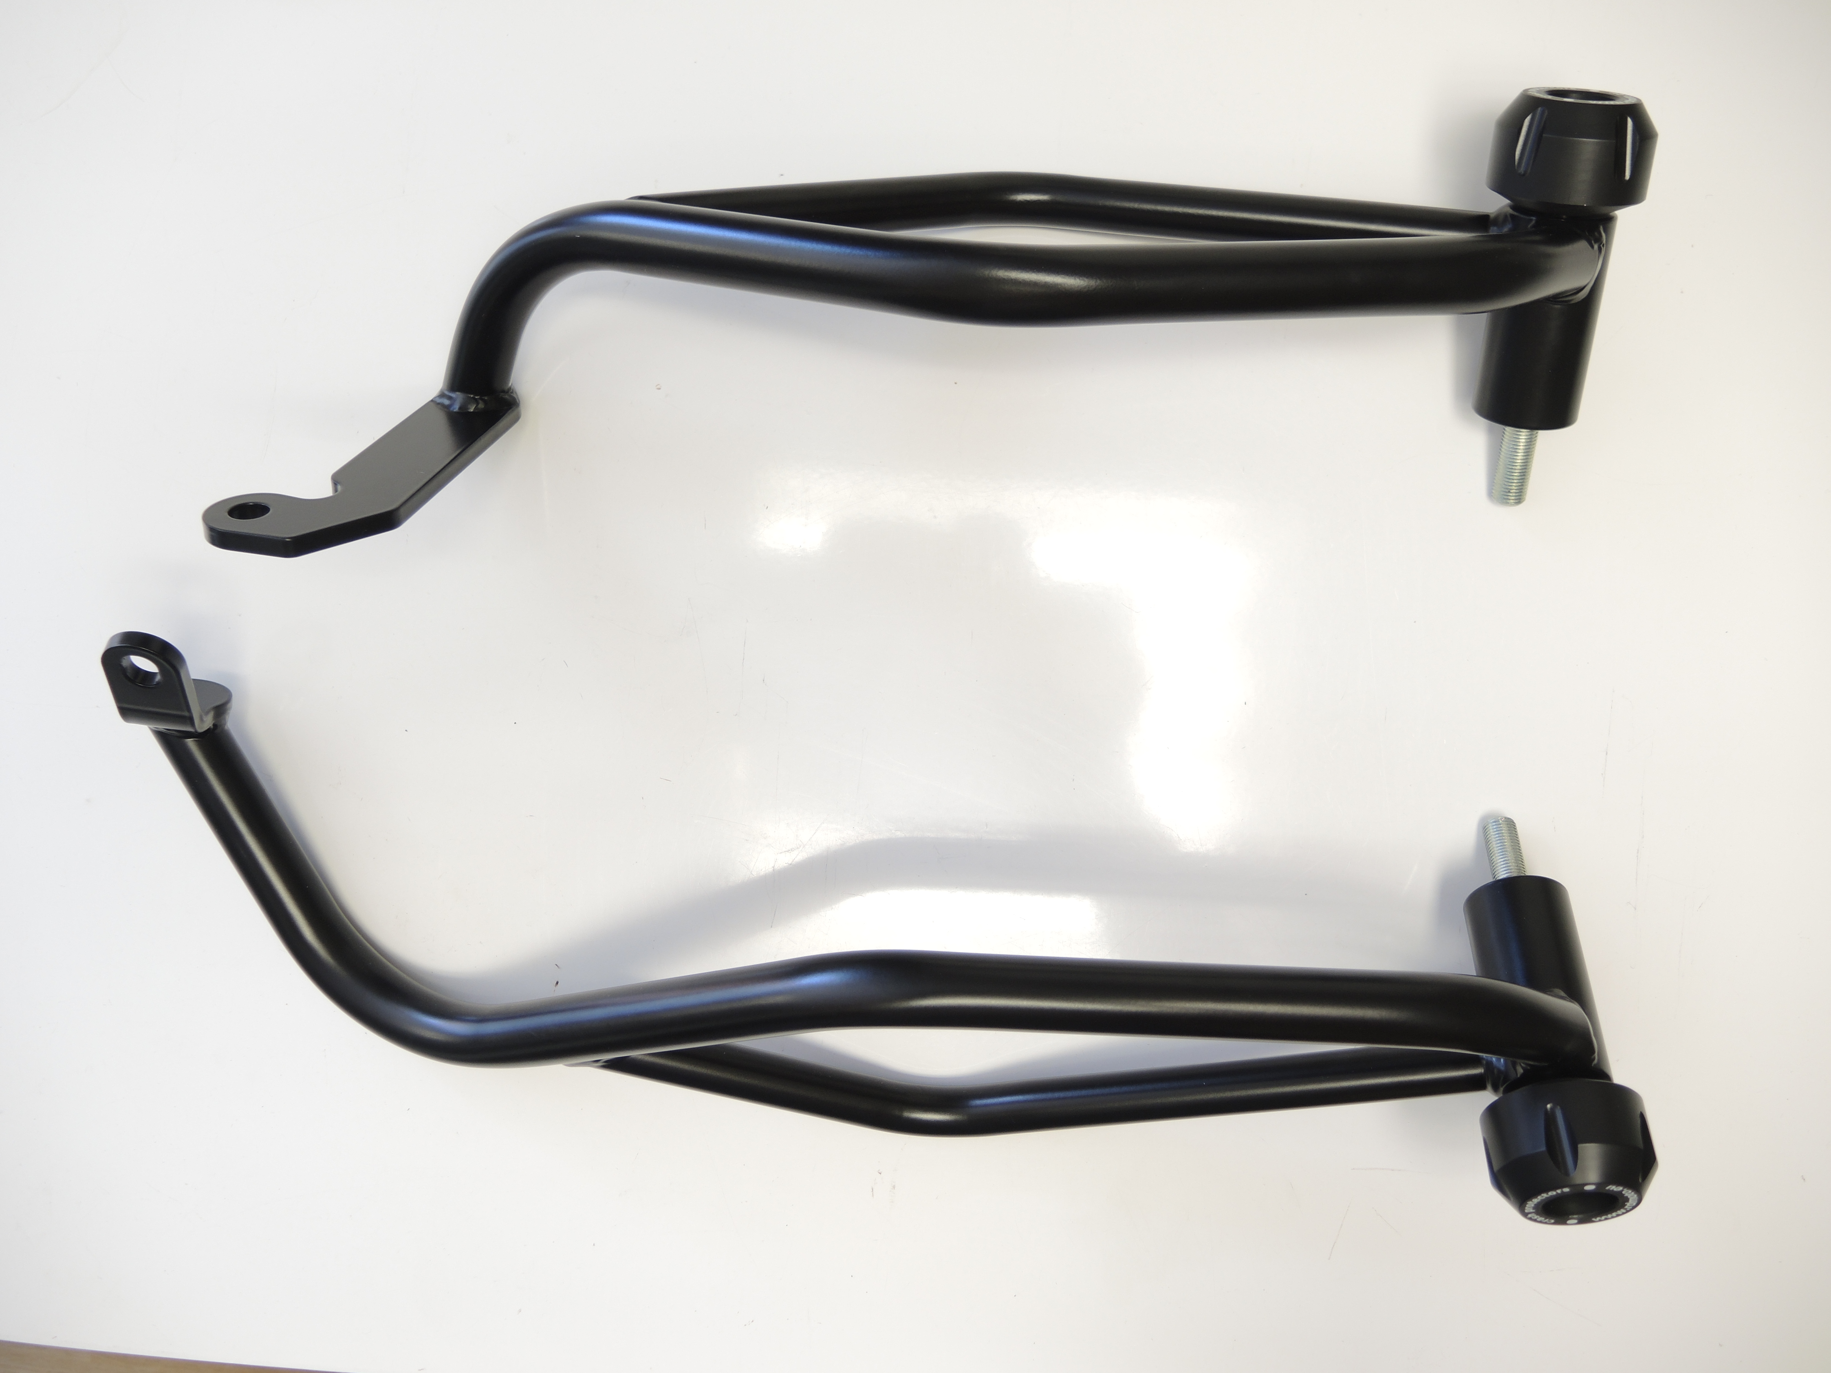
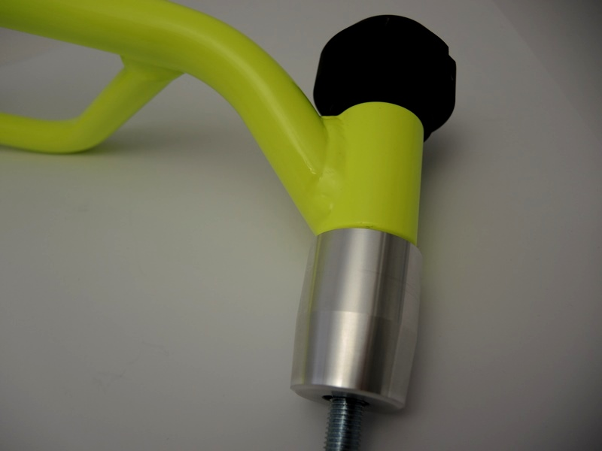

Original screws
left side,
Right side M10x40+Washer M10 flat
ID2
M12x130x1,25
ID8
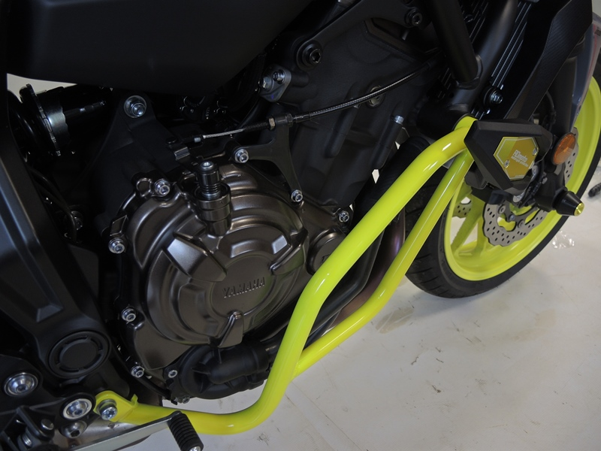
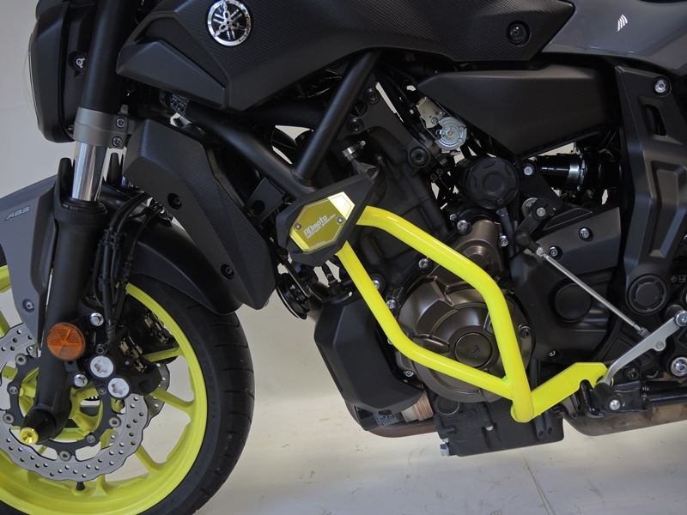
9
13,11,12
10
9
13,11,12
10
Origin.bolt
Original bolt. Rear place.
Origin.bolt
Original bolt. Rear place.

