CF79Y
Yamaha MT07

LEFT SIDE KIT |  |  |  |  | RIGHT SIDE KIT
ID | Desription | Cat.no. | Pcs |  | ID | Description | Cat.No. | Pcs
1 | Frame |  | 1 |  | 1 | Frame |  | 1
2 | Bolt M12x130x1.25 | 1027 | 1 |  | 2 | Bolt M12x130x1.25 | 1027 | 1
3 | Slider | SL01 | 1 |  | 3 | Slider | SL01 | 1
4 | SL adapter | 1137 | 1 |  | 4 | SL adapter | 1137 | 1
5 | Bolt M6x25 | 877 | 3 |  | 5 | Bolt M6x25 | 877 | 3
6 | Bolt M4x16 | 876 | 2 |  | 6 | Bolt M4x16 | 876 | 2
7 | Slider cover | CAPSL-Y | 1 |  | 7 | Bolt M10x40x1.25 | 941 | 1
8 | Dural. roller d=45mm | 1303 | 1 |  | 8 | Dural. roller d=45mm | 1303 | 1
 |  |  |  |  | 9 | Washer M10 flat | 804 | 1
 |  |  |  |  | 10 | Slider cover | CAPSL-Y | 1

We recommend to use safety glue on all threads(medium strong).

INSTRUCTIONS

- Unbolt original bolt from the frame of motorcycle.
- Fit upper part of frame with adapter ID4 and dural. roller ID8 using bolt M12.
- Unbolt original bolt from the the lower part of motorcycles frame.
- Fit left side using original bolt and right side using bolt M10x40.
- Fit slider using three bolts ID5 on the slider adapter.
- Fit cover using two bolts ID6.
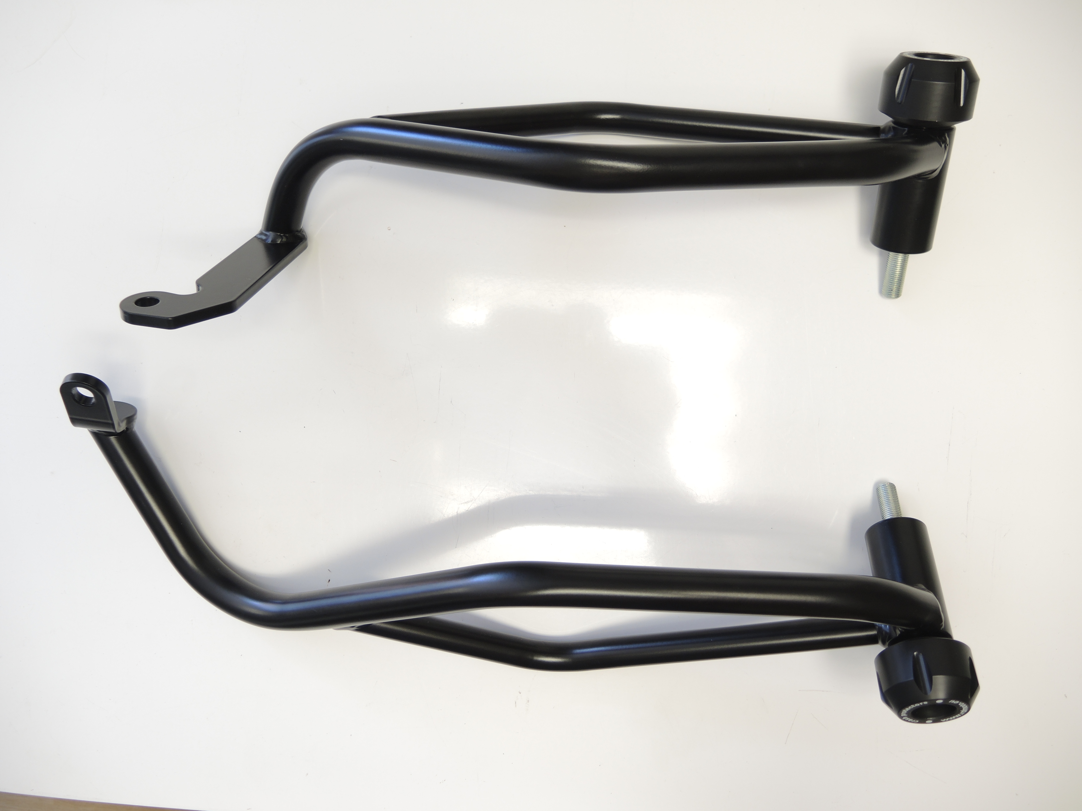

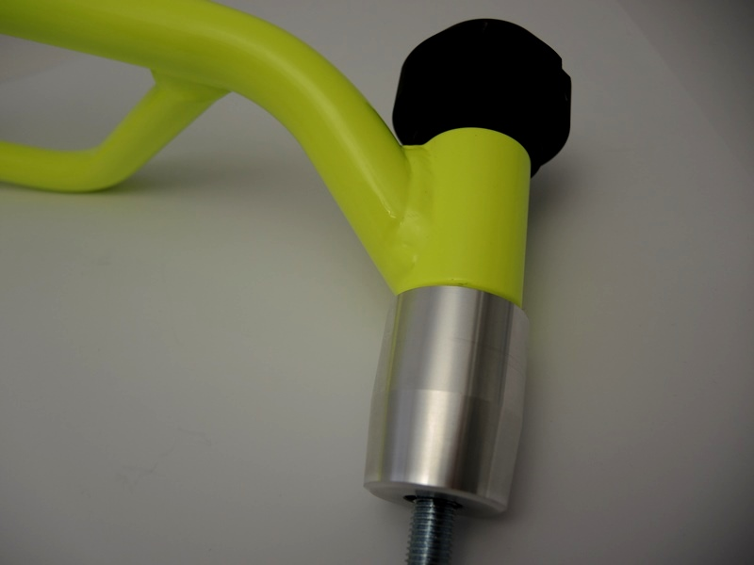

Original bolt on the left,

bolt M10x40 on the right + washer M10
ID2
M12x130x1.25
ID8
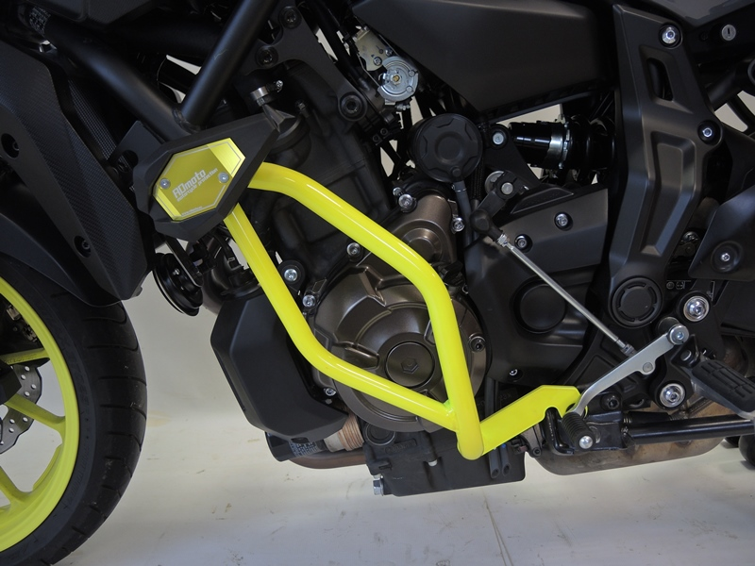
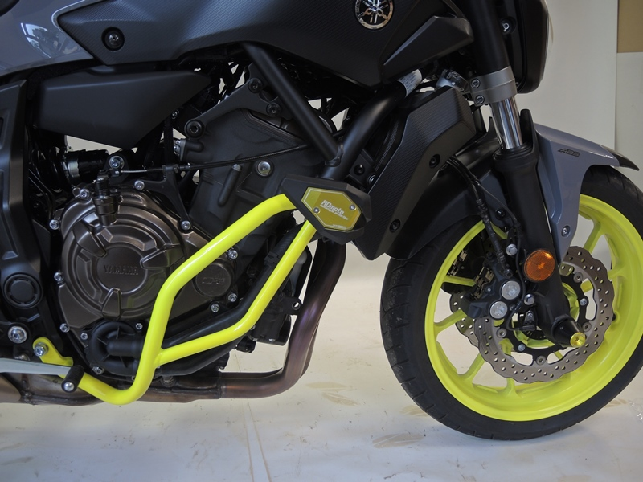
9
13,11,12
10
Origin.bolt
Original bolt. Rear place.

