CF81
KTM 1290 Super Duke/GT
2015-

LEFT SIDE KIT |  |  |  |  | RIGHT SIDE KIT
ID | Description | Cat.no. | Pcs |  |  | ID | Description | Cat.No. | Pcs
1 | Crash frame | CF81 | 1 |  |  | 1 | Crash frame | CF81 | 1
2 | Bolt M10x70 | 851 | 1 |  |  | 2 | Bolt M10x70 | 851 | 1
3 | Bolt M10x30 | 888 | 1 |  |  | 3 | Bolt M8x45 | 964 | 1
4 | Bolt M8x20 | 824 | 2 |  |  | 4 | Bolt M8x20 | 824 | 4
5 | Washer M10 | 804 | 2 |  |  | 5 | Washer M10 | 804 | 1
6 | Wsher M8 | 802 | 2 |  |  | 6 | Washer M8 | 802 | 4
7 | Cylinder 17mm | 1233 | 1 |  |  | 7 | Cylinder 26mm | 1234 | 1
8 | Adapter SLD | X92 | 1 |  |  | 8 | Adapter SLD | X92 | 1
9 | Bolt M6x35 | 989 | 2 |  |  | 9 | Bolt M6x35 | 989 | 2
10 | Washer M6 | 1023 | 2 |  |  | 10 | Washer M6 | 1023 | 2
11 | Rod 330mm | X90 | 1 |  |  | 11 | Rod | X89 | 1
12 | SLDM |  | 1 |  |  | 12 | SLDM |  | 1
13 | Dural. cylinder 7mm | 405 | 1 |  |  | 13 | Dural. cylinder 7mm | 405 | 1
 |  |  |  |  |  |  | Dural. cylinder 25mm | 1245 | 1
LEFT SIDE INSTRUCTIONS

- Fit slider ID12, adapter ID8 using bolts ID9 and washers ID10 on the frame.
- Unbolt original bolts from the left side of motorcycle.
- Fit crash frame using bolt ID2 and washer ID5 (into the thread of original bolt) (between ID frame and drop frame, insert ID.13). Fit rear part of frame using rod ID11 with cylinder ID7 and bolt ID4 with washer ID6.
- Fit crash frame using bolts ID4 and ID3 washers ID6 and cylinder ID14.
- Use bolt ID4 for tightening rod ID11.

RIGHT SIDE INSTRUCTIONS

- Fit slider ID12, adapter ID8 using bolts ID9 and washers ID10 on the frame.
- Unbolt original bolts from the right side of motorcycle.
- Fit crash frame using bolt ID2 and washer ID5 (into the thread of original bolt) (between ID frame and drop frame, insert ID.13).
- Place cylinder ID7 on the end of rod ID11.
- Fit rear part using bolt ID4 and washer ID6.
- Use bolt ID4 for tightening rod ID11.
- Fit front part of frame using bolt ID3.

We recommend to use safety glue on all threads (medium strong).
2
13
RIGHT SIDE
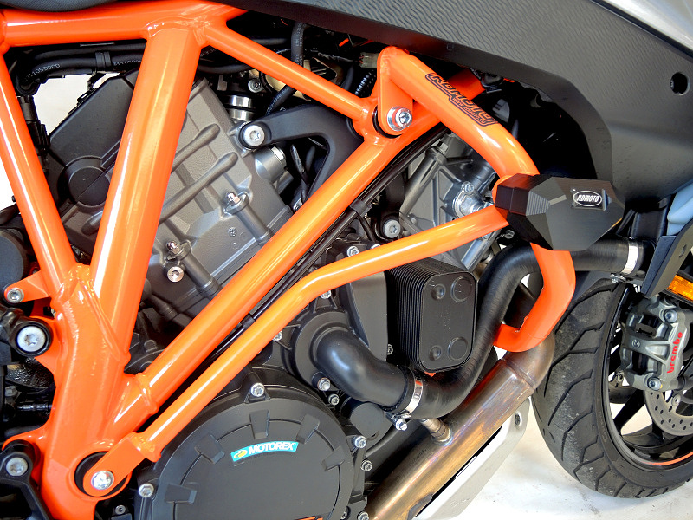
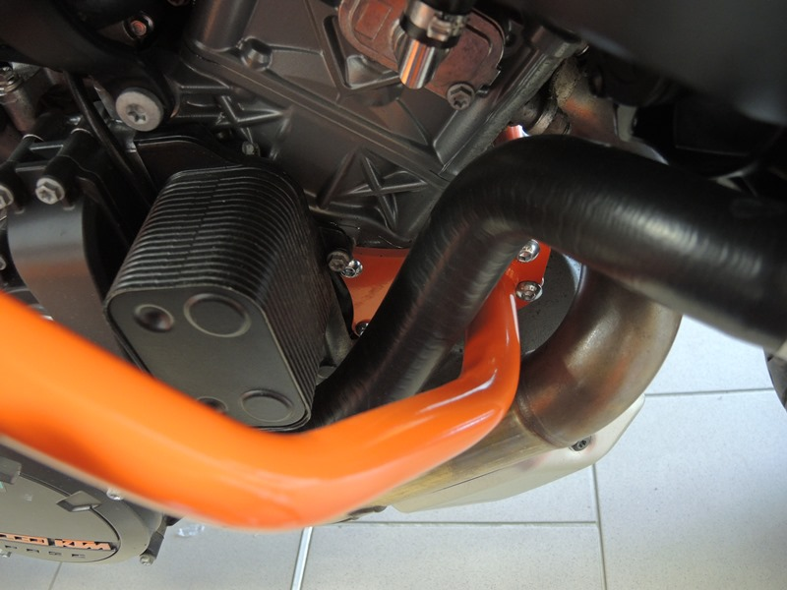
8
9
9
4
14

4
3
7
4

11
LEFT SIDE
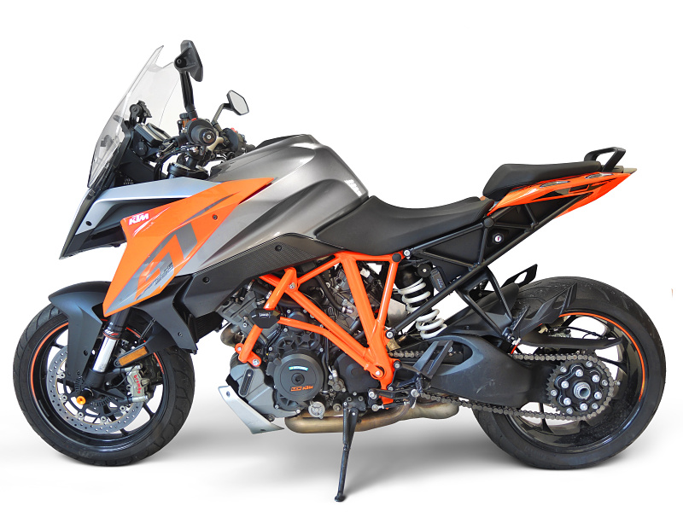
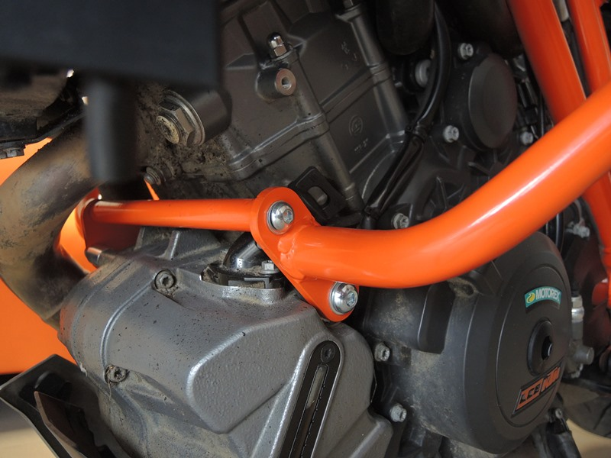
11
3
4

