CF82
KTM 1290 Super Duke R
2014-

Left side kit |  |  |  |  | Right side kit
Note | Description | Cat. No. | Pcs |  |  | Note | Description | Cat. No. | Pcs
1 | Crash frame | CF81 | 1 |  |  | 1 | Crash frame | CF81 | 1
2 | Bolt M10x70 | 851 | 1 |  |  | 2 | Bolt M10x70 | 851 | 1
3 | Bolt M10x30 | 888 | 1 |  |  | 3 | Bolt M8x45 | 964 | 1
4 | Bolt M8x20 | 824 | 2 |  |  | 4 | Bolt M8x20 | 824 | 4
5 | Washer M10 | 804 | 2 |  |  | 5 | Washer M10 | 804 | 1
6 | Washer M8 | 802 | 2 |  |  | 6 | Washer M8 | 802 | 4
7 | Roller d=17mm | 1233 | 1 |  |  | 7 | Roller d=26mm | 1234 | 1
8 | Bolt M6x16 | 962 | 2 |  |  | 8 | Bolt M6x16 | 962 | 2
9 | Washer M6 | 1023 | 2 |  |  | 9 | Washer M6 | 1023 | 2
10 | Rod d=330mm | X90 | 1 |  |  | 10 | Rod | X89 | 1
11 | SLDM |  | 1 |  |  | 11 | SLDM |  | 1
12 | Dural. roller d=7mm | 405 | 1 |  |  | 12 | Dural. roller d=7mm | 405 | 1
 |  |  |  |  |  |  | Dural. roller d=25mm | 1245 | 1
Mounting instructions for right side:

- First, mount Slider ID.11 onto the frame, using M6 ID.8 bolts and M6 ID.9 washer.
- Remove original screws on the right side of motorcycle.
- Using M10 ID.2 bolt and ID.5 washers attach the crash frame to the place of original screw(between ID frame and drop frame, insert ID.12). At rear side, push the ID.10 rod through the frame and fit the ID.7 roller. Then, screw the M8 ID.4 bolt through the frame using ID.6 washer. Do not tighten the screws yet.

- Using bolt M8 ID.4, ID.3, washer ID.6 and dural. Cylinder ID.13, attach the frame to the motorcyle, as shown on attached photo.
- Using bolt M8 ID.4 attach the ID.10 rod.

Mounting instructions for left side:

- First, mount Slider ID.11 onto the frame, using M6 ID.8 bolts and M6 ID.9 washer.
- Remove original screws on the right side of motorcycle.
- Using M10 ID.2 bolt and ID.5 washers attach the crash frame to the place of original screw(between ID frame and drop frame, insert ID.12). At the rear side you will find protruding rod ID.10, attach the roller ID.7 screw through the crash frame using M8 ID.4 bolt with ID.6. washer. Do not tighten the screws yet.
- Using M8 ID.4 bolt screw the ID.10 rod to the front part.
- Using M10 ID.3 bolt attach the frame to the motorcyce (see photo).
- Finally, tighten all screws in the assembly.

We recommend using medium strenght thread glue.

Right side:

2
12
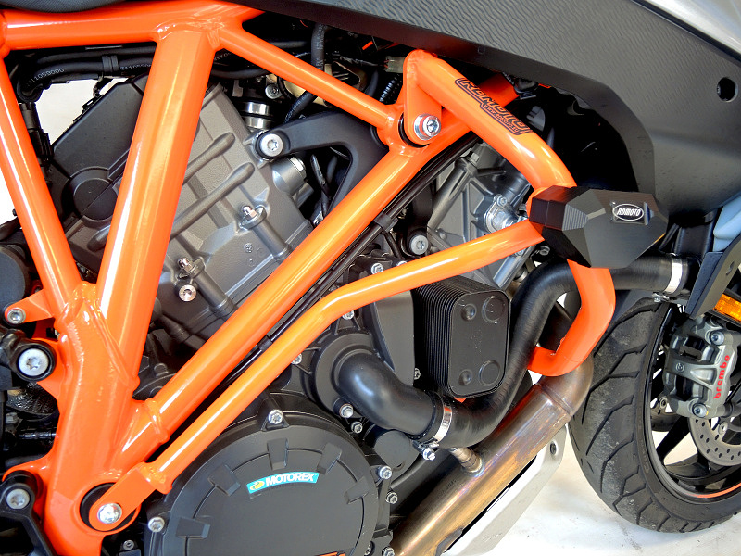
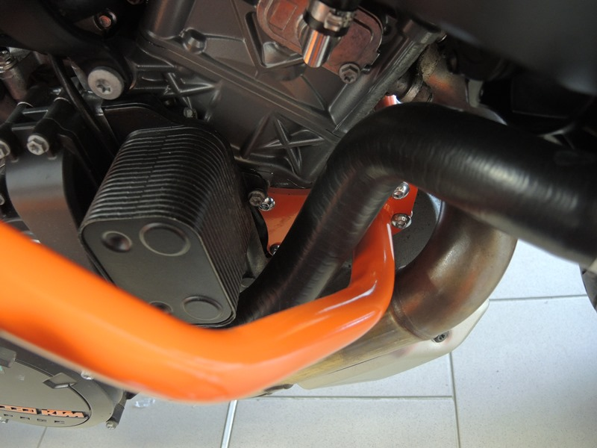
8
9
9
4
13

4
3
7
4

10

Left side:
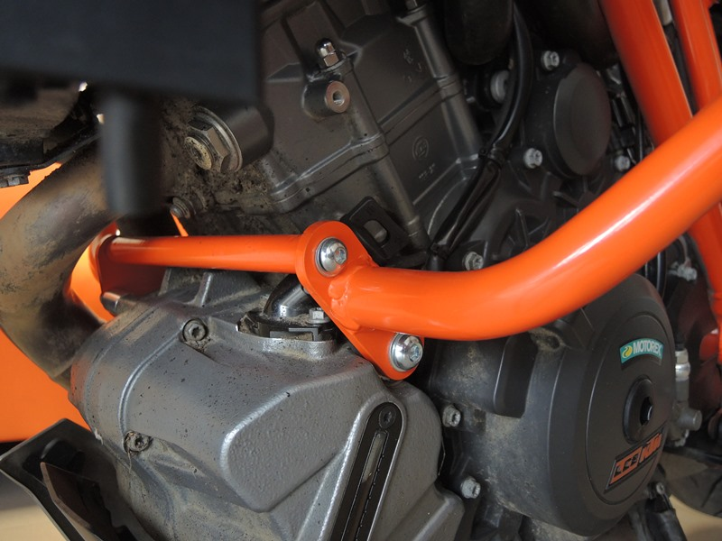
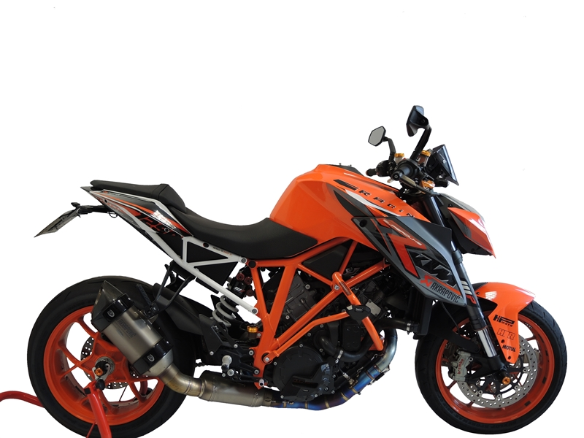
10
3
4

