CF83
KTM 950 Adventure

Kit for right side |  |  |  |  | Kit for left side
Poz. | Popis | Kat.číslo | Počet |  |  | Poz. | Popis | Kat.číslo | Počet
1 | Crash frame |  | 1 |  |  | 1 | Crash frame |  | 1
2 | Clamp | X78 | 1 |  |  | 2 | Clamp | X78 | 1
3 | Nut M8 | 951 | 2 |  |  | 3 | Nut M8 | 951 | 2
4 | Washer M8 – flat | 802 | 4 |  |  | 4 | Washer M8 – flat | 802 | 4
5 | Bolt M8x70mm | 841 | 1 |  |  | 5 | Bolt M8x70mm | 841 | 1
6 | Bolt M8x40mm | 828 | 1 |  |  | 6 | Bolt M8x40mm | 828 | 1
7 | Dural. cylinder d=12mm | 130 | 1 |  |  | 7 | Dural. cylinder d=12mm | 130 | 1
8 | Tube plug 25mm | X19 | 1 |  |  | 8 | Tube plug 25mm | X19 | 1
9 | Tape 3M |  | 2 |  |  | 9 | Tape 3M |  | 2
10 | Sticker RDmoto |  | 1 |  |  | 10 | Sticker RDmoto |  | 1
11 | Washer M8 – spring | 800 | 2 |  |  | 11 | Washer M8 – spring | 800 | 2
12 | Bolt M10 x 200 | 889 | 1 |  |  | 12
13 | Washer M10 flat | 804 | 1 |  |  | 13
14 | Dural. cylinder d=21mm | DV1158 | 1

Mounting instructions:

Install the crash frames as instructed on the attached photos.

Installation of the frames for both sides is the same.

Attention: We recommend using blue color medium strenght glue for threads of all bolts.
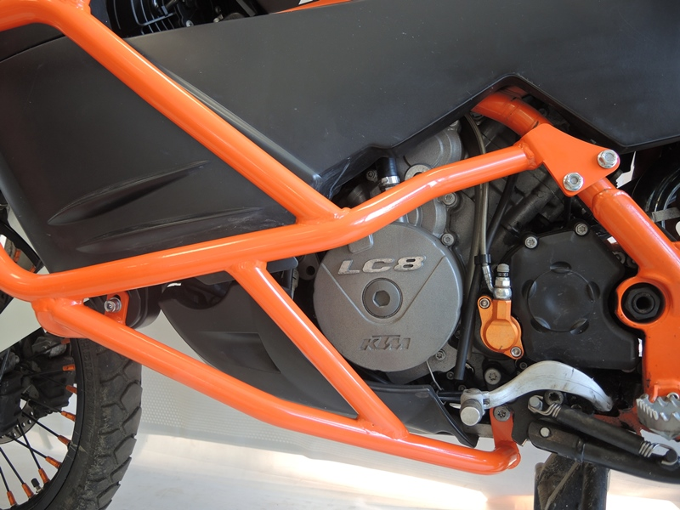
Clamp +2x Tape 3M + 2x Washer M8 ID.4 + 2x Washer M8 spring ID. 11 + 2x nut M8 ID.3

Original bolt

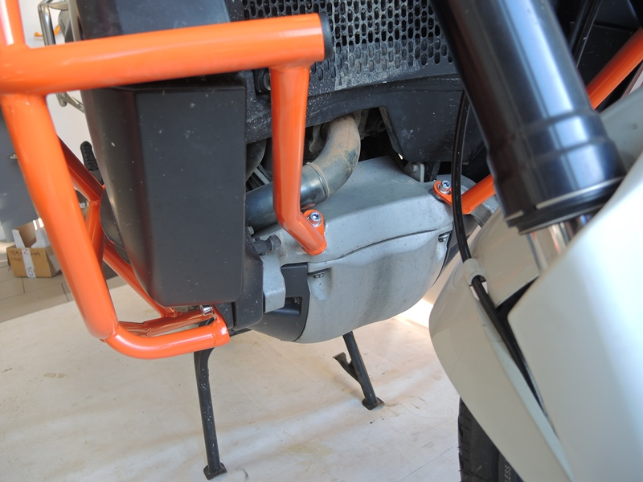
Tube plug

Bolt M8x40mm ID.6 + Washer M8 (flat) ID.4 + Dural. cylinder d=12mm ID.7

Bolt M8x70mm ID.5 + Washer M8 (flat )ID.4

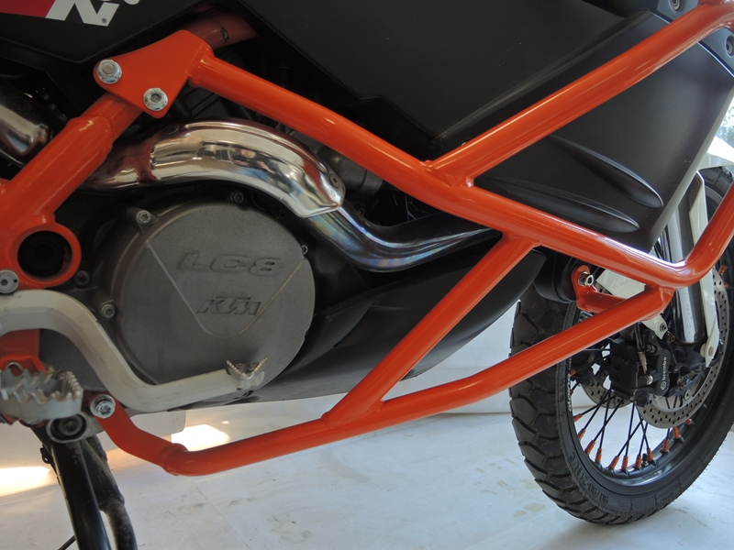
Bolt M10x200mm ID.12 + Washer M10 (flat) ID.13, Dural. cylinder ID.14. From the other side of the motorcycle, use self-locking nut.

