CF87
Kawasaki Z650_2017-

Kit for left side |  |  |  |  | Kit for right side
ID | Description | Cat. No. | Pcs. |  | ID | Description | Cat. No. | Pcs.
1 | Frame | CF87 | 1 |  | 1 | Frame | CF87 | 1
2 | Roller d=16mm | 1268 | 1 |  | 2 | Roller d=10mm | 1267 | 1
3 | Safety nut M10 | 810 | 2 |  | 3 | Safety nut M10 | 810 | 2
4 | Washer M10 flat | 804 | 1 |  | 4 | Washer M10 flat | 804 | 1
5 | Protector | PVPKN 0/16 | 1 |  | 5 | Protector | PVPKN 0/16 | 1
6 | Bolt M10x200mm | 889 | 1 |  | 6 | Bolt M10x200mm | 889 | 1
7 | Plastic cover M10 | X35 | 1 |  | 7 | Plastic cover M10 | X35 | 1
8 | Dural. insert | X131 | 1 |  | 8 | Dural. insert | X131 | 1
9 | Dural. roller d=70mm | DV7 | 1 |  | 9 | Dural. roller d=15mm | DV8 | 1
10 | Rod | 10x370x30x30mm | 1 |  | 10 | Dural. roller d=15mm | 144 | 1
11 | RDmoto sticker |  | 1 |  | 11 | RDmoto sticker |  | 1

We recommend using medium strenght thread glue.

Mounting instructions (same for both sides):

- Take off the original bolt in front left part of the motorcycle.

- Slide duralumin insert ID.8, protector ID.5, drop frame ID.1 and roller ID.9 on the M10 ID.6 bolt (ID.10 on the right side).

- Mount this assembly into the motorcycle frame using M10 ID.3 nut (from the rear).

- Then, place the ID.2 roller under the frame (in rear part) and put in the ID.10 rod, onto which you will place the M10 ID.4 washer with M10 ID.3 nut.

- Follow the same procedure on the other side and finally, tighten all bolts.

- As a last step, place the ID.7 covers and with ID.11 stickers.

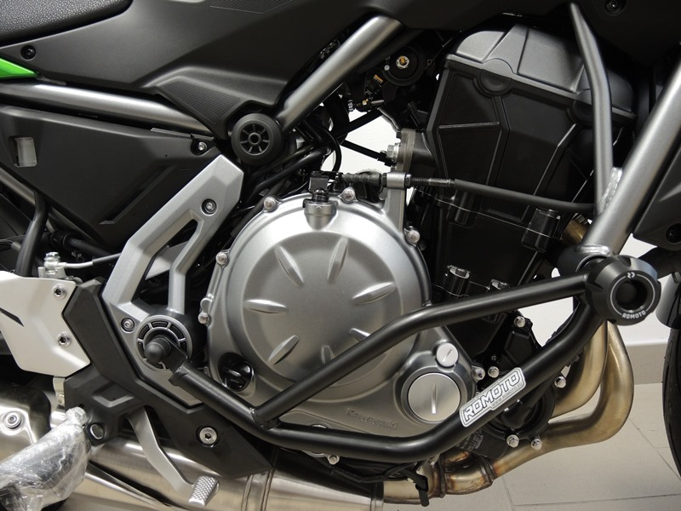
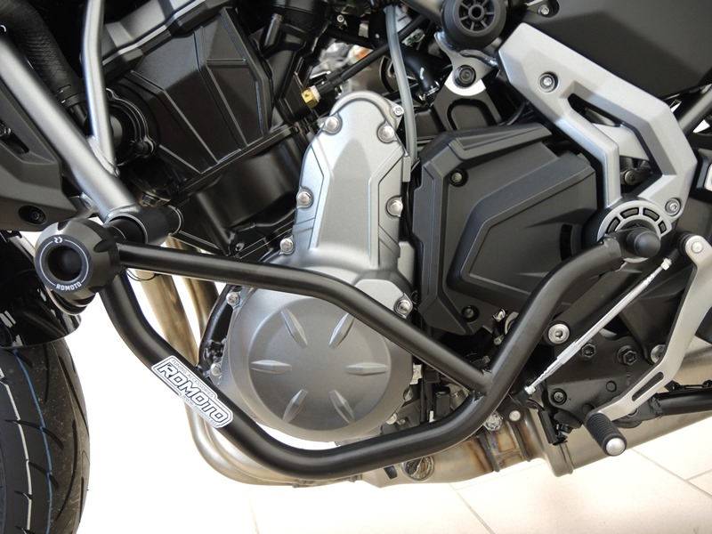
Bolt M10 ID.6+ Nut M10 ID.3+ PVPKN ID.5 + Roller ID.9 + Dural. insert ID.8
Rod 10x370 ID.9 + Washer M10 ID.4 + Roller ID.2 + Plastic cover ID.7
Bolt M10 ID.6 + Nut M10 ID.3+ roller ID.9 + roller ID.10 + PVPKN ID.5 + Dural. insert ID.8
Rod 10x370 ID.9 + Washer M10 ID.4 + Roller ID.2 + Plastic cover ID.7
9
13,11,12
10
Origin.bolt
Original bolt. Rear place.

