CF88
Kawasaki Z900 2017-

Left side kit |  |  |  |  | Right side kit
ID | Popis | Kat.č. | ks |  | ID | Popis | Kat.č. | ks
1 | Frame | CF88 | 1 |  | 1 | Frame | CF88 | 1
2 | Screw M10x85x1.25 | 934 | 1 |  | 2 | Screw M10x85x1.25 | 934 | 1
3 | Screw M10x55x1.25 | 915 | 1 |  | 3 | Screw M10x55x1.25 | 915 | 1
4 | Screw M10x40x1.25 | 941 | 1 |  | 4 | Screw M10x80x1.25 | 920 | 1
5 | Dural. roller d=43mm | 1246 | 1 |  | 5 | Dural. roller d=43mm | 1246 | 1
6 | Flat washer M10 | 804 | 2 |  | 6 | Flat washer M10 | 804 | 2
7 | Dural. roller d=27mm | 1247 | 1 |  | 7 | Dural. roller d=27mm | 1247 | 1
8 | Plastic plug-in | X19 | 1 |  | 8 | Plastic plug-in | X19 | 1

We recommend using a medium-strength thread glue.

Instructions (applicable for both left and right side):

1.) Start with one side first and only then proceed with the other side.
2.) Remove the original screw from the top of the frame.
3.) Push the ID.2 screw through frame ID.1 and ID.5 roller and snap it into the motorcycle frame (do not tighten yet)
4.) Remove the original bolt from the rear and bottom of the frame.
5.) Fit the left lower part of the frame with ID.4 screw, right side with ID.4 screw.
6.) Use ID.3 screw and ID.7 roller at the rear part.
7.) Finally, tighten all screws.
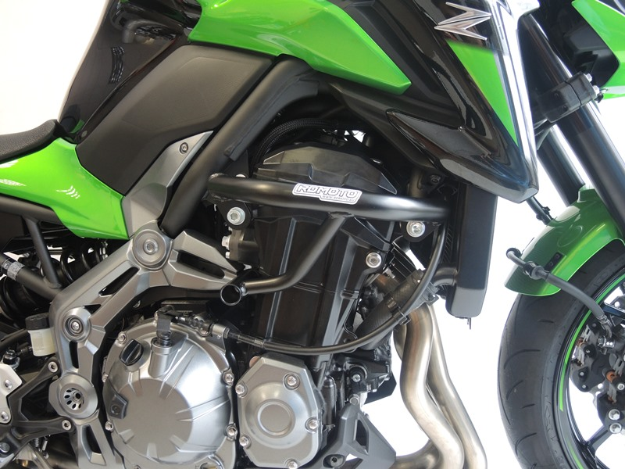

6
6
2
3
4
8
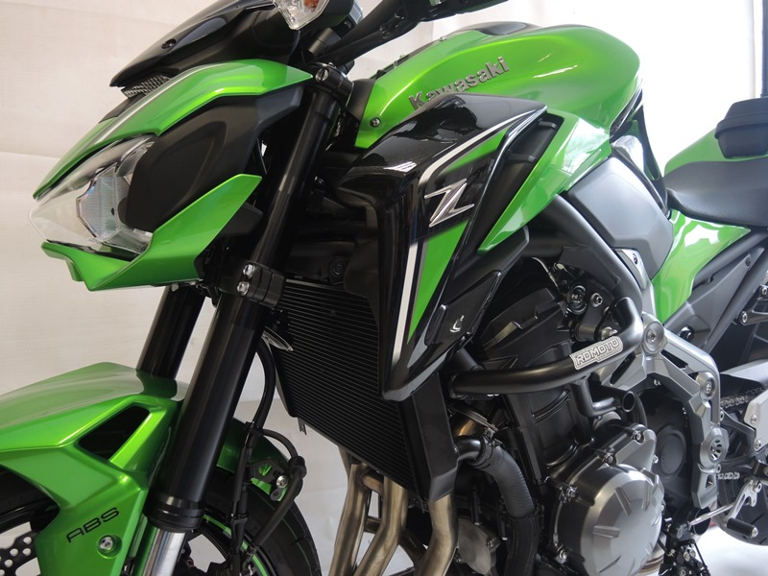
9
13,11,12
10
Origin.bolt
Original bolt. Rear place.

