CF90
Benelli TNT 125 2017-

Kit for left side |  |  |  |  | Kit for right side
ID | Description | Cat.no. | pcs |  | ID | Description | Cat.no. | Pcs
1 | Frame | CF90 | 1 |  | 1 | Rám | CF90 | 1
2 | Bolt M8x80 | 843 | 2 |  | 2 | Safety nut M8 | 809 | 2
3 | Washer M8 flat | 802 | 2 |  | 3 | Washer M8 flat | 802 | 2
4 | Bolt M10x130 | 883 | 1 |  | 4 | Washer M10 flat | 804 | 1
5 | Washer M10 flat | 804 | 1 |  | 5 | Safety nut M8 | 810 | 1
6 | Plastic plug M10 | X4 | 1 |  | 6 | Plastic plug M8 | X5 | 2
7 | RDmoto sticker |  | 1 |  | 7 | RDmoto sticker |  | 1

We recommend using a medium-strenght thread glue.

- Begin by dismantling the original plastic and the chain cover on left side, as well as disassembling the rear original screw.
- Insert the M10 ID.5 Bolt through M10 ID.6 washer, ID.1 frame and the motorcycle frame.
- Remove the two original bolts at the front part of the bike (as shown on photo), then fit the M8 ID.3 washer onto M8 ID.2 bolt and push through crash frame and the motorcycle frame.
- On the right side, attach the second part of ID.1 crash farme onto protruding ID.5 and ID.2 bolts, then attach the M10 ID.5 and M8 ID.3 washers plus M10 ID.6 and M8 ID.2 nuts.
- Tighten the whole assembly now.
- We recommend mounting screws on the left side first for easier oil filter change.

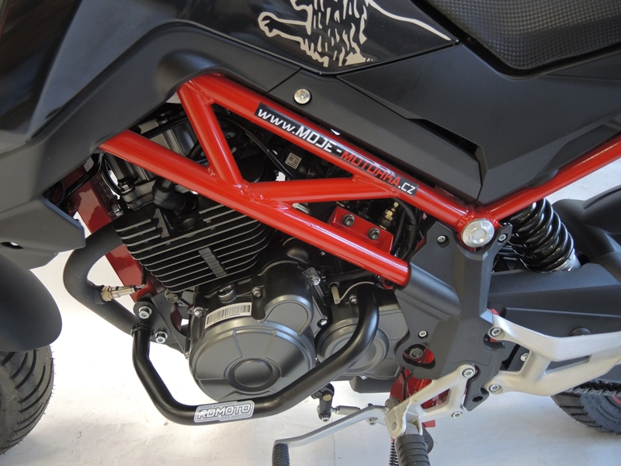

3
6
2
3
9
13,11,12
10
Origin.bolt
Original bolt. Rear place.

4

5

